Coursework 1: Von Neumann Architecture and AI-Assisted Programming
Overview
This coursework introduces students to the fundamental concepts of the Von Neumann architecture through hands-on programming exercises using the vnmsim simulator, culminating in a collaborative project that explores the emerging field of AI-assisted software development.

Learning Objectives
By completing this coursework, students will be able to:
- Understand Von Neumann Architecture: Identify and explain the core components of the Von Neumann architecture and their interactions
- Master vnmsim Programming: Develop proficiency in programming within the constraints of a simplified Von Neumann machine simulator
- Implement Fundamental Algorithms: Create programs that demonstrate conditional logic, sorting, and array processing
- Collaborate with AI Tools: Effectively use Large Language Models (LLMs) as co-developers in the software development process
- Critical AI Evaluation: Analyze the advantages, limitations, and appropriate use cases for AI-assisted programming
- Professional Documentation: Document code, processes, and reflections following industry standards

Assessment Structure
Coursework 1 Breakdown:
- Exercises 1-5: 20% of total grade (Completed/Not Completed)
- Exercise 6: 80% of total grade (Detailed rubric assessment)
Note: All exercises 1-5 must be completed and submitted to receive the 20% allocation.

Exercise 6 Assessment Criteria (80% of Total Grade):
Component | Points | Percentage
Program Implementation | 5 pts | 25%
LLM Co-development Documentation | 5 pts | 25%
Self-Evaluation & Reflection (individual) | 5 pts | 25%
Team Presentation | 5 pts | 25%

Detailed Criteria per Component
A. Program Implementation (25%)
Score | Criteria
Excellent (90–100%) | Program fully meets specifications; correct vnmsim behavior in all tested scenarios; extensive, well-structured tests; efficient, readable, and maintainable code.
Good (75–89%) | Program meets most specifications; generally correct behavior with minor issues; some meaningful tests included; code mostly clear with occasional inefficiencies.
Satisfactory (60–74%) | Program runs with partial correctness; basic alignment to specification; limited or incomplete testing; code works but lacks clarity or efficiency.
Needs Improvement (40–59%) | Program compiles but has significant functional issues; minimal testing; unclear or poorly structured code; does not fully align with spec.
Unsatisfactory (0–39%) | Program fails to run or does not address the specification; no meaningful tests; code is missing or fundamentally incorrect.

B. LLM Co-Development Documentation (25%)
Score | Criteria
Excellent (90–100%) | Clear, comprehensive documentation of AI interactions; sophisticated evaluation of AI suggestions; strong evidence of critical thinking; meaningful reflection on learning process.
Good (75–89%) | Adequate documentation with some examples of critical evaluation; basic reflection on AI collaboration; evidence of learning through interaction.
Satisfactory (60–74%) | Basic documentation meeting minimum requirements; limited critical evaluation; simple reflection on AI use.
Needs Improvement (40–59%) | Incomplete or superficial documentation; little evidence of critical thinking; minimal engagement with collaboration process.
Unsatisfactory (0–39%) | Missing or inadequate documentation; no evidence of meaningful AI collaboration; failure to meet basic requirements.

C. Team Presentation & Demo (25%)
Score | Criteria
Excellent (90–100%) | Clear, professional delivery; highly engaging demonstration of working system; strong technical accuracy; seamless teamwork; confident and accurate responses in Q&A.
Good (75–89%) | Effective delivery with minor clarity or engagement issues; demonstration shows most features working; generally accurate content; good team coordination; satisfactory Q&A handling.
Satisfactory (60–74%) | Basic presentation with limited engagement; demonstration works partially; some inaccuracies or gaps; uneven team participation; Q&A responses limited.
Needs Improvement (40–59%) | Unclear or disorganized presentation; demonstration unreliable or incomplete; weak teamwork; poor handling of Q&A.
Unsatisfactory (0–39%) | No meaningful presentation or demo; system not shown; unprofessional delivery; inability to address Q&A.

D. Self-Evaluation & Reflection (25%)
Score | Criteria
Excellent (90–100%) | Deep, thoughtful reflection with specific evidence of individual learning; clear articulation of lessons learned; strong critical insight; realistic and well-justified next steps.
Good (75–89%) | Solid reflection with some evidence of learning; identifies lessons and growth areas; next steps described but not fully developed.
Satisfactory (60–74%) | Basic reflection with limited depth; acknowledges some learning but without strong evidence; next steps vague or generic.
Needs Improvement (40–59%) | Superficial or incomplete reflection; little evidence of learning; minimal or unclear future planning.
Unsatisfactory (0–39%) | No meaningful reflection submitted; fails to identify learning or next steps; missing or irrelevant content.

Exercise 1: Understanding the vnmsim Interface
Objective: Familiarize yourself with the vnmsim platform and identify components of the Von Neumann architecture.
Tasks:
- Launch the vnmsim simulator
- Take a screenshot of the initial interface
- Identify and describe the various elements present
- Write a brief report correlating the elements you see in the simulator with the Von Neumann architecture's conceptual components
Deliverables:
- Screenshot of vnmsim interface
- Brief report identifying Von Neumann components in the simulator

REPORT (you may extend the report as needed beyond this page)
Declaration of use of AI tools. If you've used AI tools to aid in understanding or completing this exercise, please acknowledge it below.
Acknowledgement of AI use: | No (Yes/No)
AI tool used: | [e.g., OpenAI, BARD, etc.]
Purpose: | [e.g., Clarification of a concept, content generation, error-checking, etc.]
Shared session (if available) | Example: https://chat.openai.com/share/24259216-abc1-4343-974d-95357368aae8
In the Von Neumann machine simulator there are such elements:
- Memory – holds both program operations and data.
- CPU – consists of the control unit (CU), arithmetic and logic unit (ALU) and main registers (PC,MAR,MDR,ACC), runs the fetch-decode-execute-store cycle.
- Program counter (PC) – holds the address of next operation.
- Memory access register (MAR) – holds the address of a memory cell.
- Memory data register (MDR) – holds the data of a memory cell.
- Accumulator (ACC) – register on which the arithmetic operations are applied.
- Address bus – transfers the addresses of operations or memory cells from memory to CPU.
- Data bus – transfers data from memory to CPU and vice versa.
- Program – input field where you write code of a program.
- Compile button – compiles the program.
- Step button – runs one step of a CPU cycle.
- Run button – runs the program step by step until halted.
- Finish button – runs the program without visualisation until halted.
- Reset button – resets the program, sets PC to 0.
- Manual button – shows controls of the simulator, the ISA, basic patterns and errors.
- Examples button – loads example programs.
- My saved programs button – allows to load a program saved in the browser.
- Save button – allows to save a program in the browser.
- Trash button – deletes selected saved program from the browser.
- Import button – prompts for a .vnm, .asm or .txt file to load as a program.
- Download button – allows to download the program as a .vnm file.
- Program lines – shows line numbers of a program for jump operations.
- Memory cells – places in memory to store data in.
- Speed slider – controls the speed of visualisation and operations.
The elements correspond with Von Neumann’s architecture principles:
- Memory homogeneity – the program and data are stored in the memory together.
- Addressability – the memory cells are identifiable by their labels.
- Sequential processing – the CPU runs the operation cycle, processing operations one by one.
- Single processor – there is only one CPU.

Exercise 2: Exploring Pre-existing Programs
Objective: Understand the limited instruction set of the vnmsim and document the behavior of sample programs.
Tasks:
- For each example program provided within the vnmsim:
  - Run each program
  - Analyze each program: break down its functionality, purpose, and behavior
  - Document the initial and final states of the simulator for each program (screenshot)
  - Evaluate: Does each program work as intended? Yes/No, and why?
- Write a brief report explaining the programs' operation, emphasizing the role of each instruction and the outcome for the particular input values you chose
Note:
The instruction set available for this simulator of a simple von Neumann computer is very limited. Hence, the implementation of solutions has to take into consideration its limitations and creative use of them to solve each case.
Deliverables:
- Screenshots of initial and final states for each program
- Analysis report of program functionality and behavior
REPORT (you may extend the report as needed beyond this page)
Declaration of use of AI tools. If you've used AI tools to aid in understanding or completing this exercise, please acknowledge it below.
Acknowledgement of AI use: | Yes (Yes/No)
AI tool used: | Claude Sonnet 5.5 Medium [e.g., OpenAI, BARD, etc.]
Purpose: | Clarification of terms purpose, functionality and behaviour in the task and example generation. My opinion - it was sort of useful. An online dictionary explained the terms better.[e.g., Clarification of a concept, content generation, error-checking, etc.]
Shared session (if available) | https://claude.ai/share/864df123-e5ce-4746-a4b5-871755743d5a Example: https://chat.openai.com/share/24259216-abc1-4343-974d-95357368aae8
- Addition

Purpose:
The program computes the sum of two whole numbers.

Functionality:
Code analysis | Visualised algorithm
// X + Y = Z is a comment.
LOD X loads the value of memory cell X into ACC.
ADD Y adds the value of memory cell Y to ACC.
STO Z stores the value of ACC into memory cell Z.
HLT halts the program.

Behaviour:
For any X and Y, set Z to the value of X+Y.

Initial state:
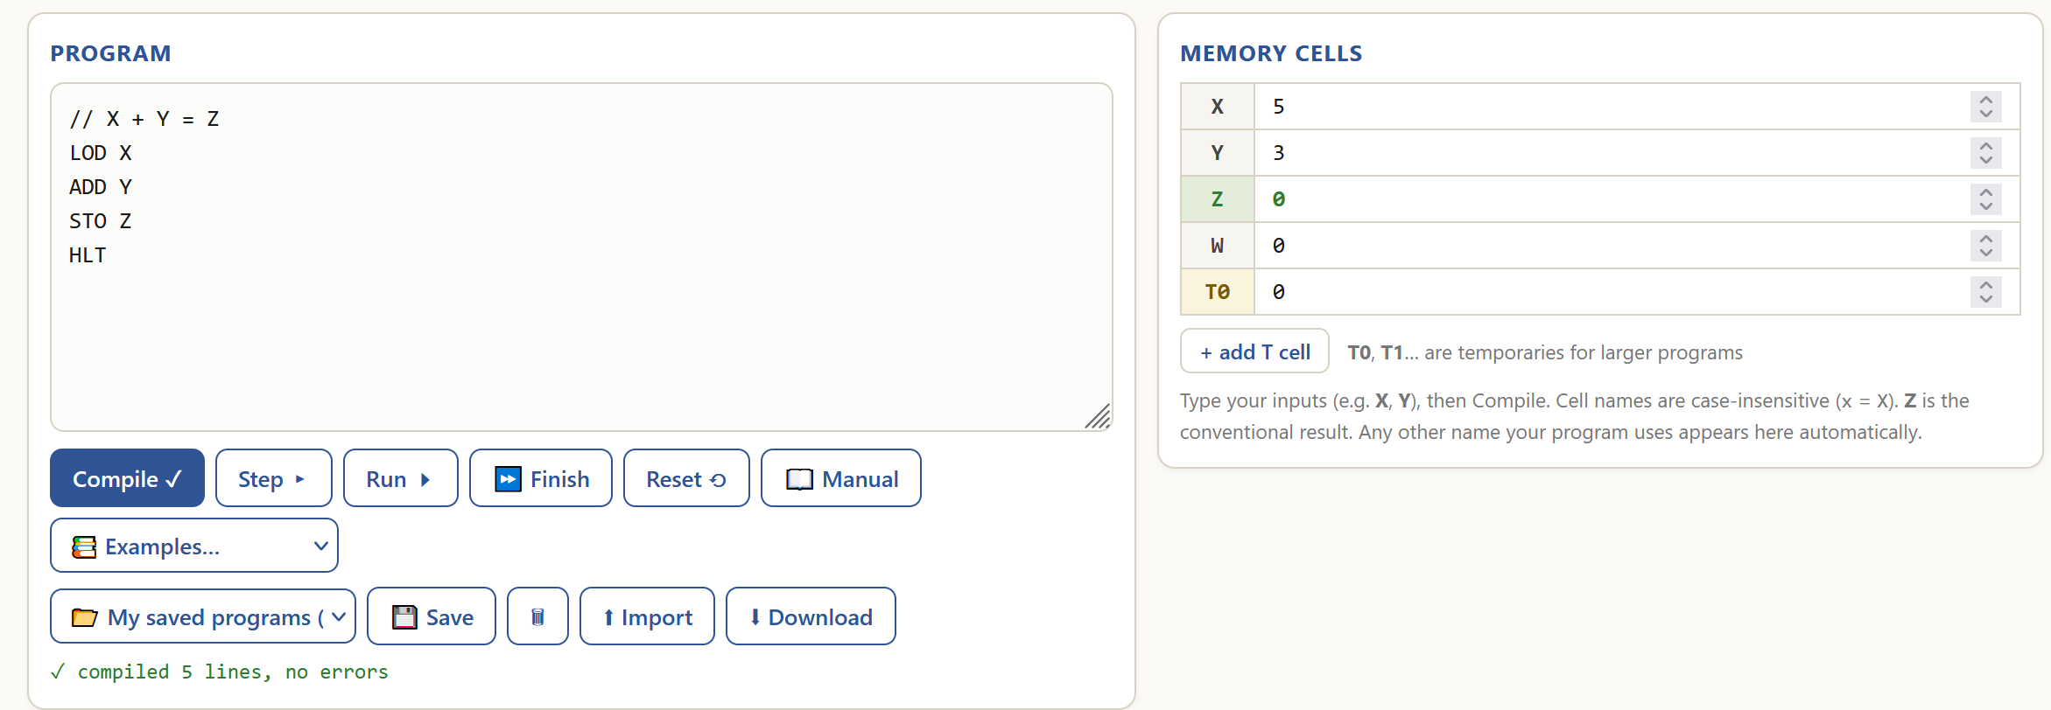

Final state:
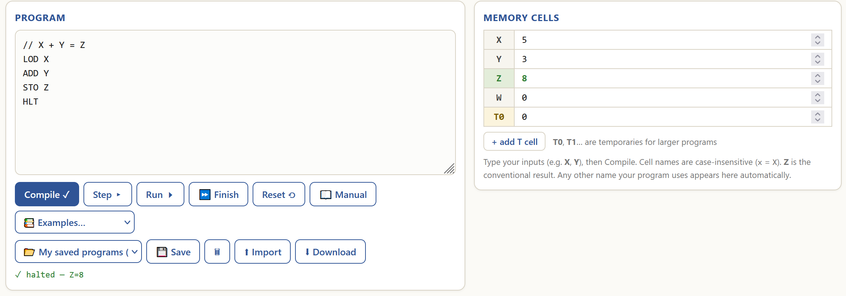
The program works as intended because it correctly adds two numbers together (5+3=8).

- Subtraction

Purpose:
The program computes the difference of two whole numbers.

Functionality:
Code analysis | Visualised algorithm
// X - Y = Z is a comment.  LOD X loads the value of memory cell X into ACC.  SUB Y subtracts the value of memory cell Y from ACC.  STO Z stores the value of ACC into memory cell Z.  HLT halts the program. | 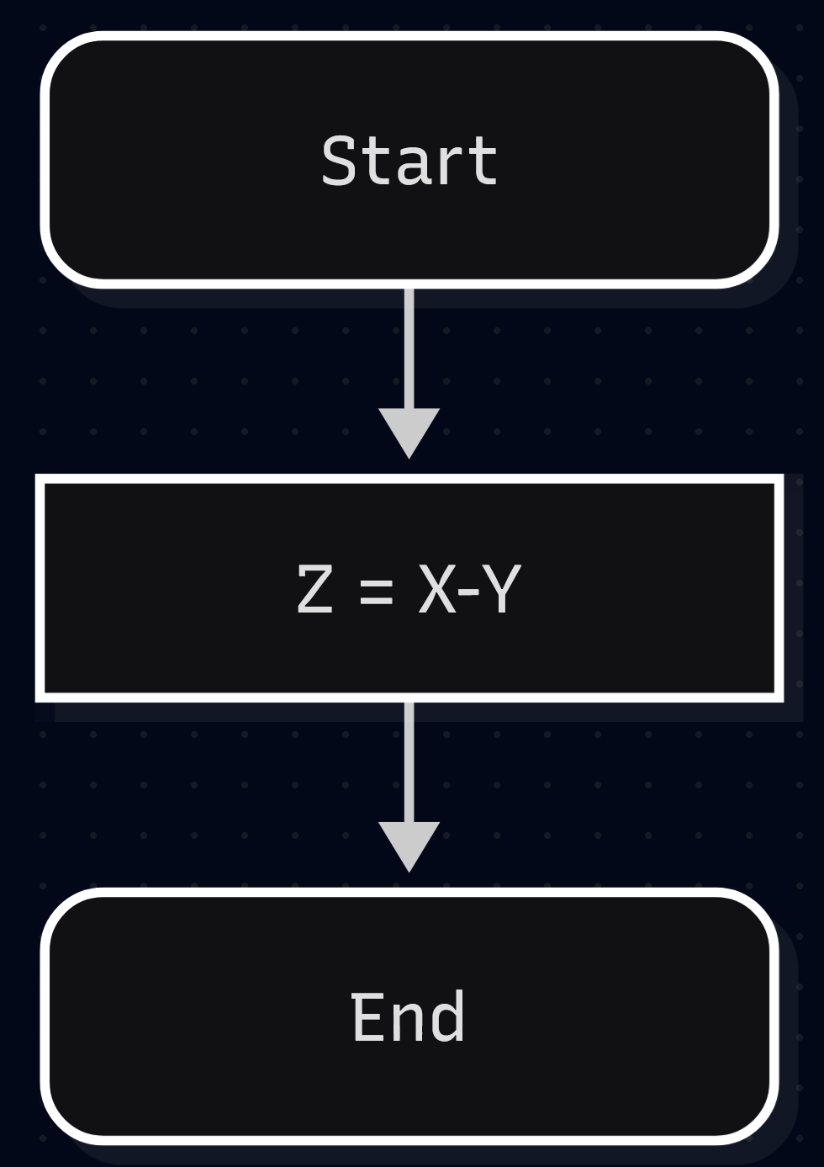

Behaviour:
For any X and Y, set Z to the value of X-Y.

Initial state:
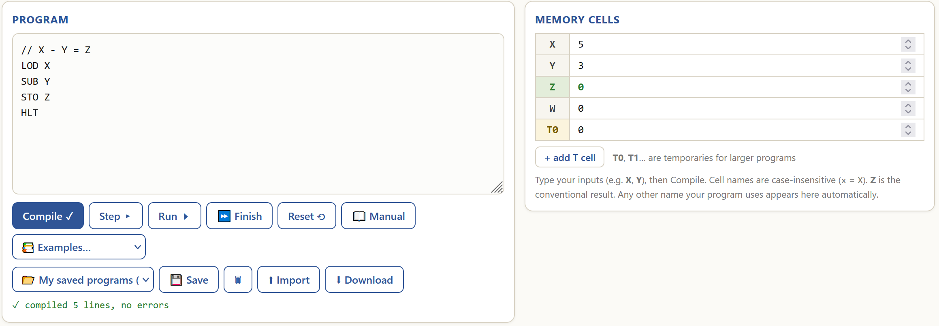
Final state:
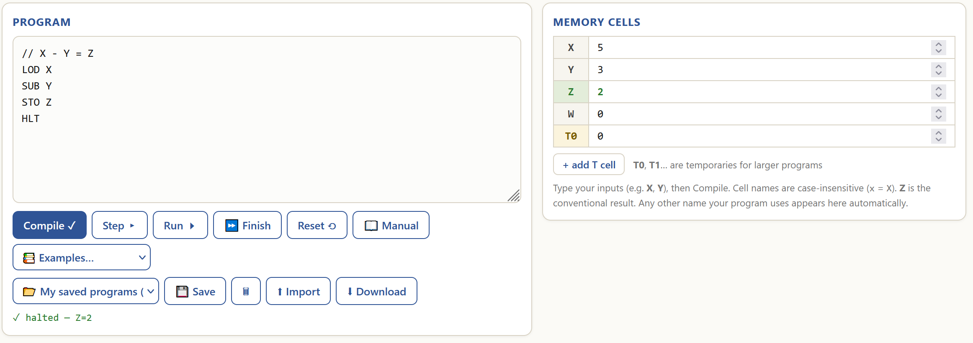

The program works as intended because it correctly subtracts one number from another (5-3=2).

- Multiplication

Purpose:
The program calculates the product of two whole numbers.

Functionality:
Code analysis | Visualised algorithm
// X * Y = Z is a comment.  LOD X loads the value of memory cell X into ACC.  MUL Y multiplies ACC’s value by the value of memory cell Y.  STO Z stores the ACC’s value into memory cell Z.  HLT halts the program. | 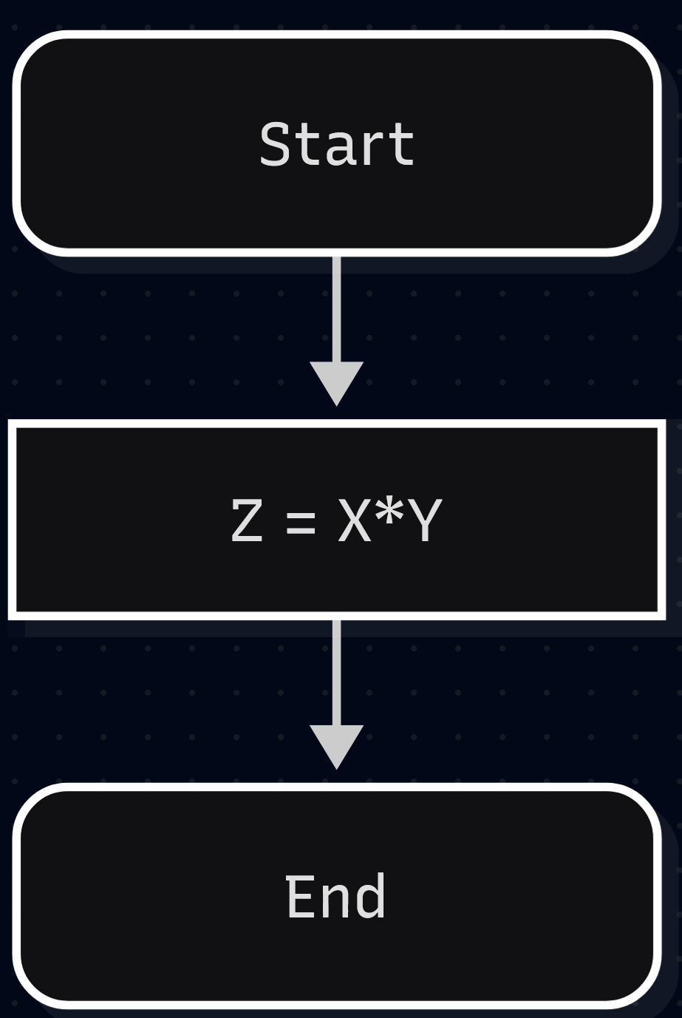

Behaviour:
For any X and Y, set Z to the value of X*Y.

Initial state:
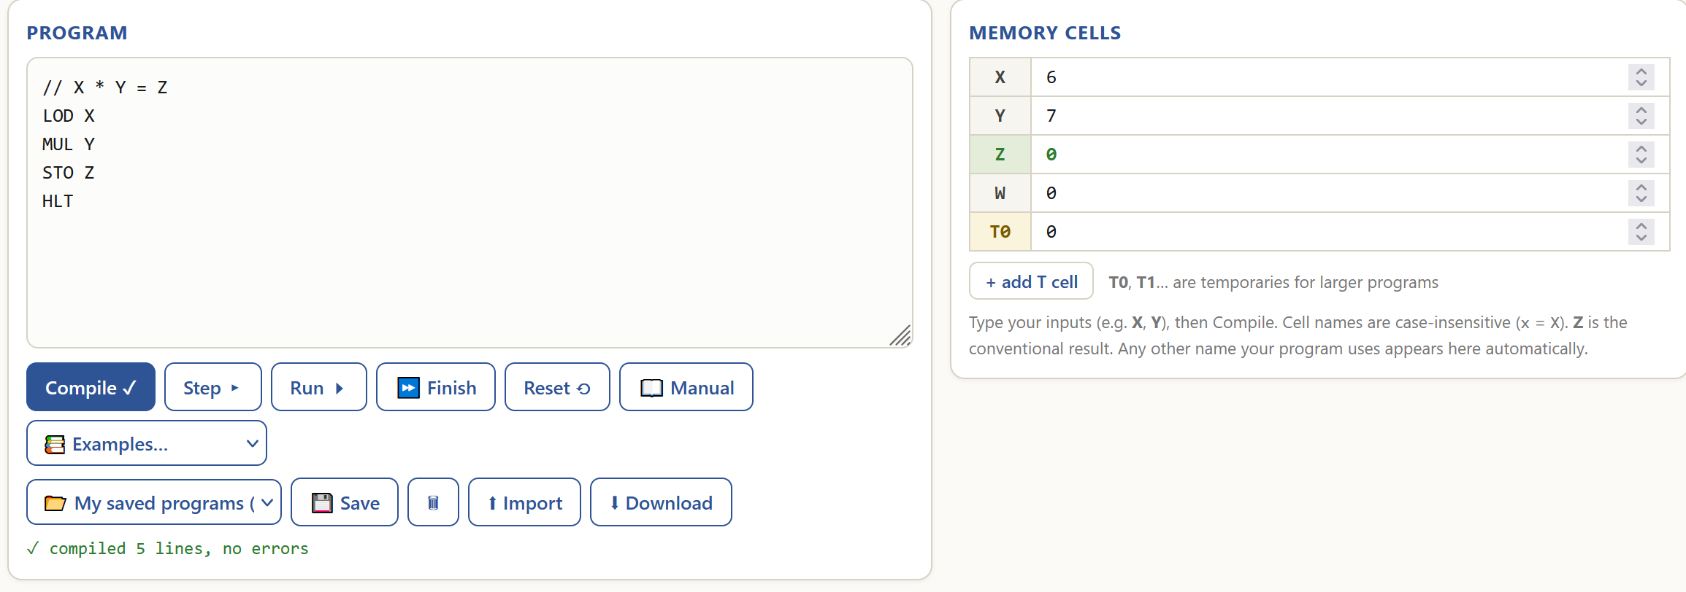
Final state:
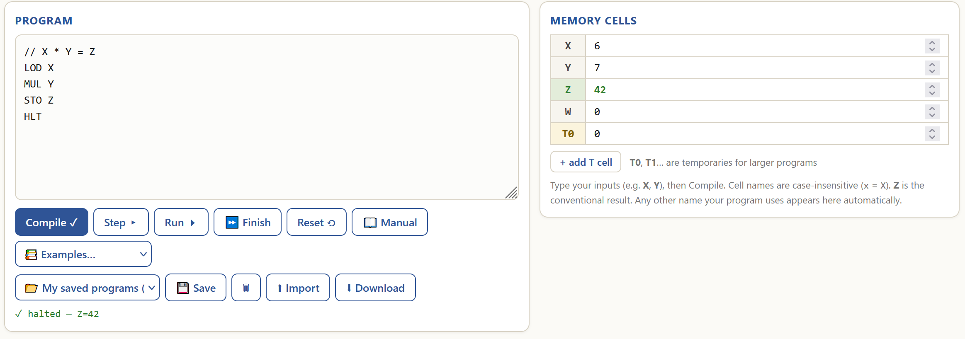
The program runs as intended because it multiplies two numbers correctly (6*7=42).

- Division

Purpose:
The program implements integer division of one number by another.

Functionality:
Code analysis | Visualised algorithm
// X / Y = Z is a comment.  LOD X loads the value of memory cell X into ACC.  DIV Y divides ACC’s value by the value of memory cell Y without remainder.  STO Z stores the ACC’s value into memory cell Z.  HLT halts the program. | 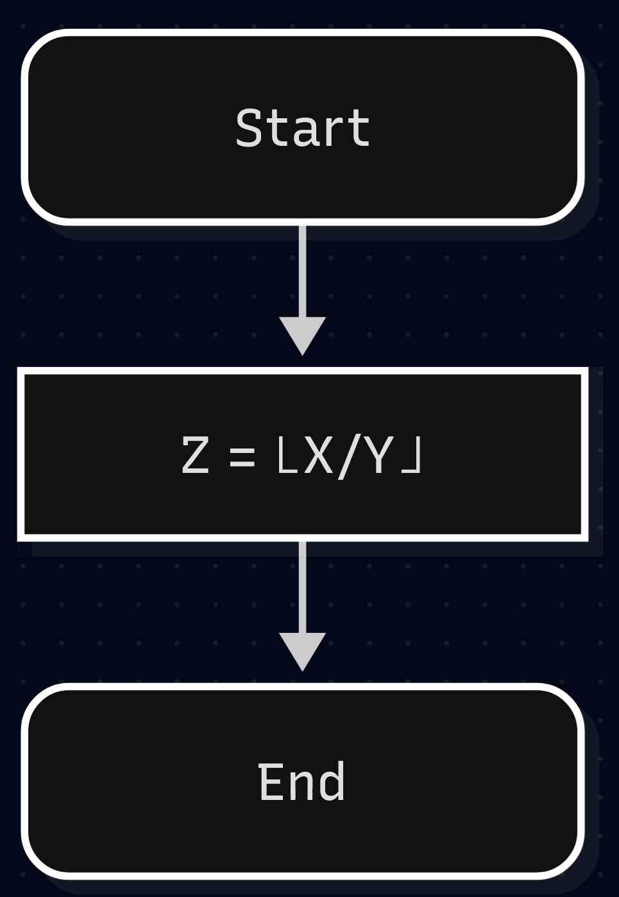

Behaviour:
General case – for any X and a non-zero Y, set Z to the value of X/Y rounded down.
Edge case – for any X and Y=0, give a zero-division error.

General case tests:
Initial state:
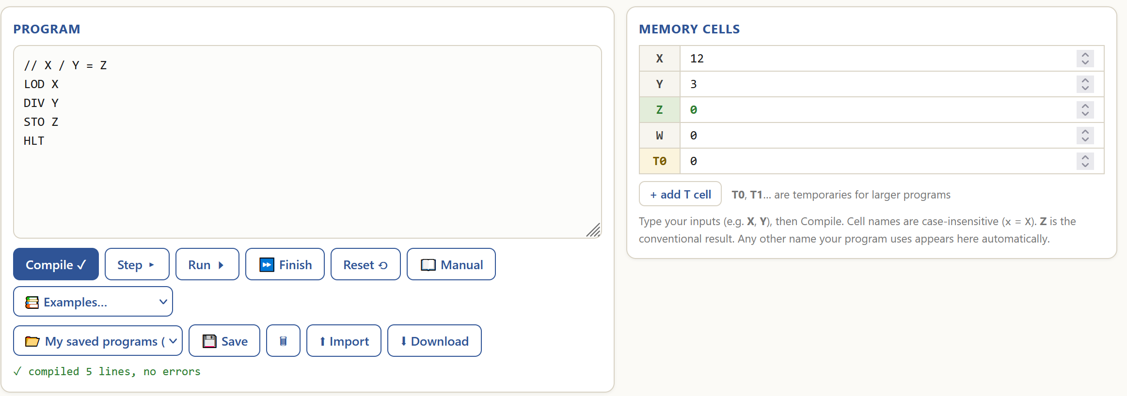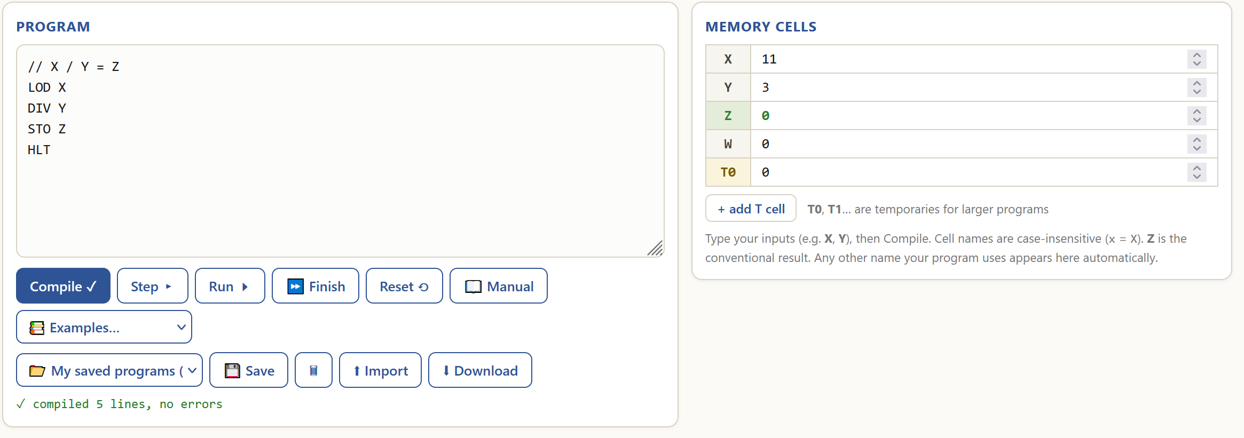
Final state:
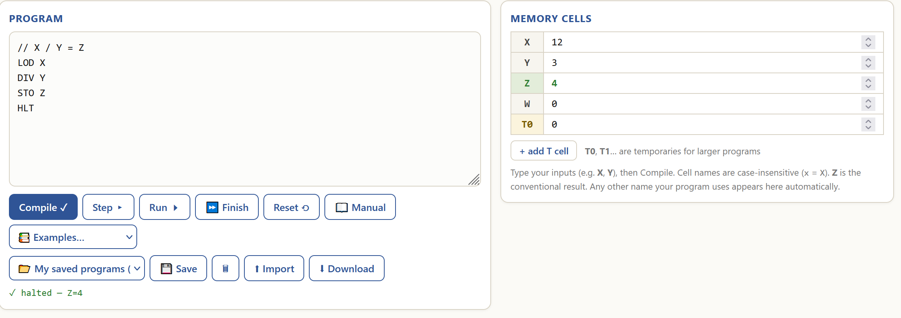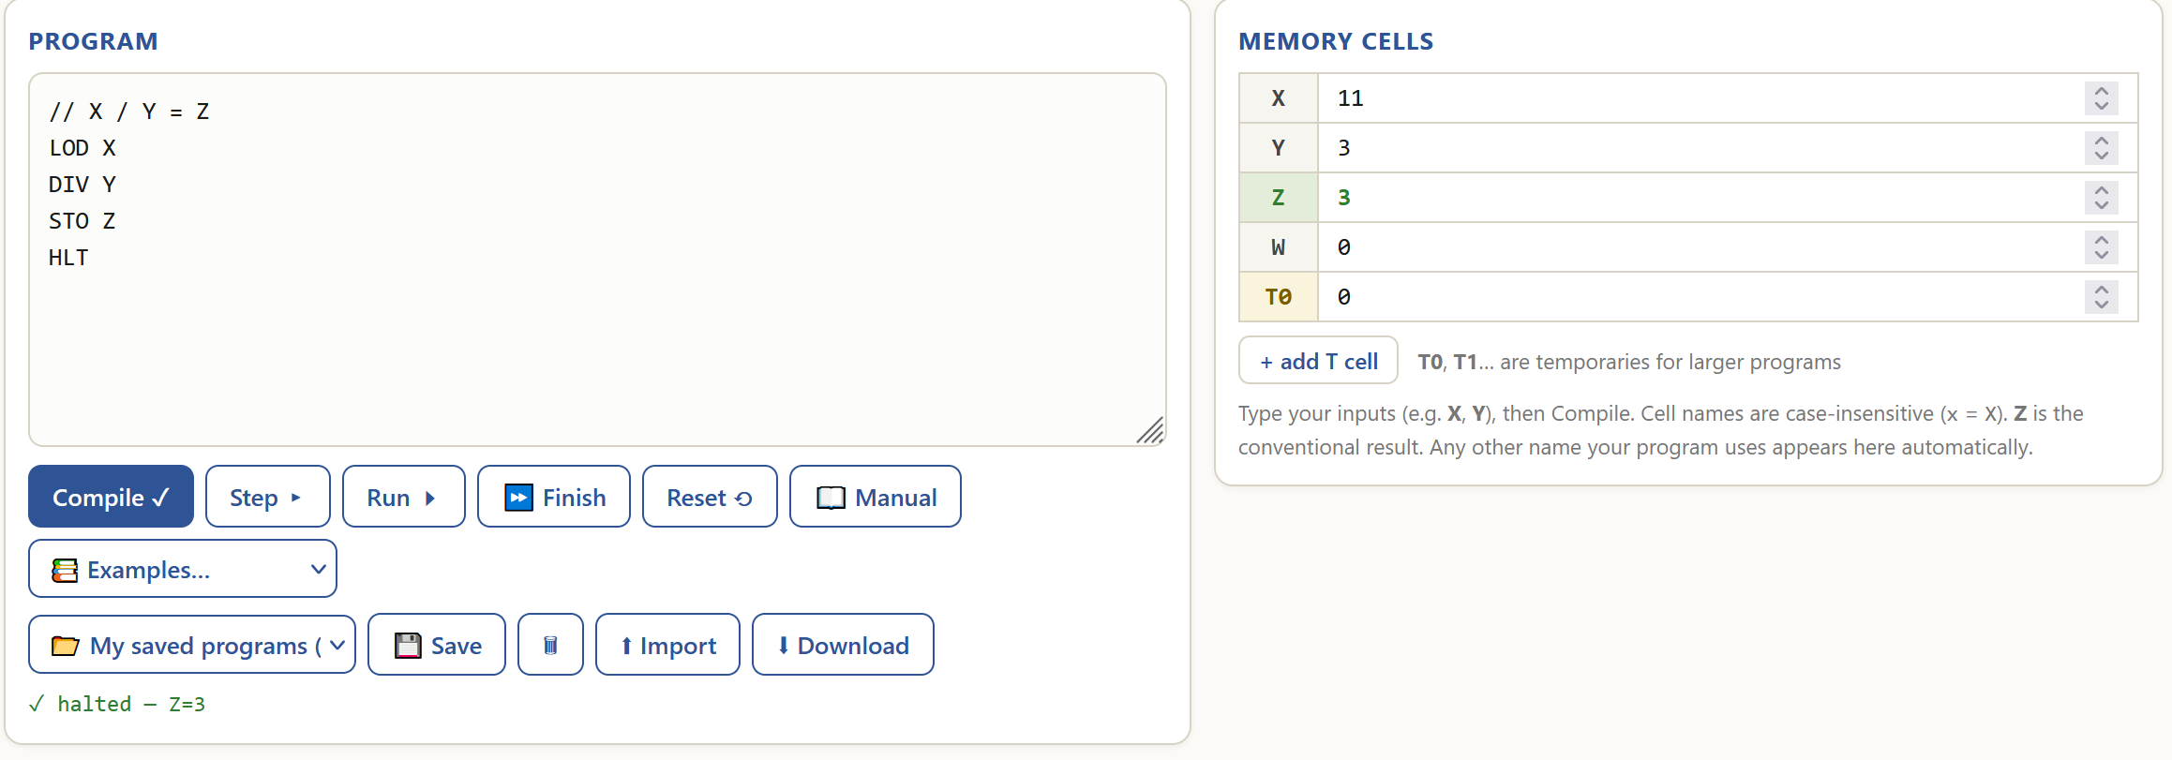
Edge case test:
Initial state:
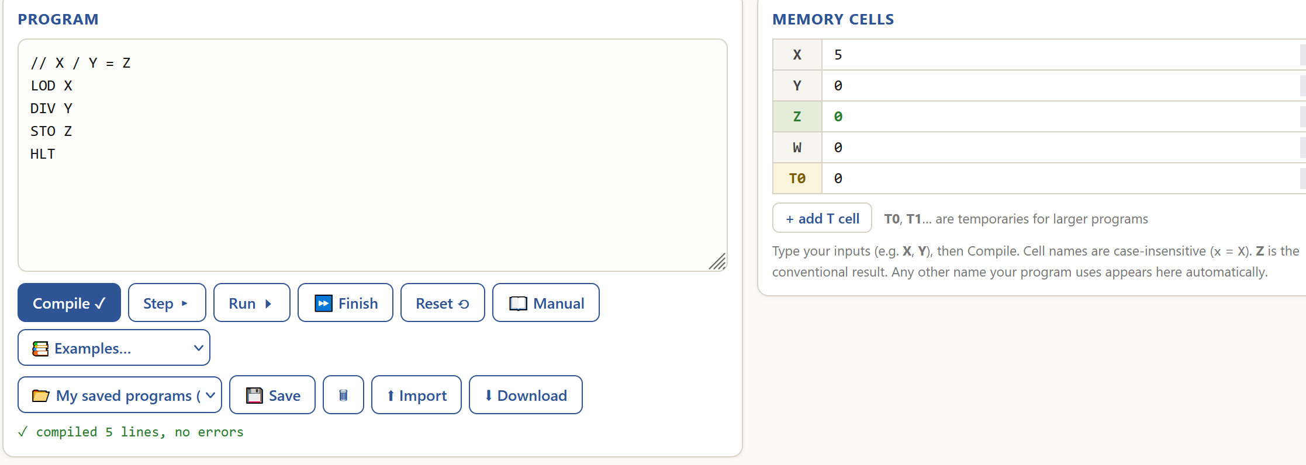
Final state:
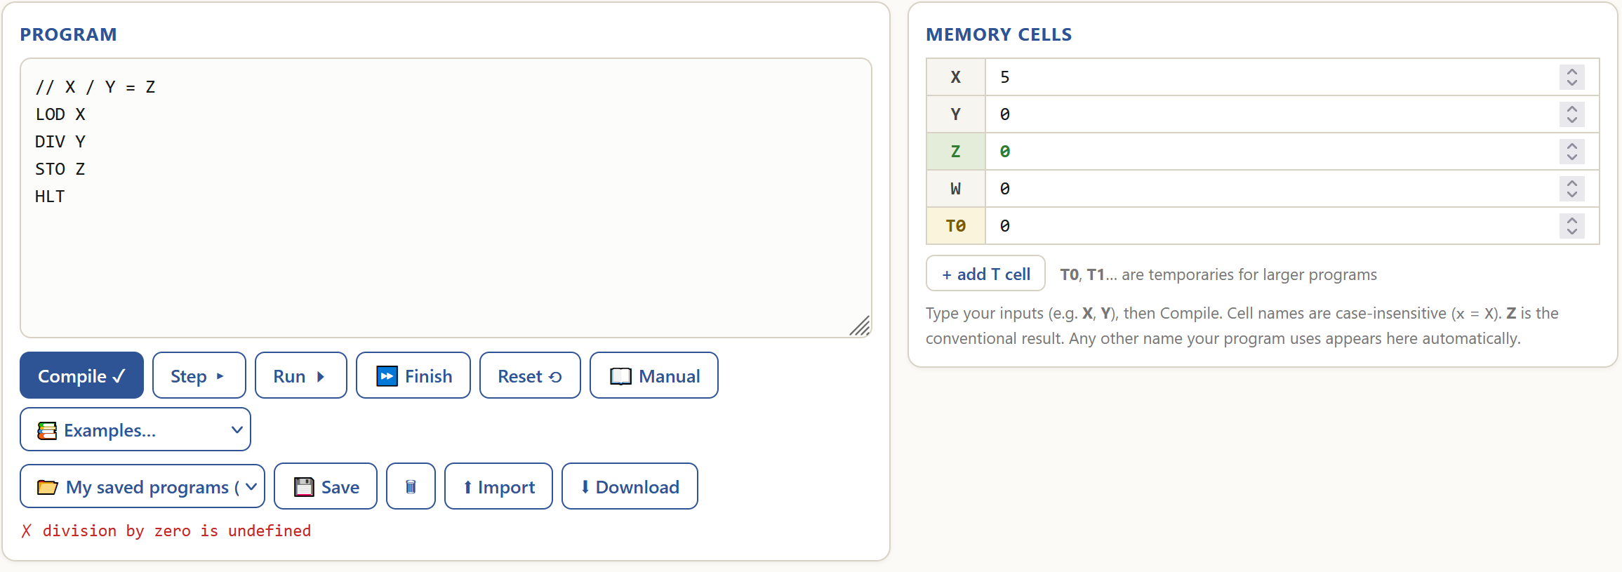

The program works as intended for the general case because it correctly divides one number by another without remainder (12/3=4, 11/3=3.6667 rounded down to 3). It does not handle the edge case of division by zero and just gives out an error.

- Power

Purpose:
The program computes a whole non-negative power of a whole number.

Functionality:
Code analysis | Visualised algorithm
// X^Y = Z is a comment.  LOD #1 loads immediate 1 into ACC.  STO Z stores ACC’s value into memory cell Z.  LOD Y loads the value of memory cell Y into ACC.  JMZ 12 sets PC to 12 if ACC’s value is 0.  LOD Z loads the value of memory cell Z into ACC.  MUL X multiplies ACC’s value by the value of memory cell X.  STO Z stores ACC’s value into memory cell Z.  LOD Y loads the value of memory cell Y into ACC.  SUB #1 subtracts immediate 1 from ACC.  STO Y stores ACC’s value into memory cell Y.  JMP 4 sets PC to 4.  HLT halts the program. | 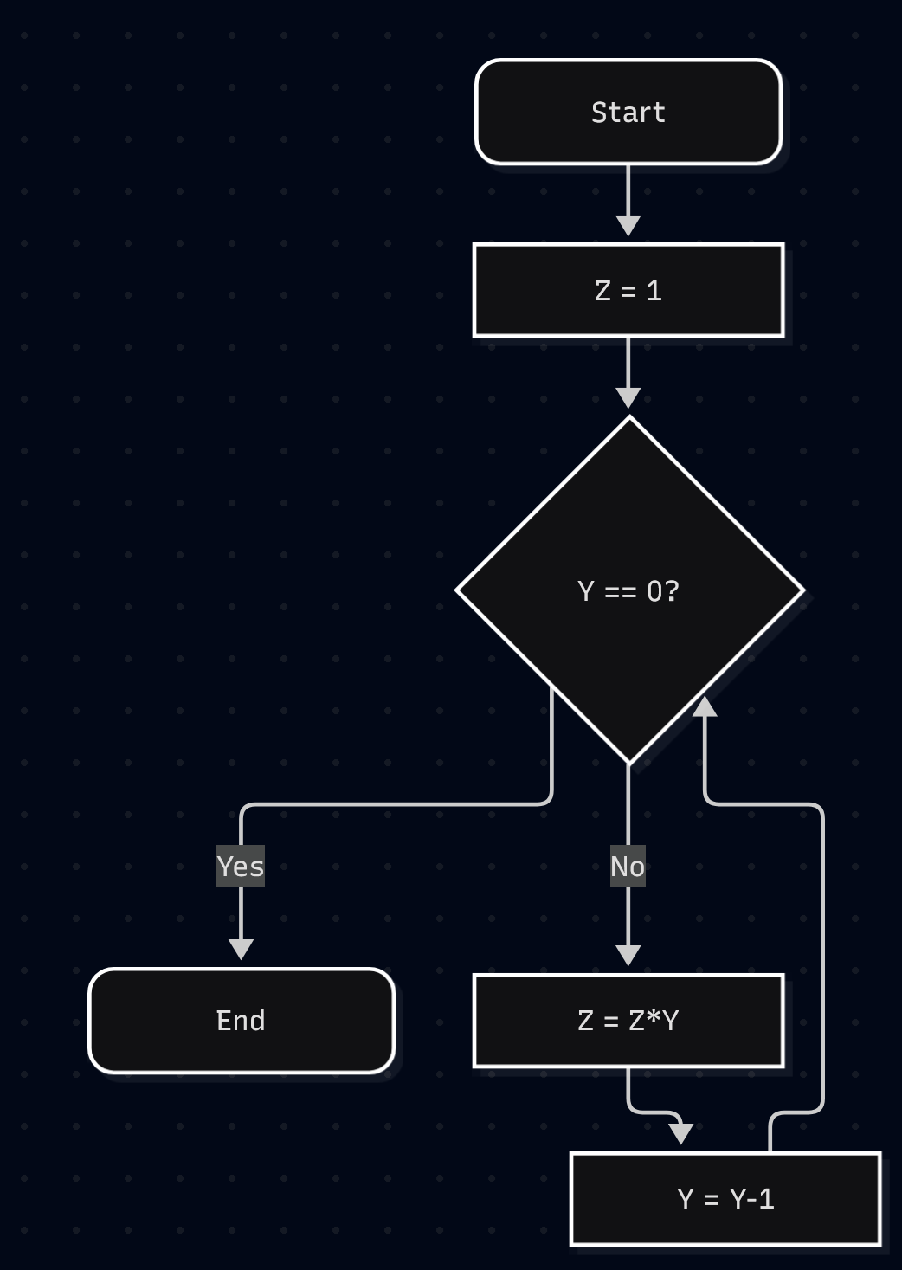

Behaviour:
General case - for any X and a Y greater than or equal to zero, set Z to the value of X^Y.
Edge case – for any X and a Y less than zero, give a step limit exceeded error.

General case tests:
Initial state:
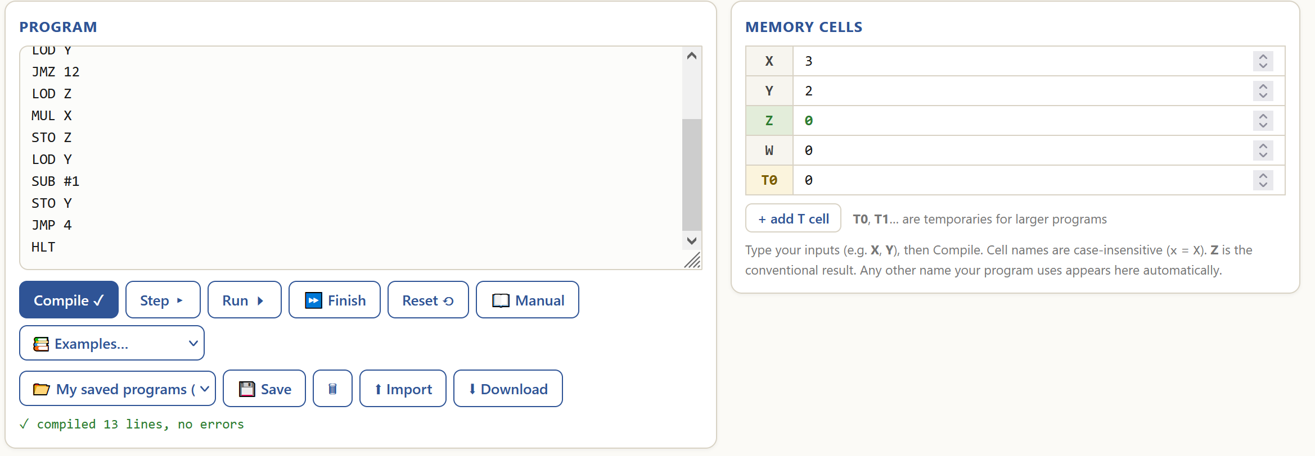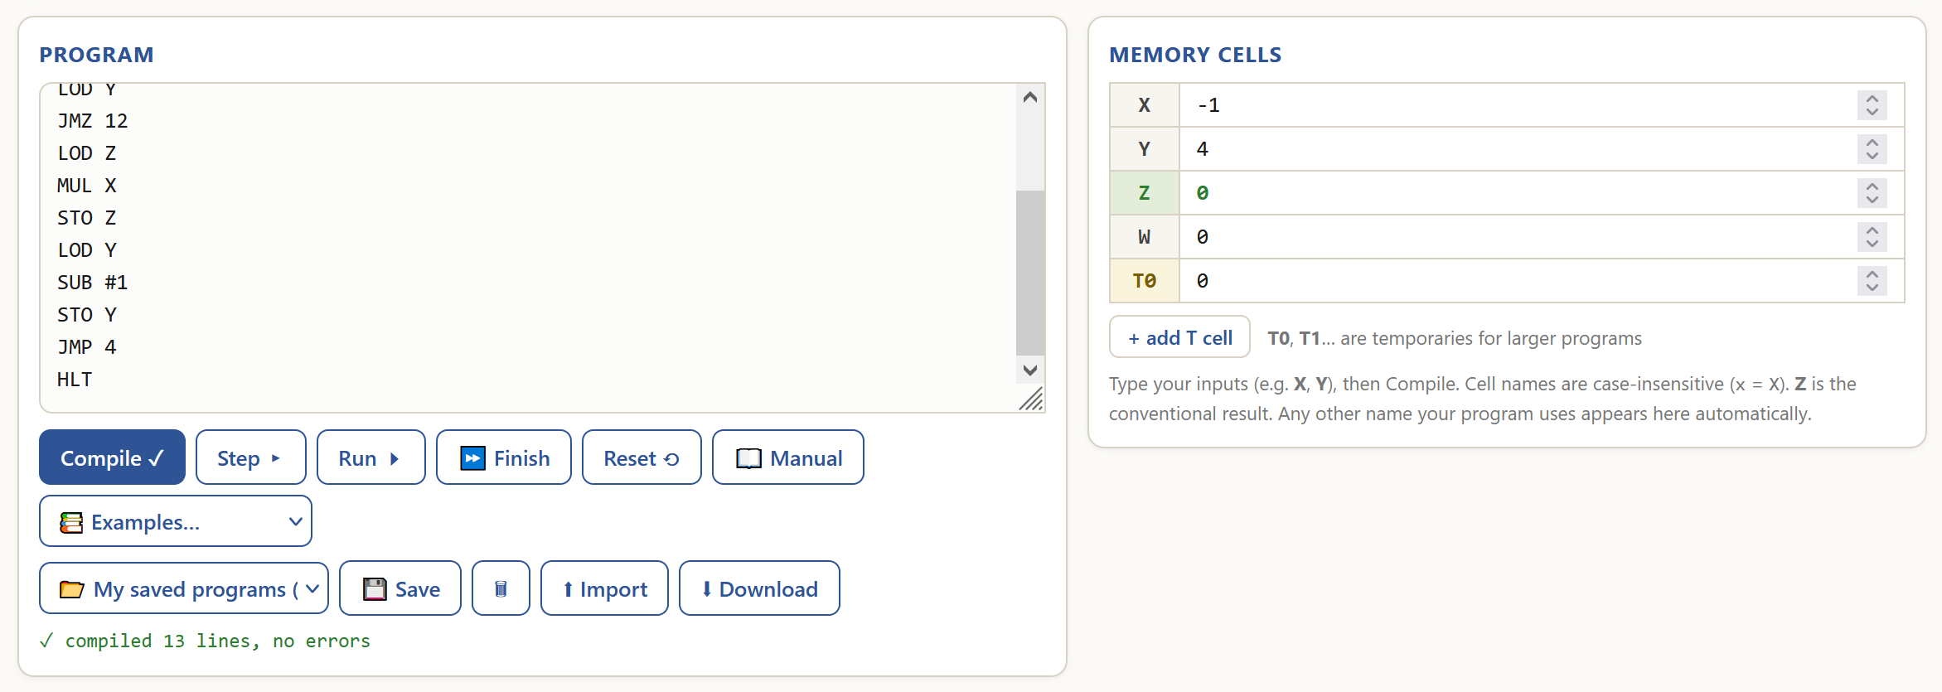
Final state:
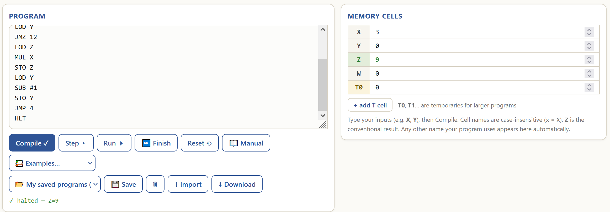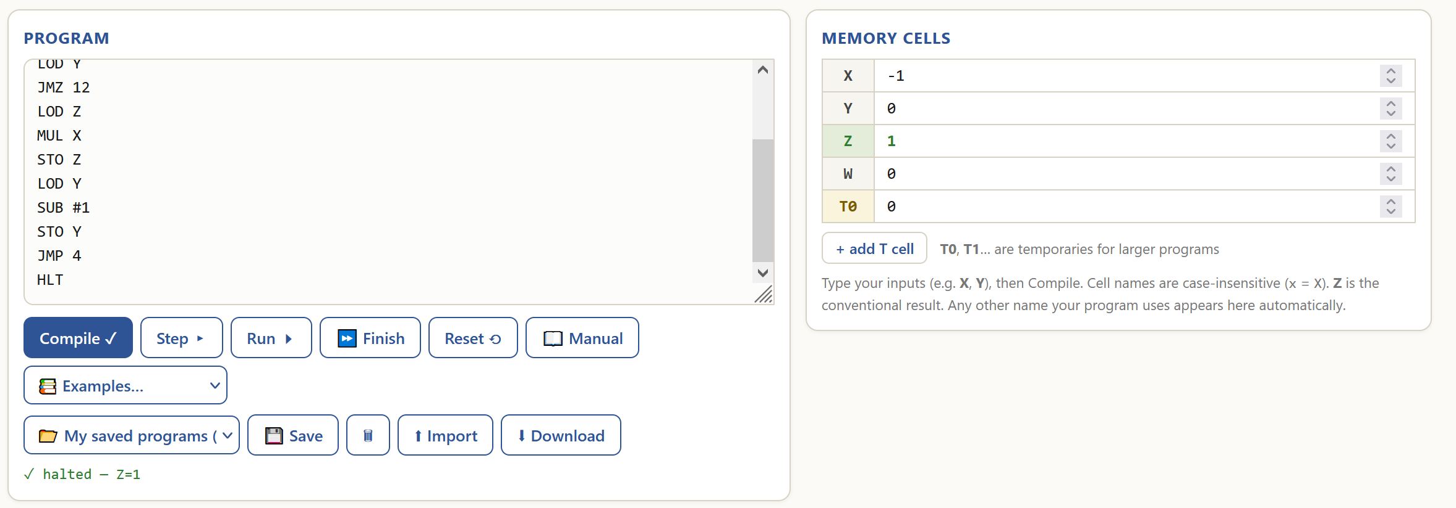
Edge case test:
Initial state:
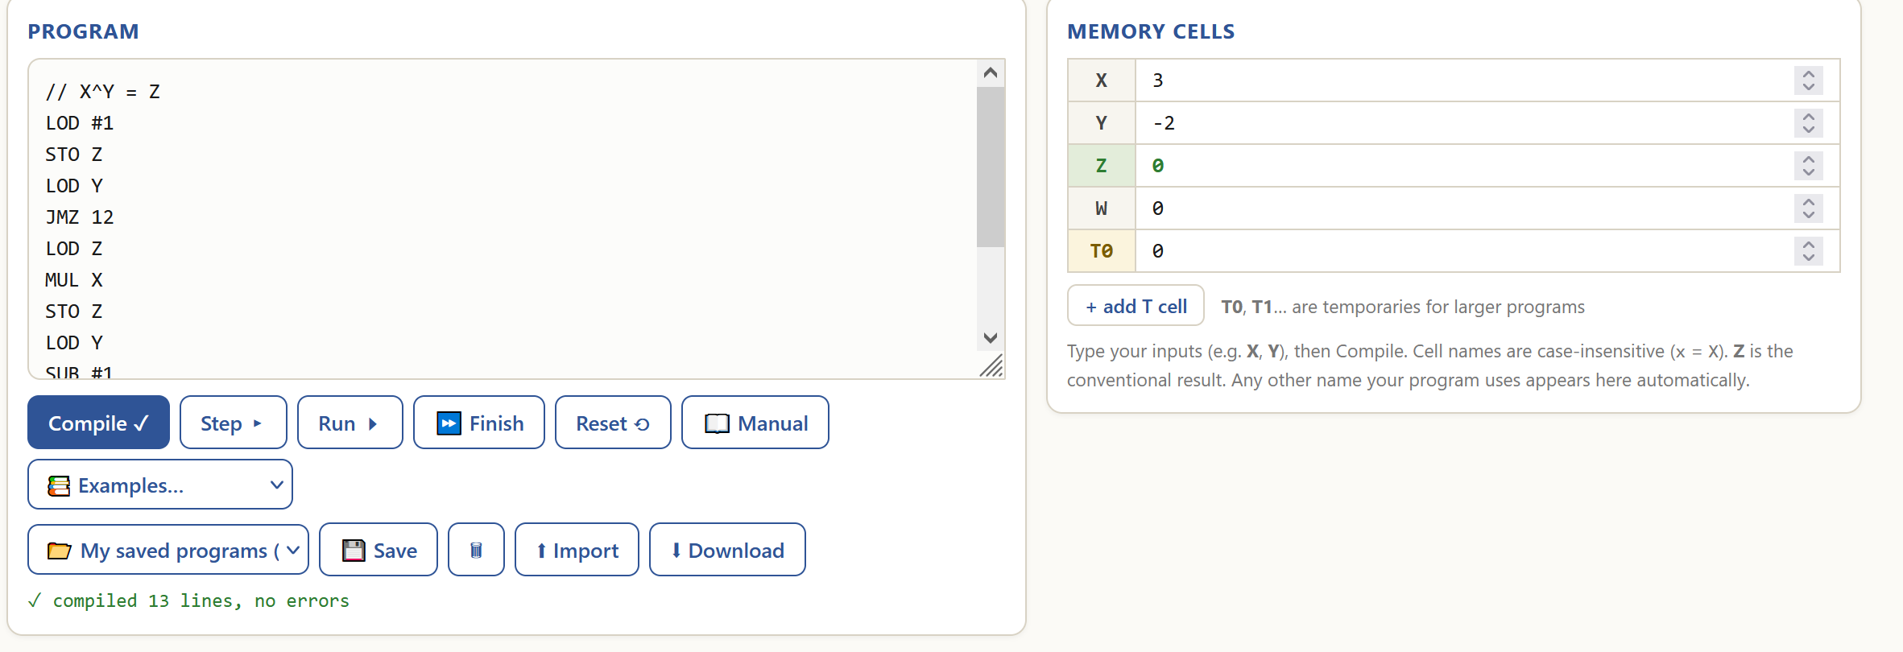
Final state:
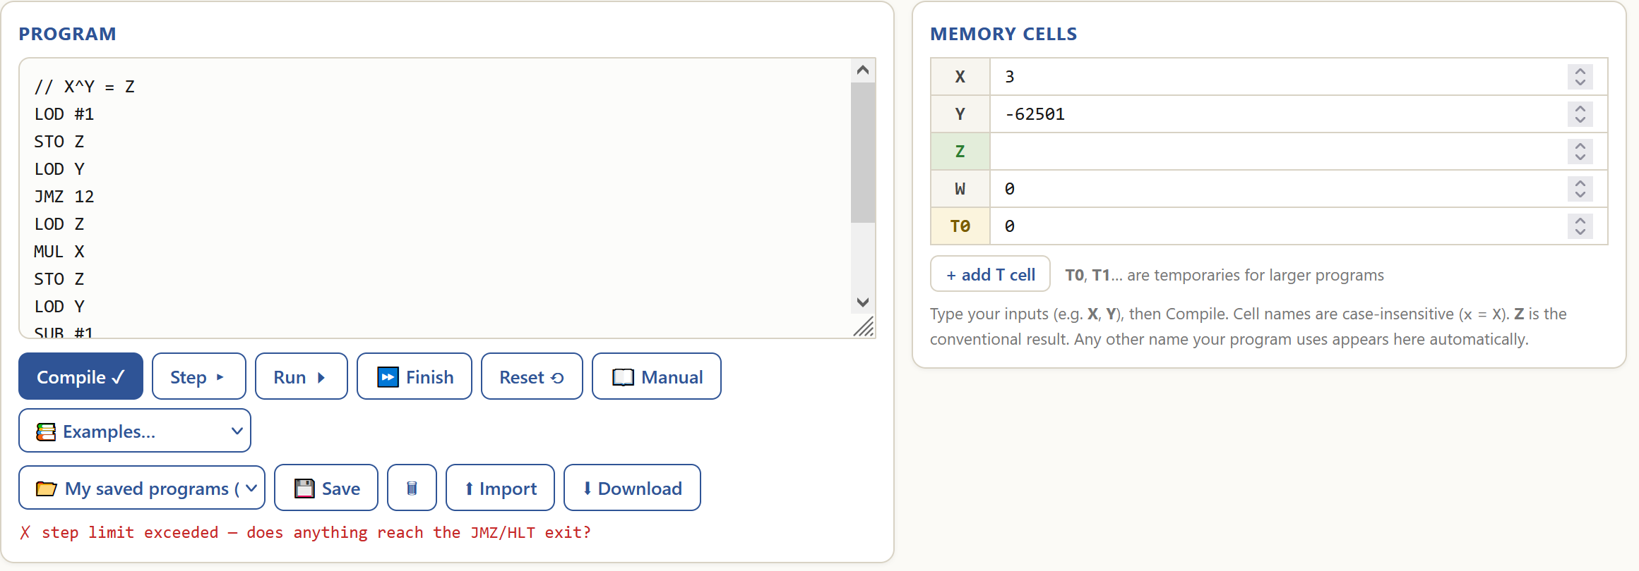
The program works as intended for the general case because it computes the whole power of a whole number correctly (3^2 = 9 and (-1)^4 = 1). It does not handle the edge case and just gives out an error.

- Is X even?

Purpose:
The program checks if a number is even or odd.

Functionality:
Code analysis | Visualised algorithm
// is X even? Z=1 if yes is a comment.  LOD X loads the value of memory cell X into ACC.  DIV #2 performs integer division on ACC’s value by immediate 2.  MUL #2 multiplies ACC’s value by immediate 2.  STO Y stores ACC’s value into memory cell Y.  LOD X loads the value of memory cell X into ACC.  SUB Y subtracts the value of memory cell Y from ACC.  JMZ 11 sets PC to 11 if ACC’s value is 0.  LOD #0 loads immediate 0 into ACC.  STO Z stores ACC’s value into memory cell Z.  JMP 13 sets PC to 13.  LOD #1 loads immediate 1 into ACC.  STO Z stores ACC’s value into memory cell Z.  HLT halts the program. | 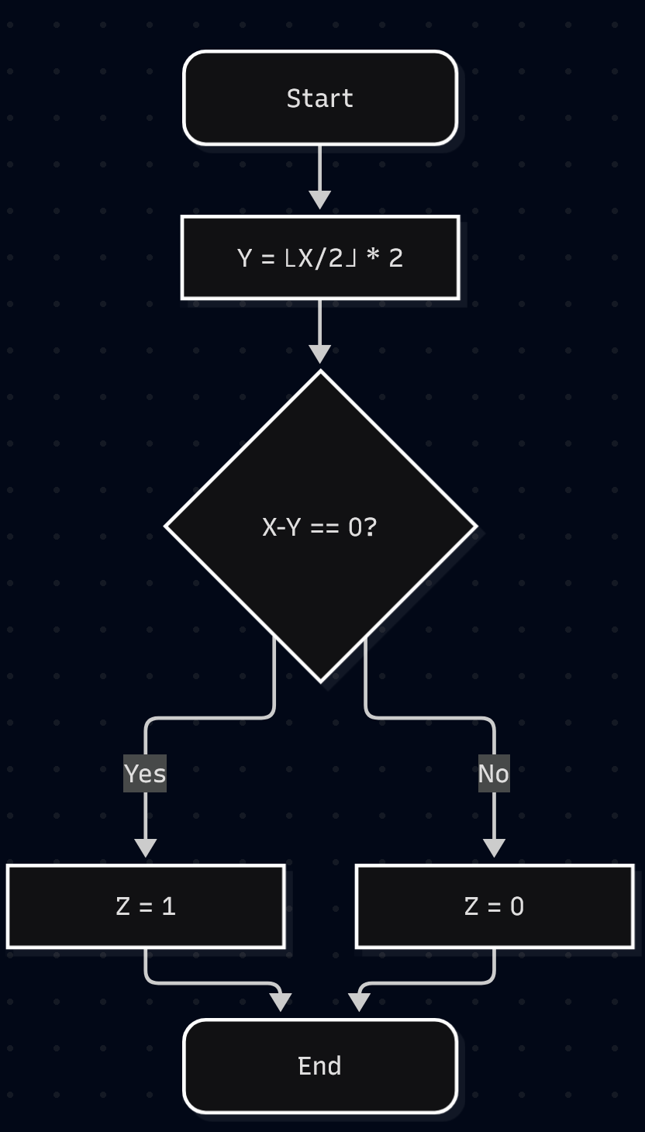

Behaviour:
For an even X, set Z to 1.
For an odd X, set Z to 0.

Initial state:
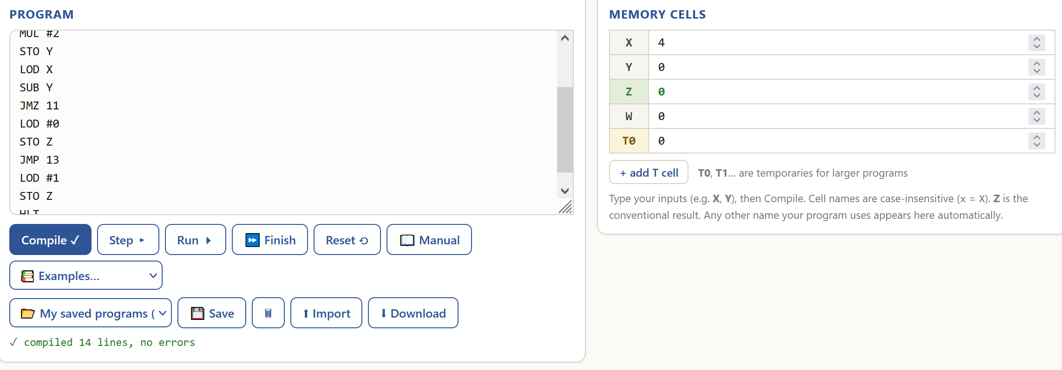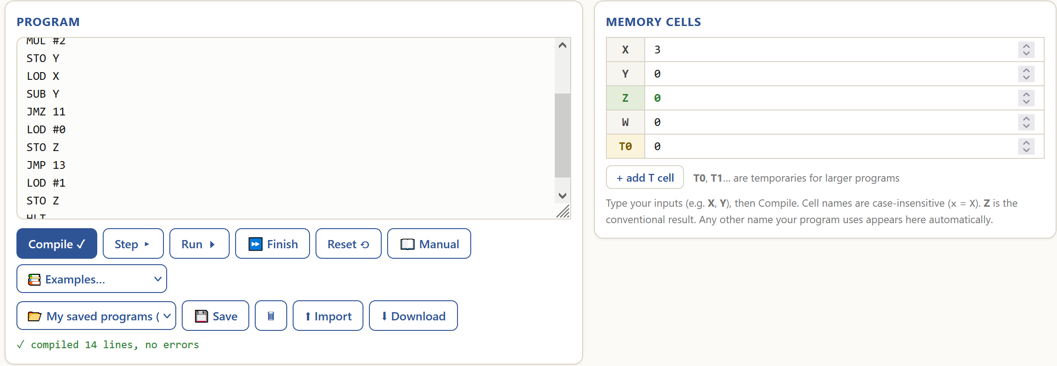
Final state:
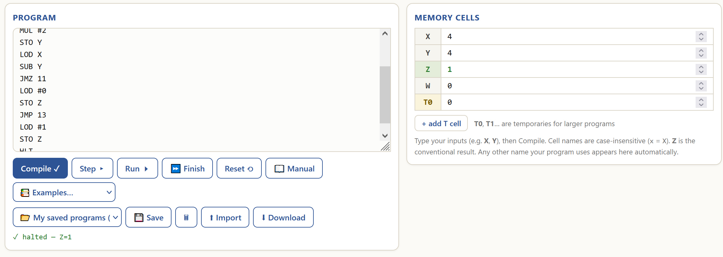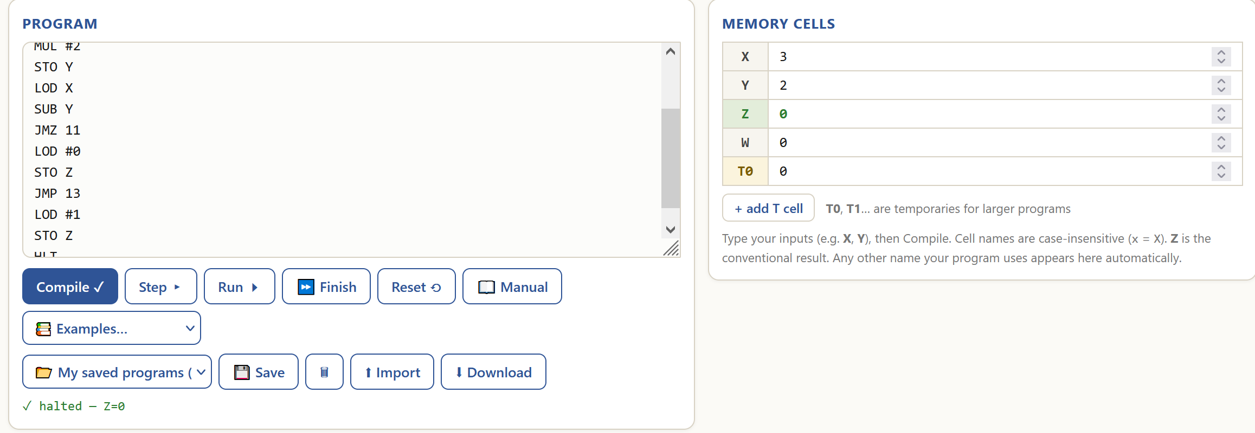
The program works as intended because it correctly returns Z=1 if a number is even (4 is even) and Z=0 if a number is odd (3 is odd).

- Sum 1..X = Z

Purpose:
The program calculates the sum of whole numbers from 1 to X.

Functionality:
Code analysis | Visualised algorithm
// sum 1..X -> Z is a comment.  LOD #0 loads immediate 0 into ACC.  STO Z stores ACC’s value into memory cell Z.  LOD X loads the value of memory cell X into ACC.  JMZ 12 sets PC to 12 if ACC’s value is 0.  LOD Z loads the value of memory cell Z into ACC.  ADD X adds the value of memory cell X to ACC.  STO Z stores ACC’s value into memory cell Z.  LOD X loads the value of memory cell X into ACC.  SUB #1 subtracts immediate 1 from ACC.  STO X stores ACC’s value into memory cell X  JMP 3 sets PC to 3.  HLT halts the program. | 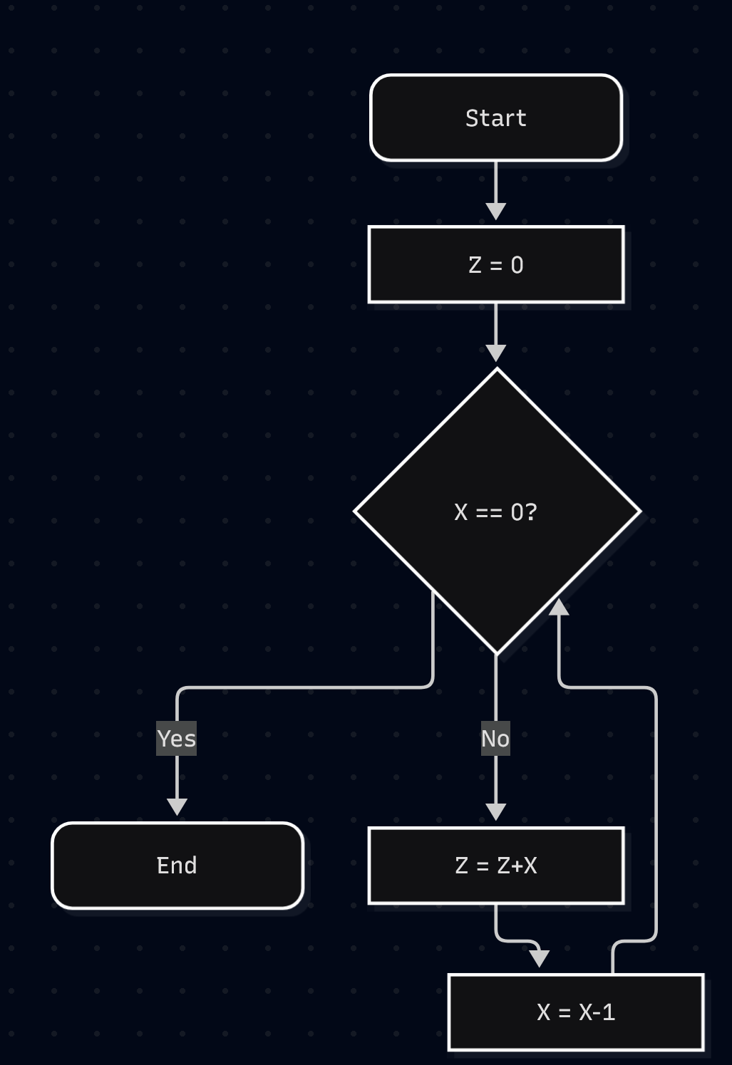

Behaviour:
General case – for X greater than or equal to zero, set Z to the sum of numbers from 1 to X.
Edge case – for X less than zero, give a step limit exceeded error.

General case tests:
Initial state:
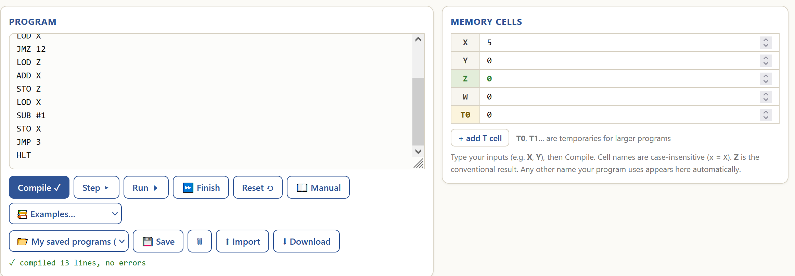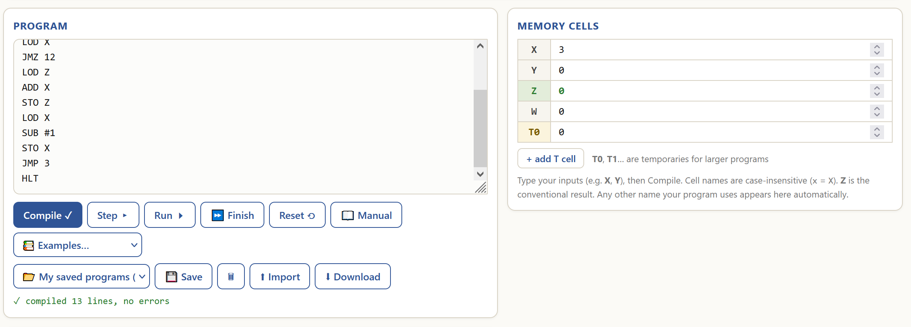

Final state:
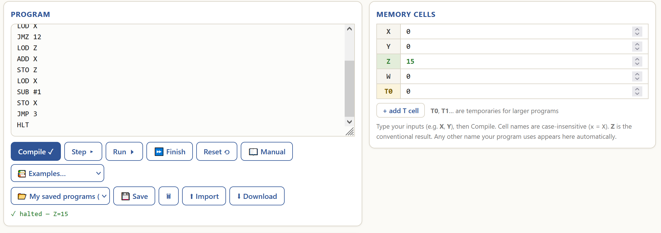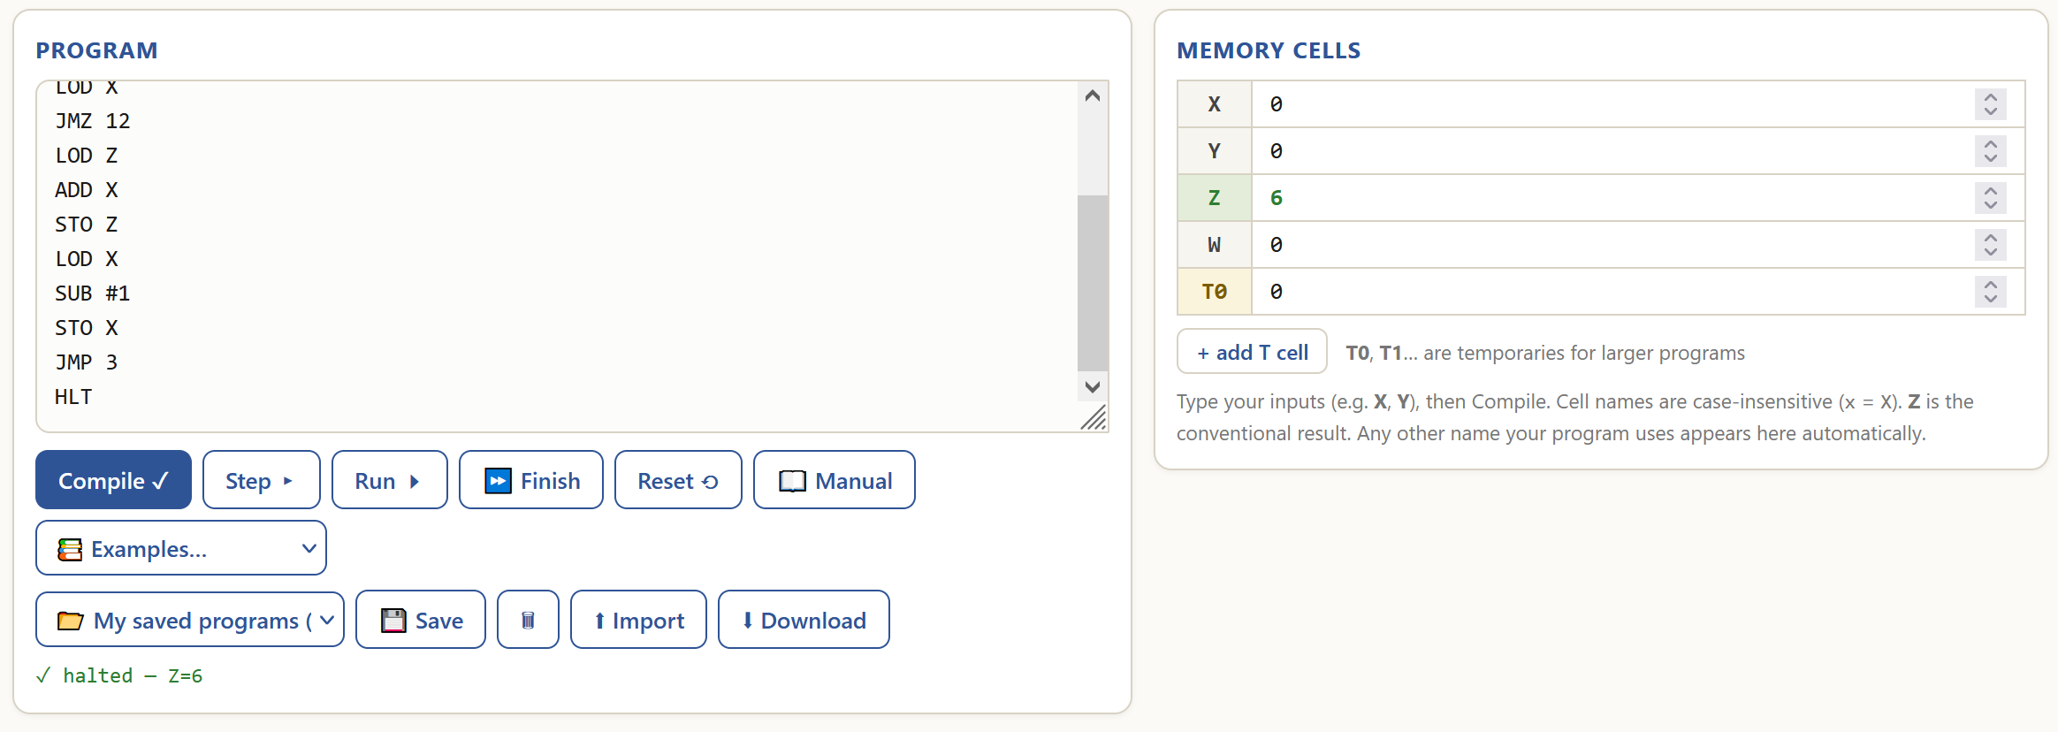
Edge case test:
Initial state:
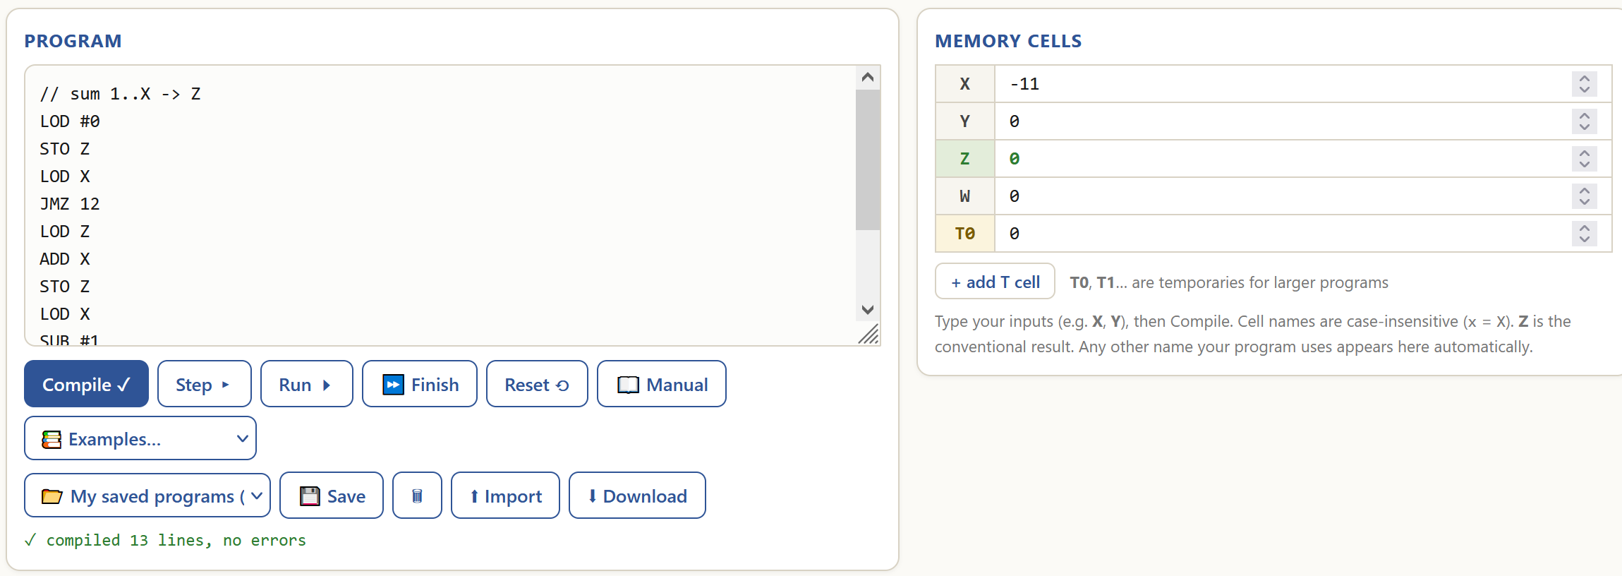
Final state:
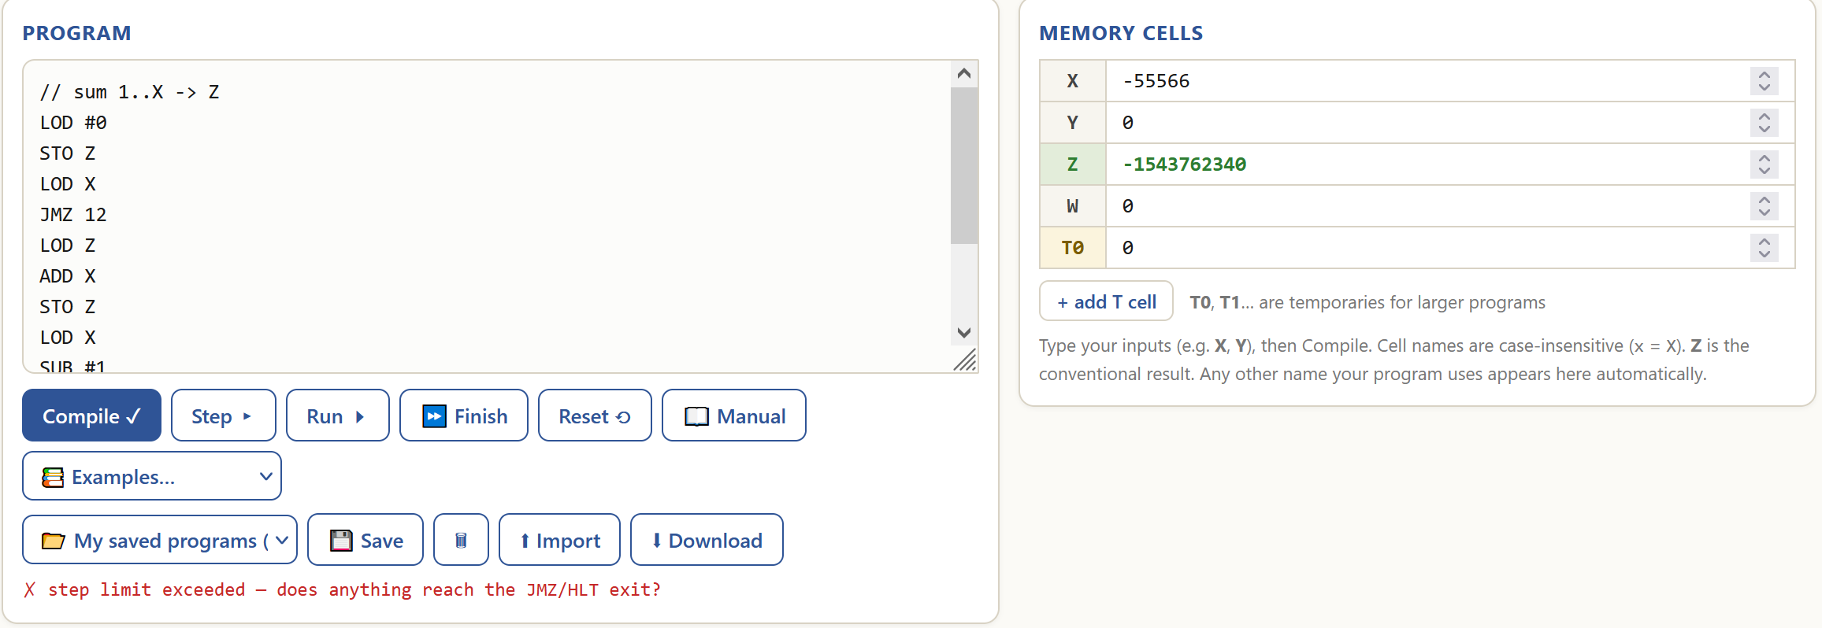
The program works as intended for the general case because it calculates the sum of numbers from 1 to X correctly (1+2+3+4+5=15 and 1+2+3=6). It does not handle the edge case and gives an error.

- Factorial X! = Z

Purpose:
The program calculates the factorial of a number.

Functionality:
Code analysis | Visualised algorithm
// X! -> Z is a comment.  LOD #1 loads immediate 1 into ACC.  STO Z stores ACC’s value into memory cell Z.  LOD X loads the value of memory cell X into ACC.  JMZ 12 sets PC to 12 if ACC’s value is 0.  LOD Z loads the value of memory cell Z into ACC.  MUL X multiplies ACC’s value by the value of memory cell X.  STO Z stores ACC’s value into memory cell Z.  LOD X loads the value of memory cell X into ACC.  SUB #1 subtracts immediate 1 from ACC.  STO X stores ACC’s value into memory cell X.  JMP 3 sets PC to 3.  HLT halts the program. | 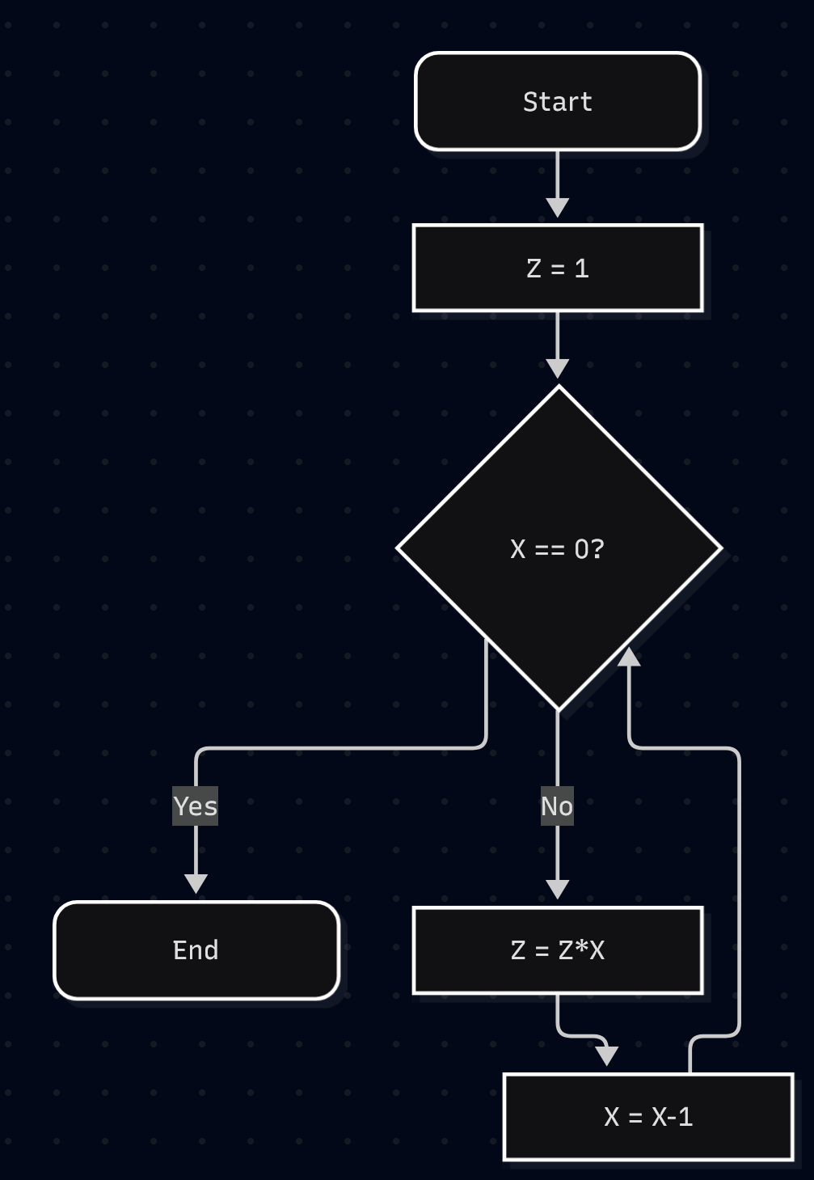

Behaviour:
General case – for X greater than or equal to zero, set Z to the factorial of X.
Edge case – for X less than zero, give a step limit exceeded error.

General case tests:
Initial state:
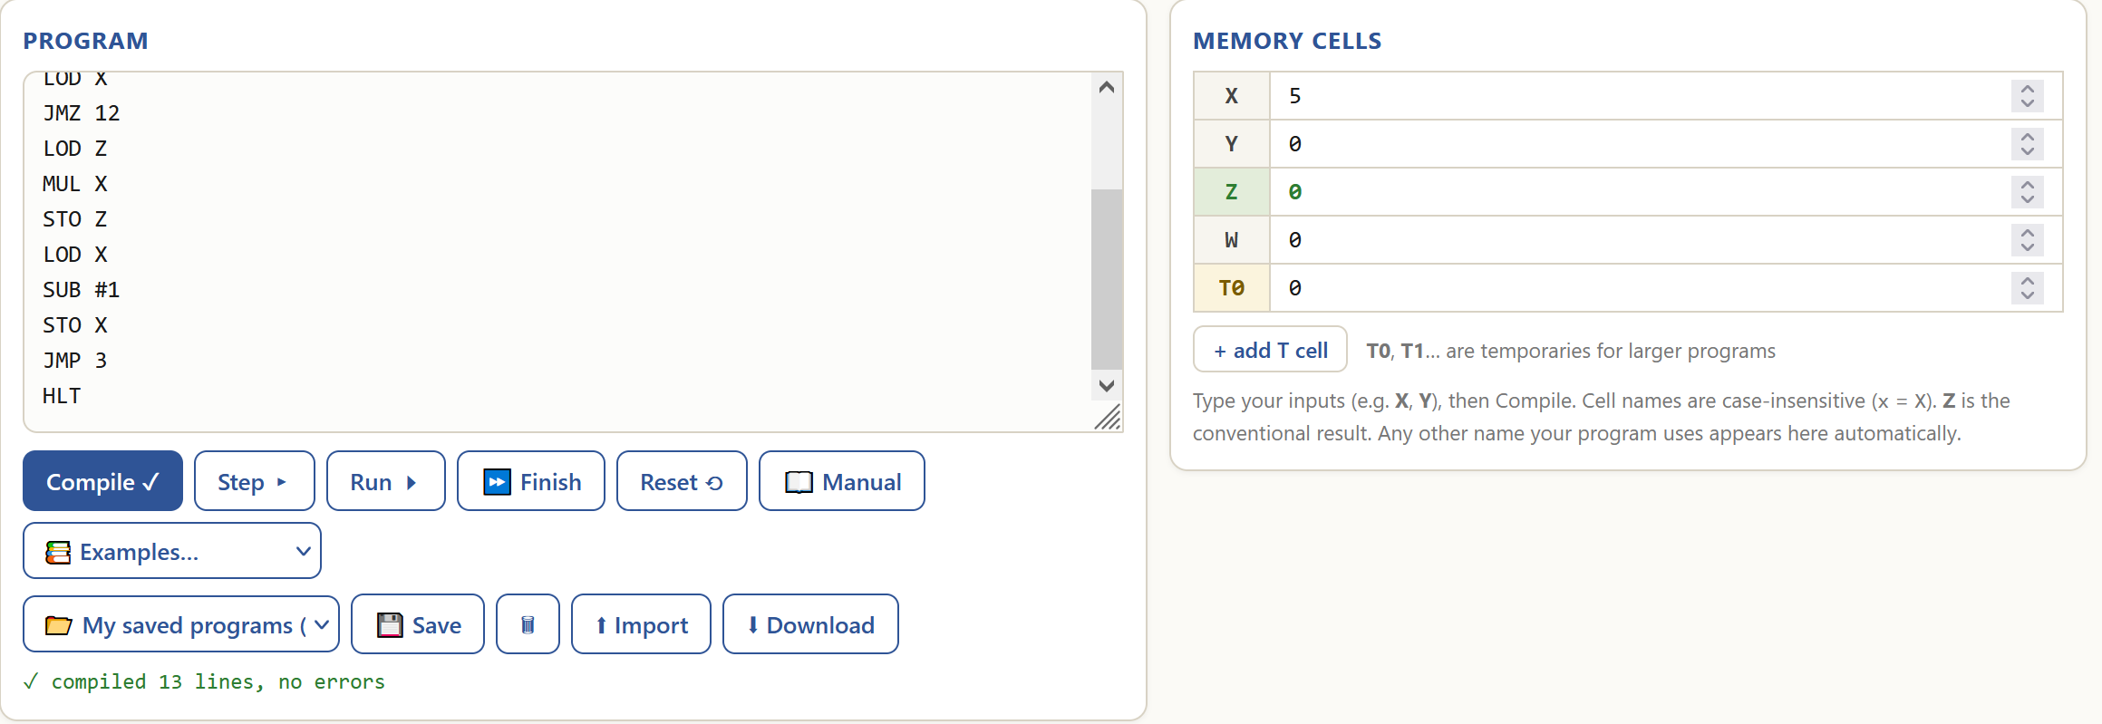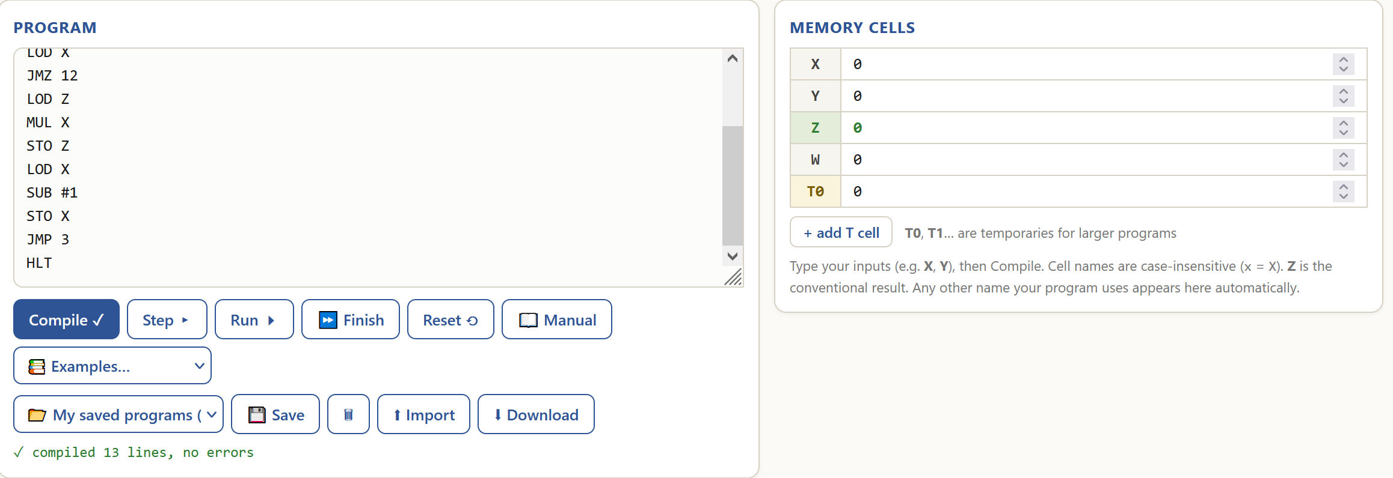

Final state:
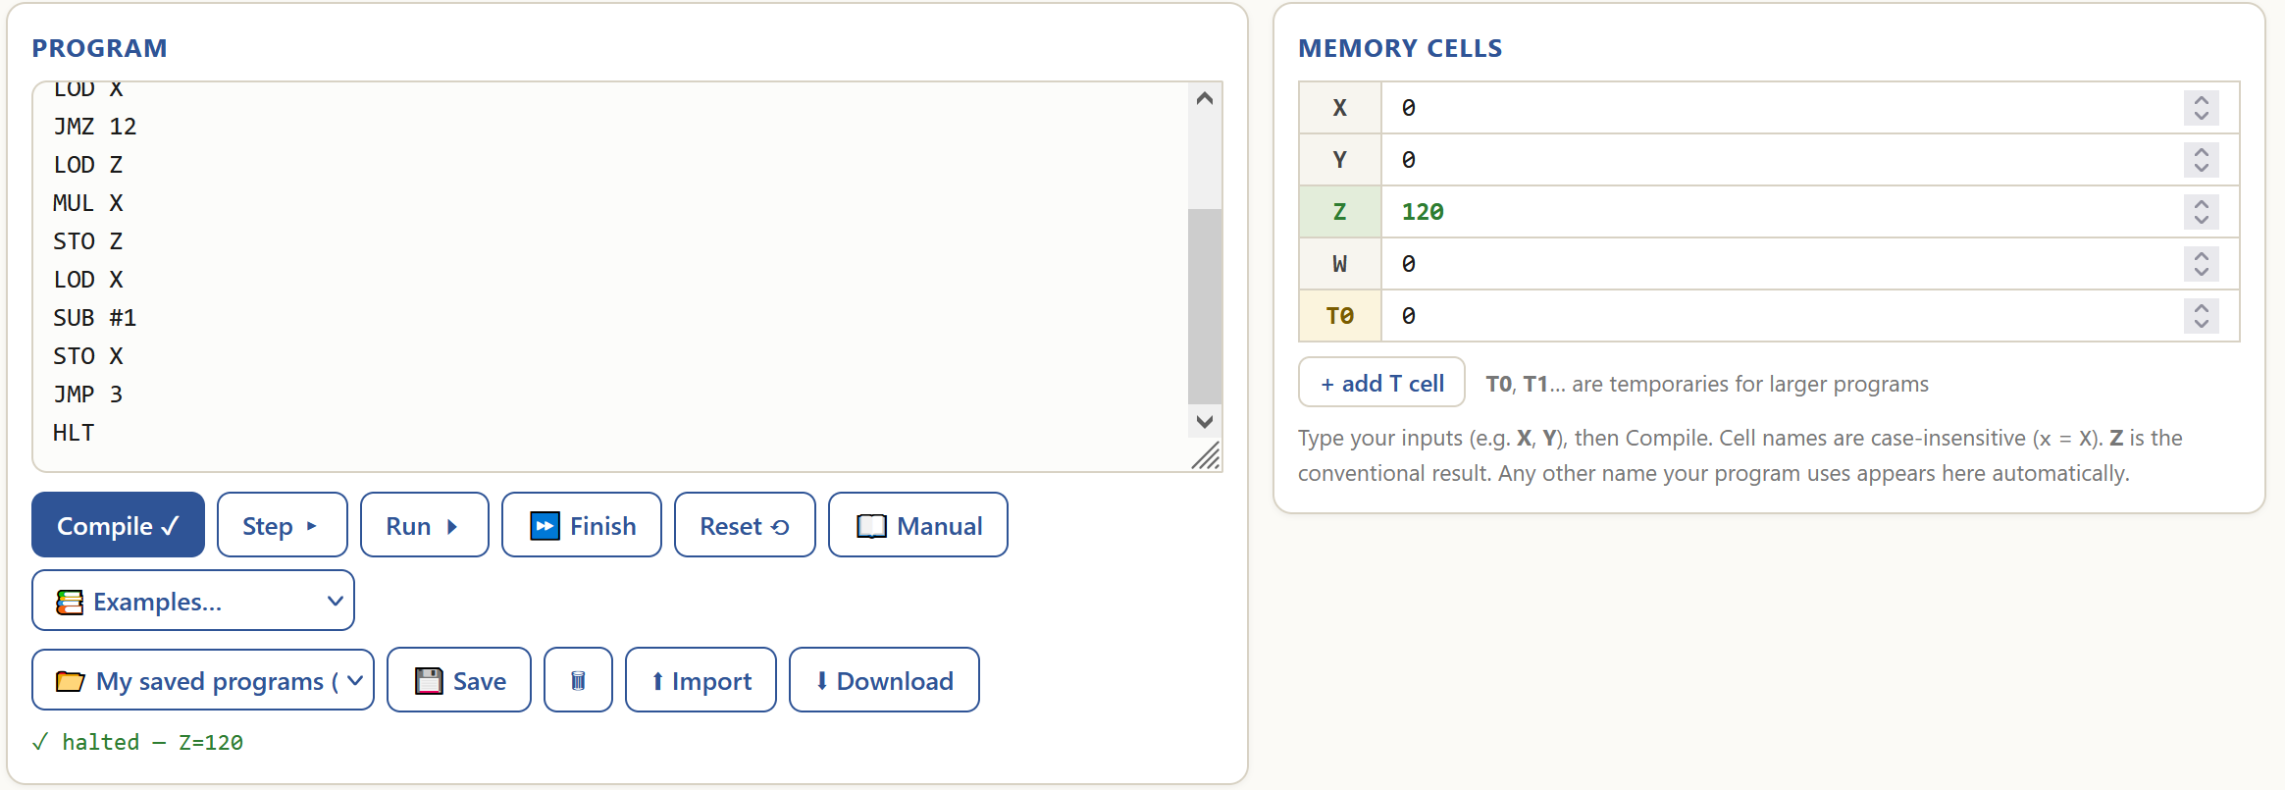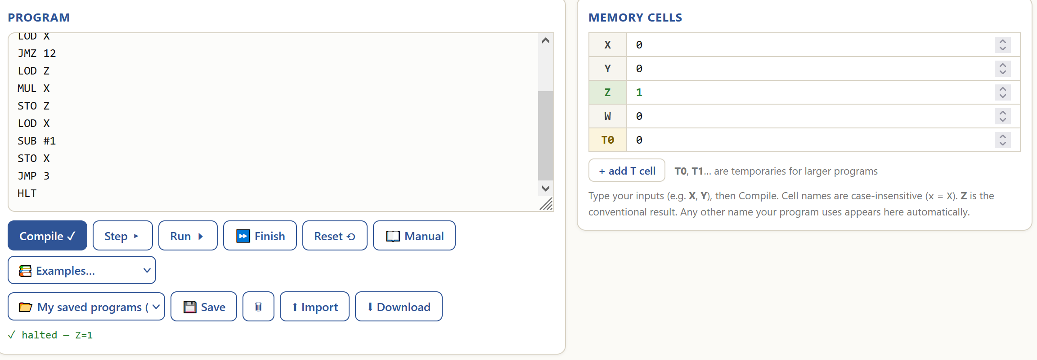
Edge case test:
Initial state:
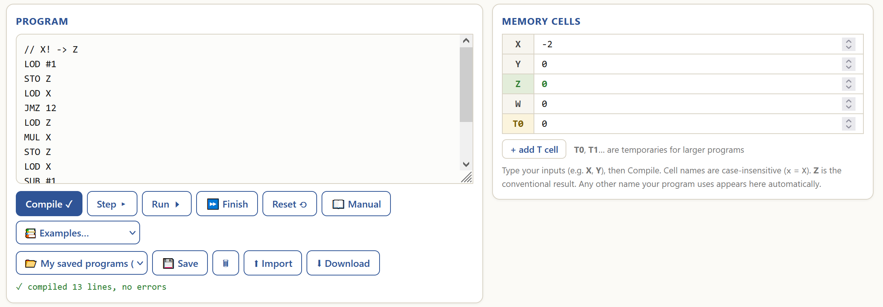
Final state:
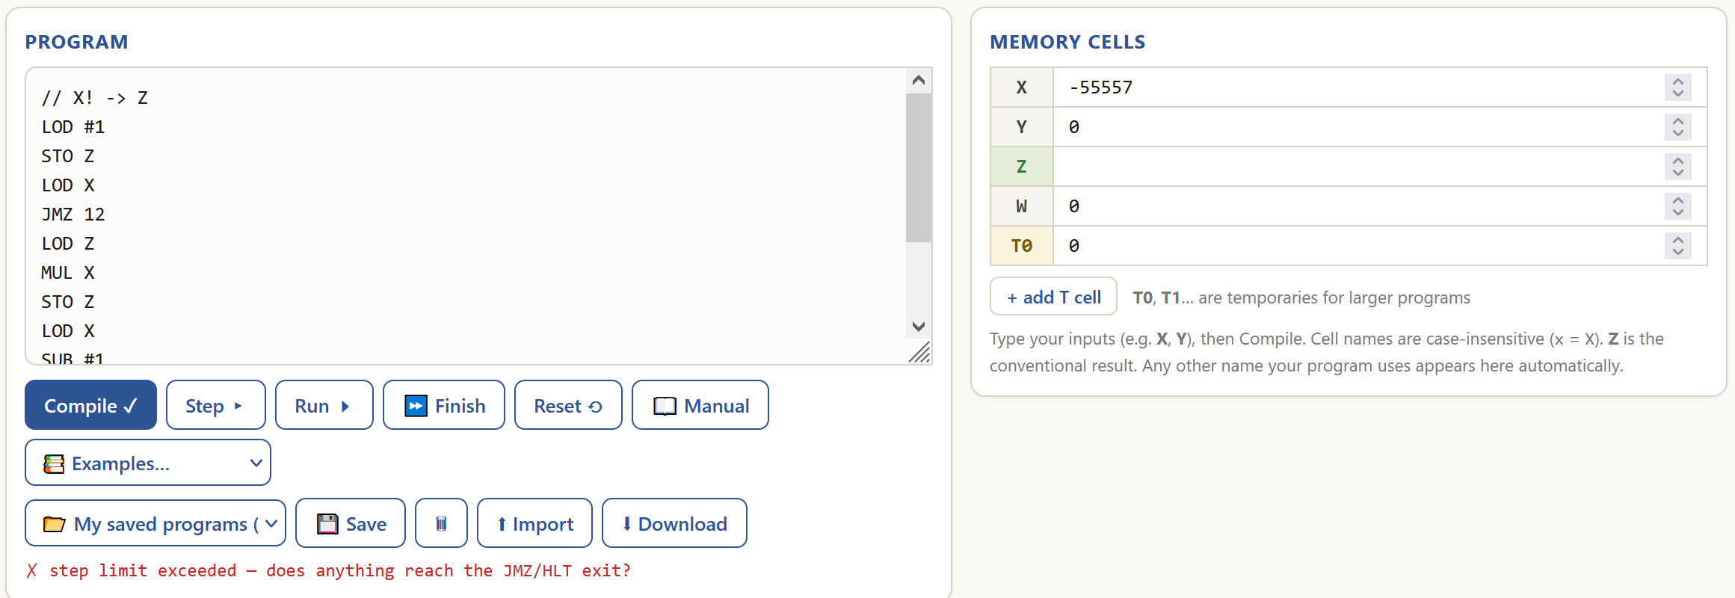
The program works as intended for the general case because it calculates the factorial of a number correctly (5! = 120 and 0! = 1). It does not handle the edge case and gives an error.

- Collatz conjecture

Purpose:
The program computes the amount of steps and the maximum value of A_{n} until the given number (A₁) reaches 1 for the Collatz conjecture:
A_{n+1} = 3 * A_{n} + 1 if A_{n} is odd, A_{n+1} = A_{n} / 2 if A_{n} is even.

Functionality:
Code analysis | Visualised algorithm
// Hailstone flight recorder: X -> Z = steps to reach 1, T0 = current value, T1 = peak, T2 = scratch is a comment.  LOD X loads the value of memory cell X into ACC.  STO T0 stores ACC’s value into memory cell T0.  STO T1 stores ACC’s value into memory cell T1.  LOD #0 loads immediate 0 into ACC.  STO Z stores ACC’s value into Z.  LOD T0 loads the value of memory cell T0 into ACC.  SUB #1 subtracts immediate 1 from ACC.  JMZ 34 sets PC to 34 if ACC’s value is 0.  LOD T0 loads the value of memory cell T0 into ACC.  DIV #2 performs integer division by immediate 2 on ACC.  MUL #2 multiplies ACC by immediate 2.  SUB T0 subtracts value of memory cell T0 from ACC.  JMZ 18 sets PC to 18 if ACC’s value is 0.  LOD T0 loads the value of memory cell T0 into ACC.  MUL #3 multiplies ACC by immediate 3.  ADD #1 add immediate 1 to ACC.  JMP 20 sets PC to 20.  LOD T0 loads the value of memory cell T0 into ACC.  DIV #2 performs integer division by immediate 2 on ACC.  STO T0 stores ACC’s value into memory cell T0.  LOD Z loads the value of memory cell Z into ACC.  ADD #1 adds immediate 1 to ACC.  STO Z stores ACC’s value into memory cell Z.  LOD T1 loads the value of memory cell T1 into ACC.  SUB T0 subtracts the value of memory cell T0 from ACC.  JMZ 6 sets PC to 6 if ACC’s value is 0.  STO T2 stores ACC’s value into memory cell T2.  SUB #1 subtracts immediate 1 from ACC.  DIV T2 performs integer division by immediate 2 on ACC.  JMZ 6 sets PC to 6 if ACC’s value is 0.  LOD T0 loads the value of memory cell T0 into ACC.  STO T1 stores ACC’s value into memory cell T1.  JMP 6 sets PC to 6.  HLT halts the program. | 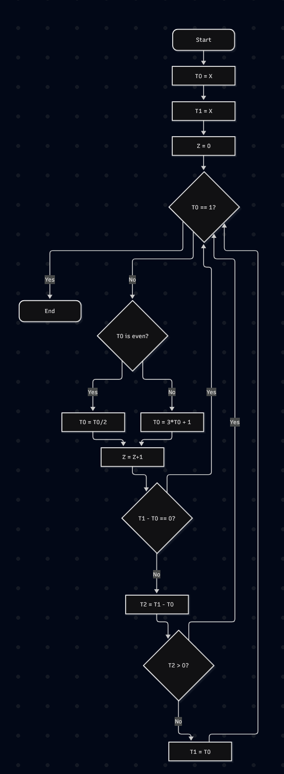

Behaviour:
General case – for X greater than zero, do the following
Z = 0
T1 = X
while X is not equal to 1, do
if X is odd, do
X = 3*X + 1
If X > T1, do
T1 = X
else, do
X = X/2
Z = Z + 1
If T1 > T0, do
T1 = T0
The step amount is stored in Z, the peak is stored in T1.

Edge case – for X less than or equal to zero, give a step limit exceeded error.

General case tests:
Initial state:
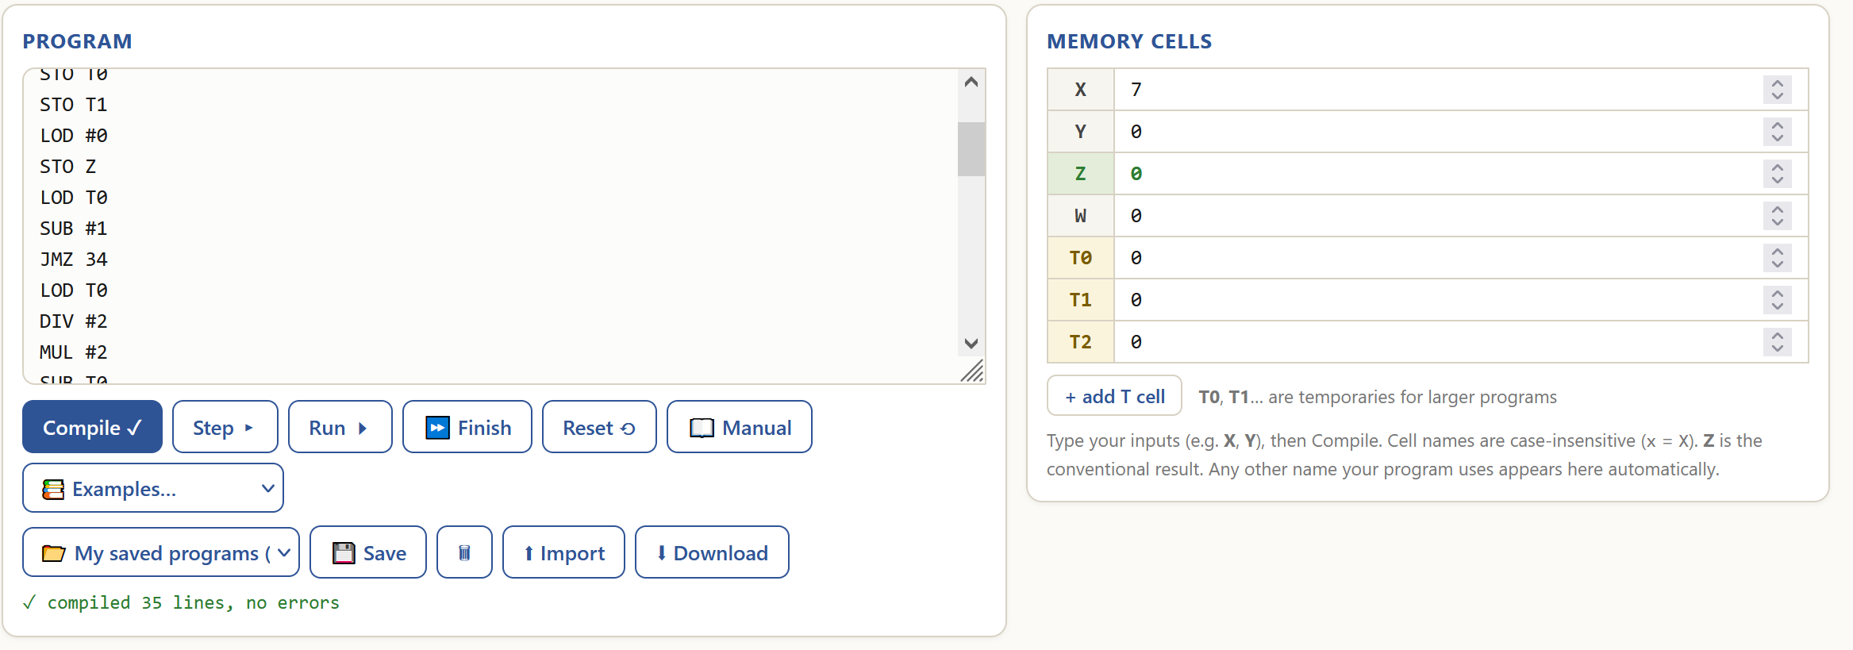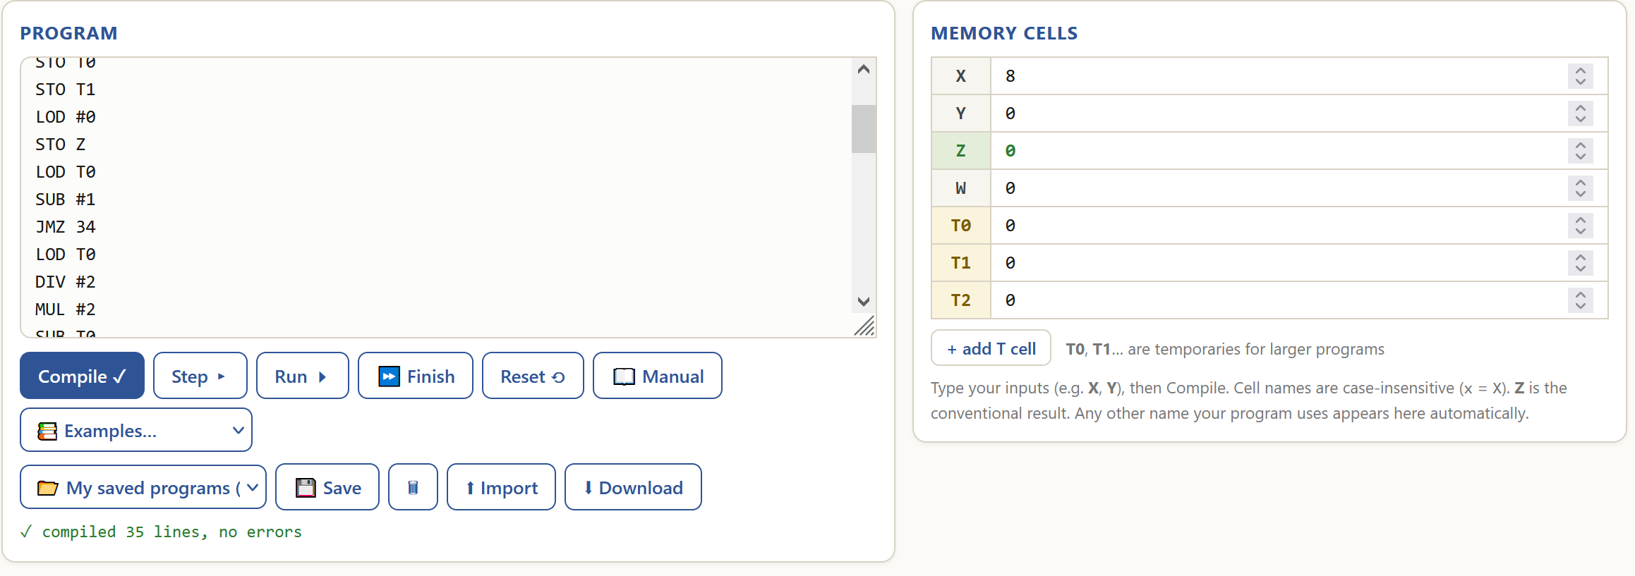

Final state:
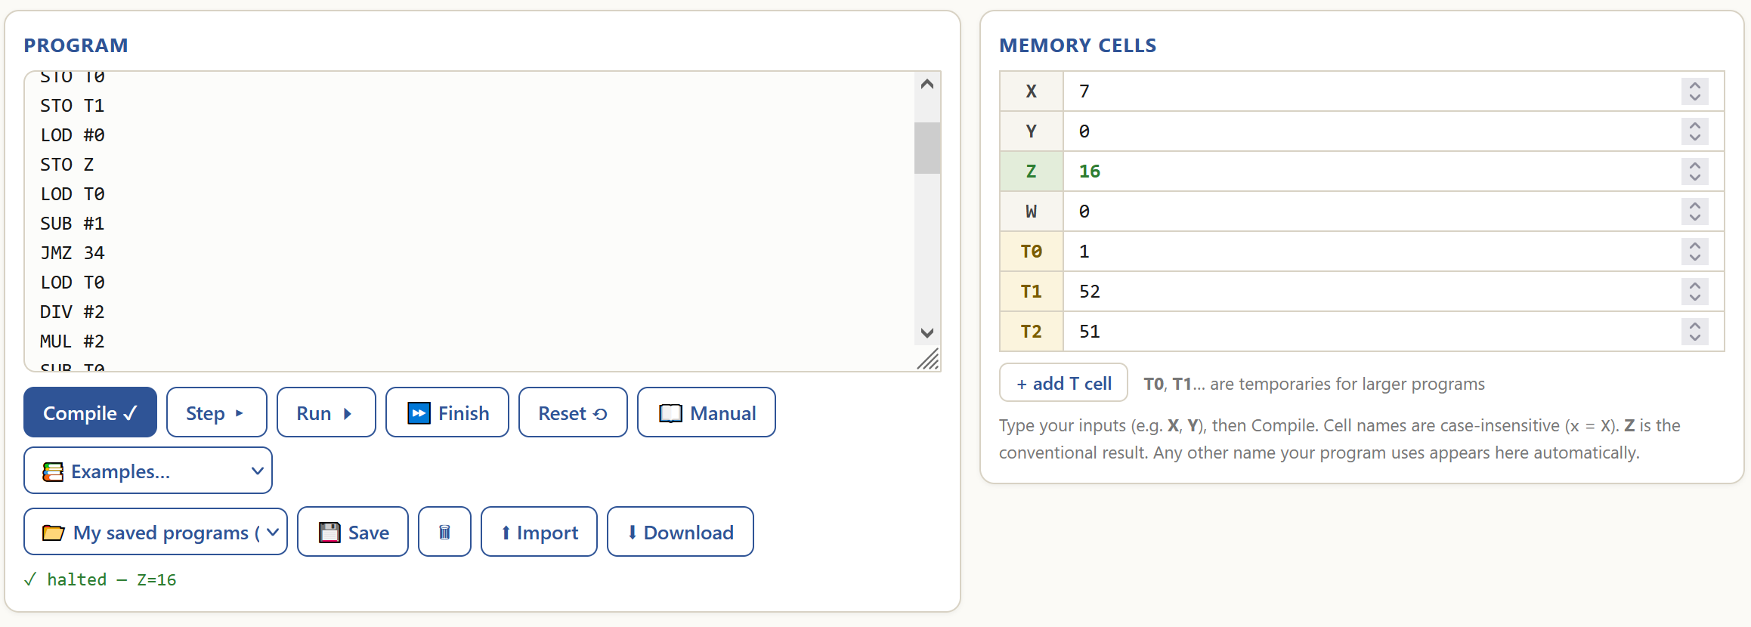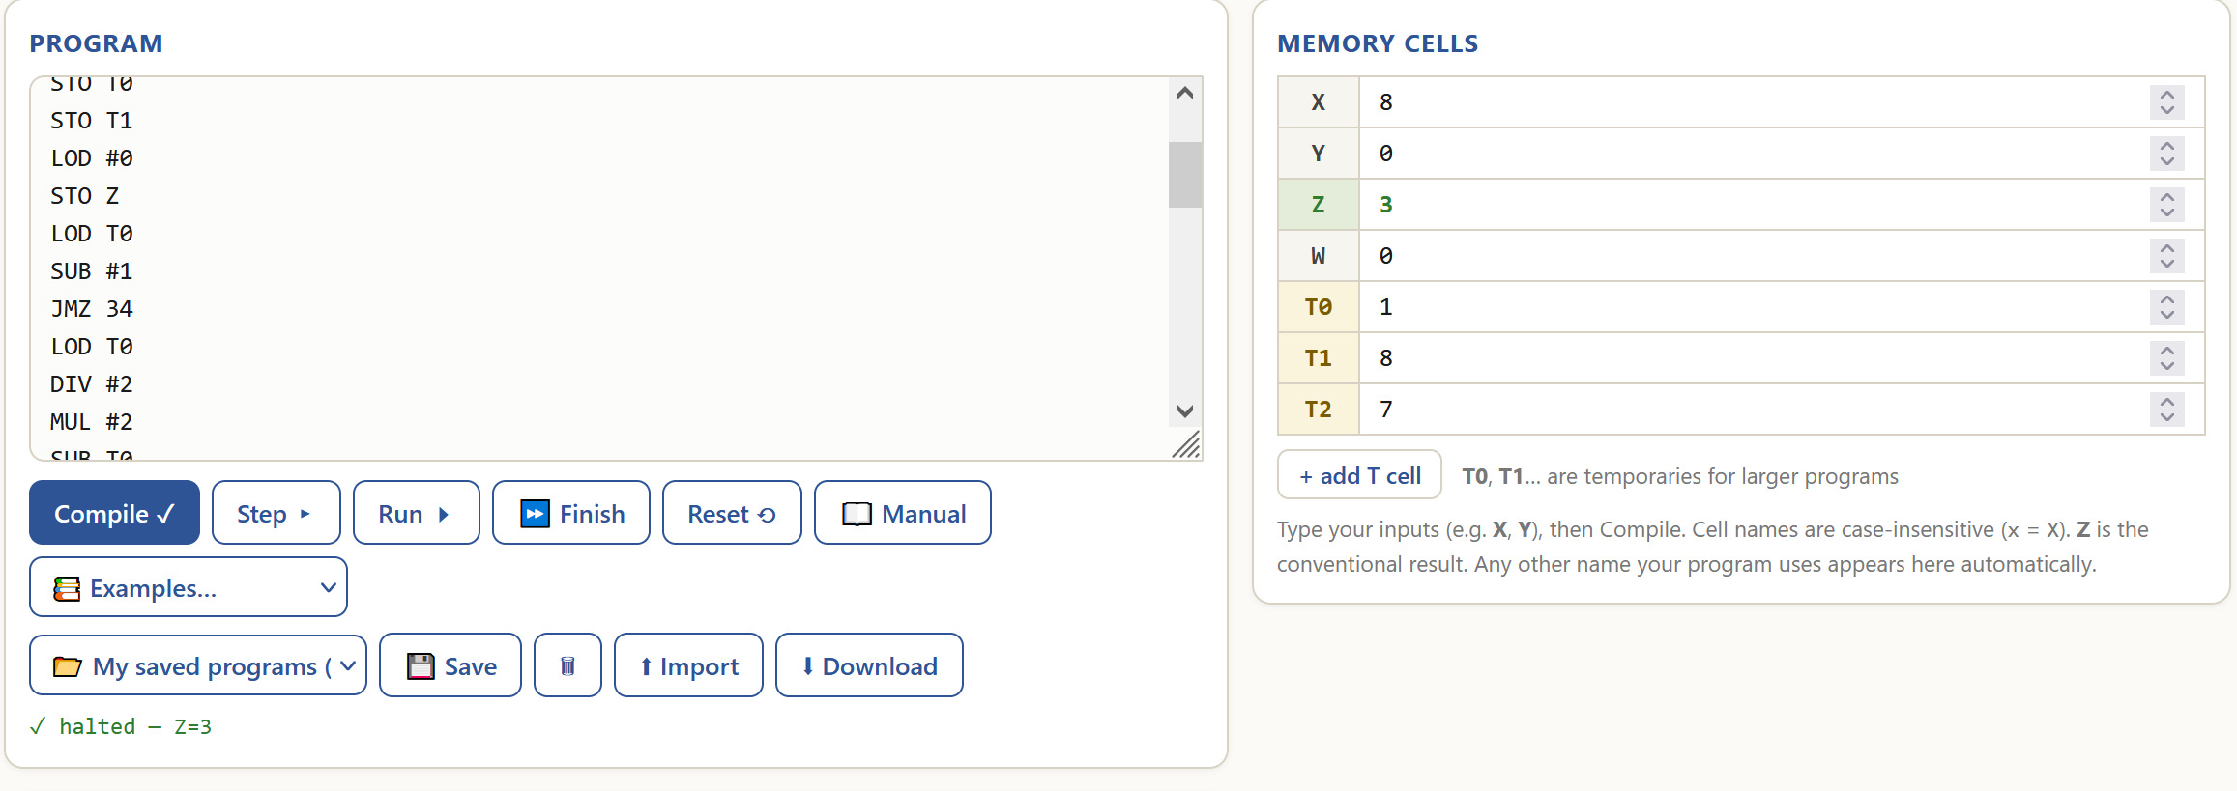
Edge case test:
Initial state:
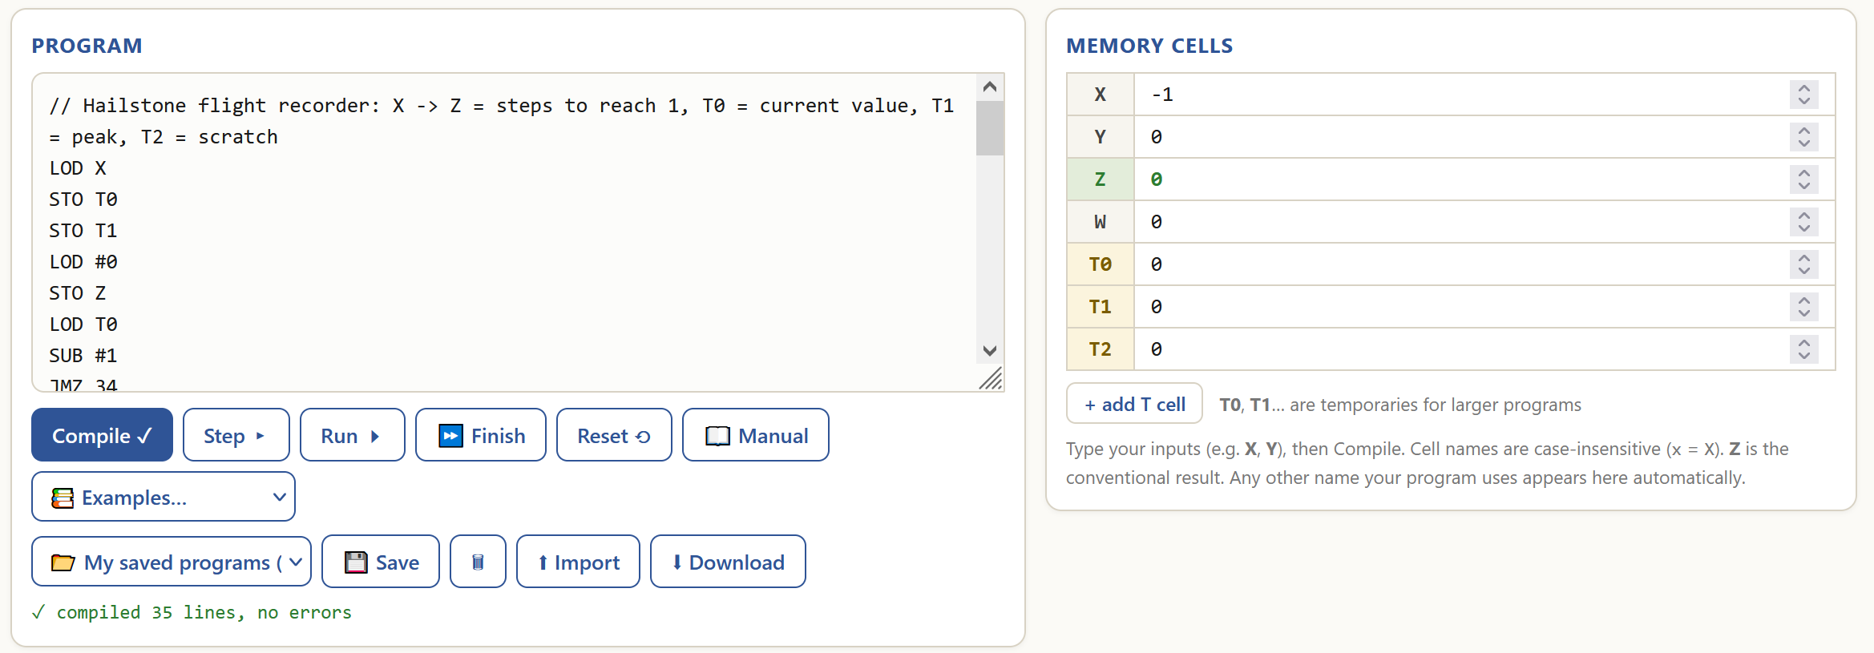
Final state:
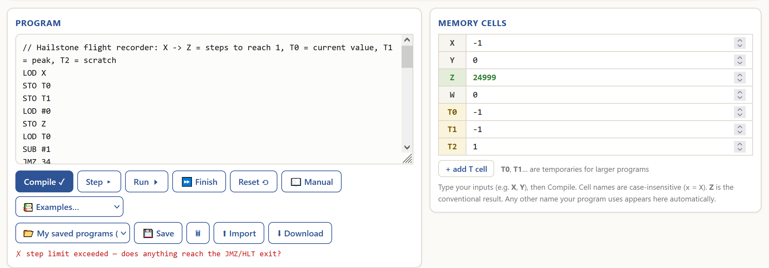
The program works as intended for the general case because it calculate the amount of steps and the maximum value correctly. (7 -> 22 -> 11 -> 34 -> 17 -> 52 (peak) -> 26 -> 13 -> 40 -> 20 -> 10 -> 5 -> 16 -> 8 -> 4 -> 2 -> 1 (halt) – 16 steps and 8 (peak) -> 4 -> 2 -> 1 (halt) – 3 steps). It does not handle the edge case and gives an error.

- Binary converter

Purpose:
Converts an 8-bit integer into binary and converts it beck into decimal.

Functionality:
Code analysis | Visualised algorithm
// Binary converter: X (0..255) -> bits T0 (LSB) .. T7 (MSB); Z = X rebuilt from the bits is a comment.
LOD X loads the value of memory cell X into ACC.
STO T8 stores ACC’s value into memory cell T8.
DIV #2 performs integer division by immediate 2 on ACC.
STO T9 stores ACC’s value into memory cell T9.
LOD T8 loads the value of memory cell T8 into ACC.
SUB T9 subtracts the value of memory cell T9 from ACC.
SUB T9 subtracts the value of memory cell T9 from ACC.
STO T0 stores ACC’s value into memory cell T0.
LOD T9 loads the value of memory cell T9 into ACC.
STO T8 stores ACC’s value into memory cell T8.
DIV #2 performs integer division by immediate 2 on ACC.
STO T9 stores ACC’s value into memory cell T9.
LOD T8 loads the value of memory cell T8 into ACC.
SUB T9 subtracts the value of memory cell T9 from ACC.
SUB T9 subtracts the value of memory cell T9 from ACC.
STO T1 stores the ACC’s value into memory cell T1.
LOD T9 loads the value of memory cell T9 into ACC.
STO T8 stores ACC’s value into memory cell T8.
DIV #2 performs integer division by immediate 2 on ACC.
STO T9 stores ACC’s value into memory cell T9.
LOD T8 loads the value of memory cell T8 into ACC.
SUB T9 subtracts the value of memory cell T9 from ACC.
SUB T9 subtracts the value of memory cell T9 from ACC.
STO T2 stores ACC’s value into memory cell T2.
LOD T9 loads the value of memory cell T9 into ACC.
STO T8 stores ACC’s value into memory cell T8.
DIV #2 performs integer division by immediate 2 on ACC.
STO T9 stores ACC’s value into memory cell T9.
LOD T8 loads the value of memory cell T8 into ACC.
SUB T9 subtracts the value of memory cell T9 from ACC.
SUB T9 subtracts the value of memory cell T9 from ACC.
STO T3 stores ACC’s value into memory cell T3.
LOD T9 loads the value of memory cell T9 into ACC.
STO T8 stores ACC’s value into memory cell T8.
DIV #2 performs integer division by immediate 2 on ACC.
STO T9 stores ACC’s value into memory cell T9.
LOD T8 loads the value of memory cell T8 into ACC.
SUB T9 subtracts the value of memory cell T9 from ACC.
SUB T9 subtracts the value of memory cell T9 from ACC.
STO T4 stores ACC’s value into memory cell T4.
LOD T9 loads the value of memory cell T9 into ACC.
STO T8 stores ACC’s value into memory cell T8.
DIV #2 performs integer division by immediate 2 on ACC.
STO T9 stores ACC’s value into memory cell T9.
LOD T8 loads the value of memory cell T8 into ACC.
SUB T9 subtracts the value of memory cell T9 from ACC.
SUB T9 subtracts the value of memory cell T9 from ACC.
STO T5 stores ACC’s value into memory cell T5.
LOD T9 loads the value of memory cell T9 into ACC.
STO T8 stores ACC’s value into memory cell T8.
DIV #2 performs integer division by immediate 2 on ACC.
STO T9 stores ACC’s value into memory cell T9.
LOD T8 loads the value of memory cell T8 into ACC.
SUB T9 subtracts the value of memory cell T9 from ACC.
SUB T9 subtracts the value of memory cell T9 from ACC.
STO T6 stores ACC’s value into memory cell T6.
LOD T9 loads the value of memory cell T9 into ACC.
STO T8 stores ACC’s value into memory cell T8.
DIV #2 performs integer division by immediate 2 on ACC.
STO T9 stores ACC’s value into memory cell T9.
LOD T8 loads the value of memory cell T8 into ACC.
SUB T9 subtracts the value of memory cell T9 from ACC.
SUB T9 subtracts the value of memory cell T9 from ACC.
STO T7 stores ACC’s value into memory cell T7.
LOD T7 loads the value of memory cell T7 into ACC.
MUL #2 multiplies ACC’s value by immediate 2.
ADD T6 adds the value of memory cell T6 to ACC.
MUL #2 multiplies ACC’s value by immediate 2.
ADD T5 adds the value of memory cell T5 to ACC.
MUL #2 multiplies ACC’s value by immediate 2.
ADD T4 adds the value of memory cell T4 to ACC.
MUL #2 multiplies ACC’s value by immediate 2.
ADD T3 adds the value of memory cell T3 to ACC.
MUL #2 multiplies ACC’s value by immediate 2.
ADD T2 adds the value of memory cell T2 to ACC.
MUL #2 multiplies ACC’s value by immediate 2.
ADD T1 adds the value of memory cell T1 to ACC.
MUL #2 multiplies ACC’s value by immediate 2.
ADD T0 adds the value of memory cell T0 to ACC.
STO Z stores ACC‘s value into memory cell Z.
HLT halts the program.

Behaviour:
General case – for X greater than or equal to 0 and less than 256, set T7 to T0 to bits of X by performing divisions by 2, then set Z to 128*T7 + 64*T6 + 32*T5 + 16*T4 + 8*T3 + 4 * T2 + 2*T1 + T0.
Edge case 1 – for X less than zero and greater than -256, do the same as in the general case but replace ‘1’ bits with -1.
Edge case 2 – for X greater than 255 or less than -255, do the same as in the general case or edge case 1 for X equal to (X mod 256).

General case tests:
Initial state:
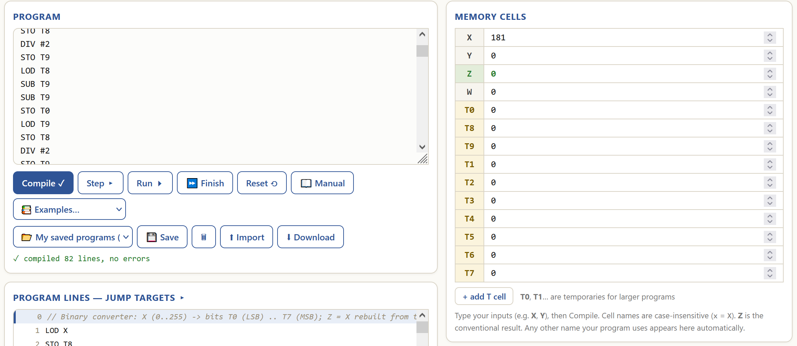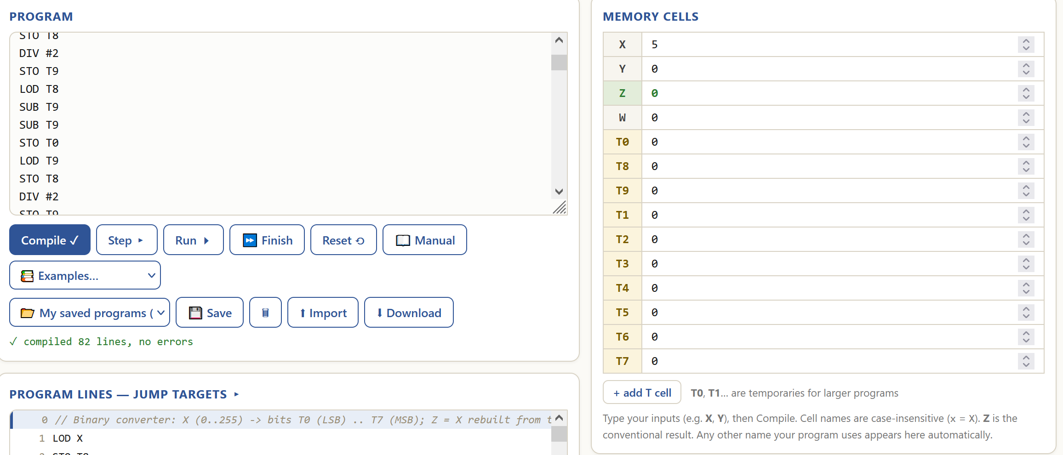
Final state:
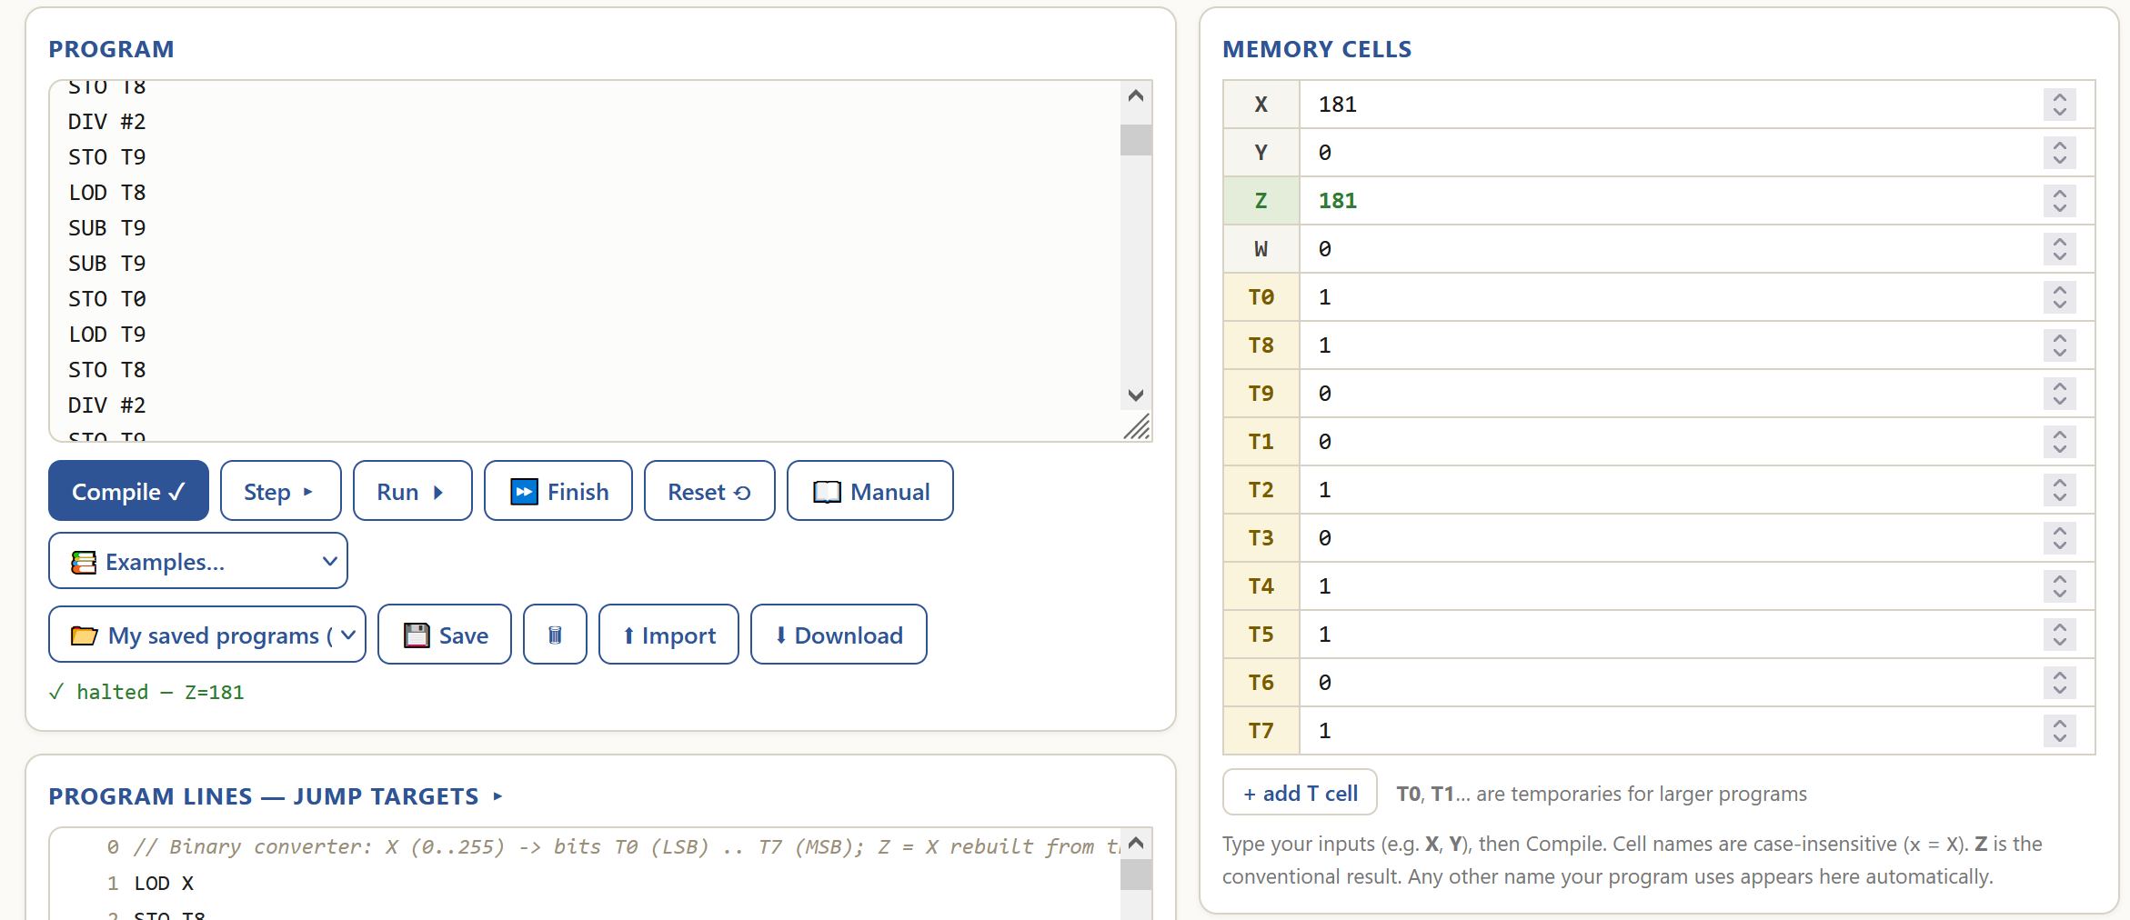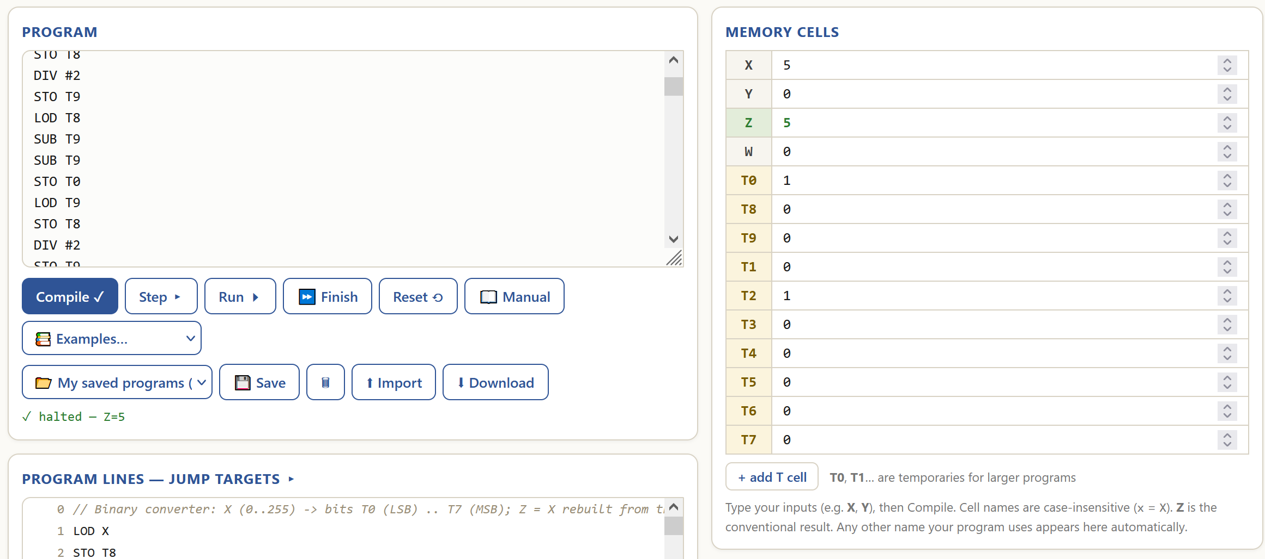
Edge case 1 test:
Initial state:
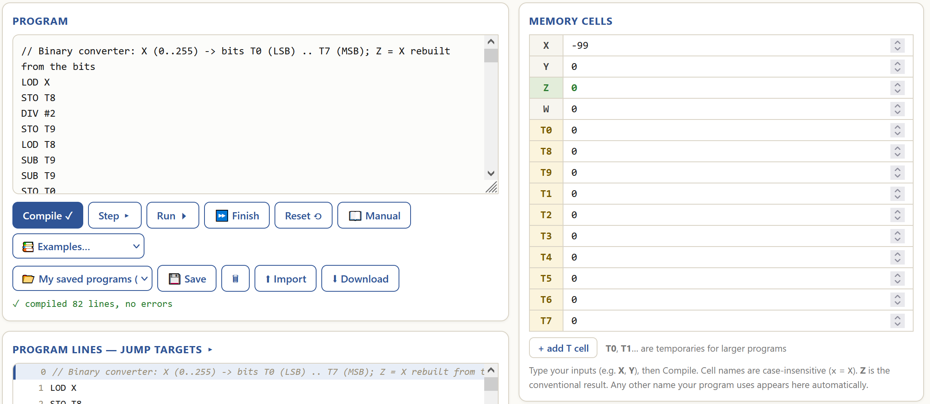
Final state:
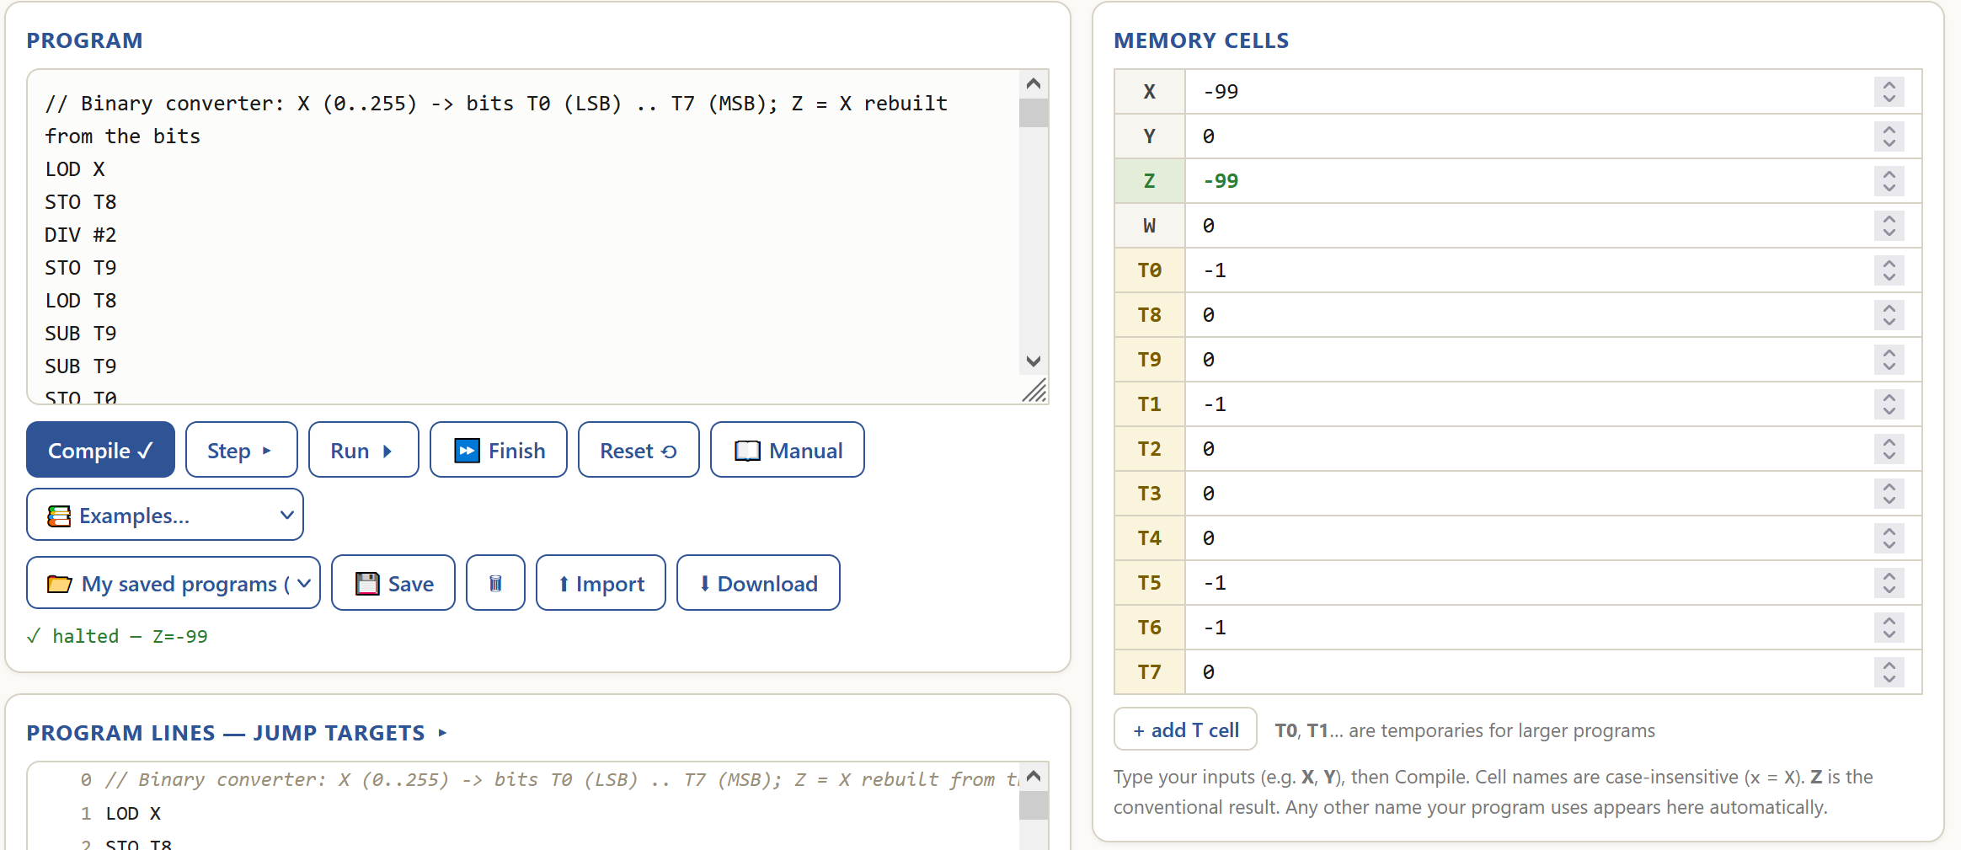
Edge case 2 test:
Initial state:
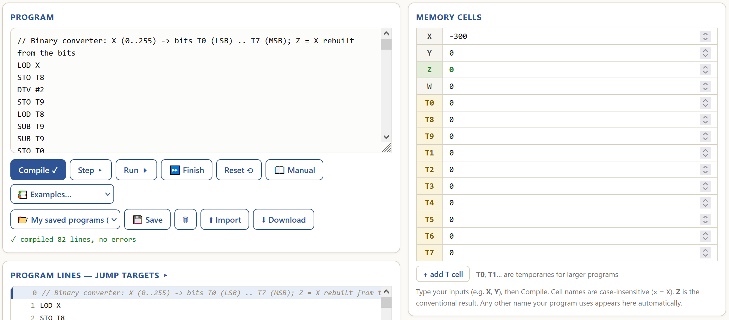
Final state:
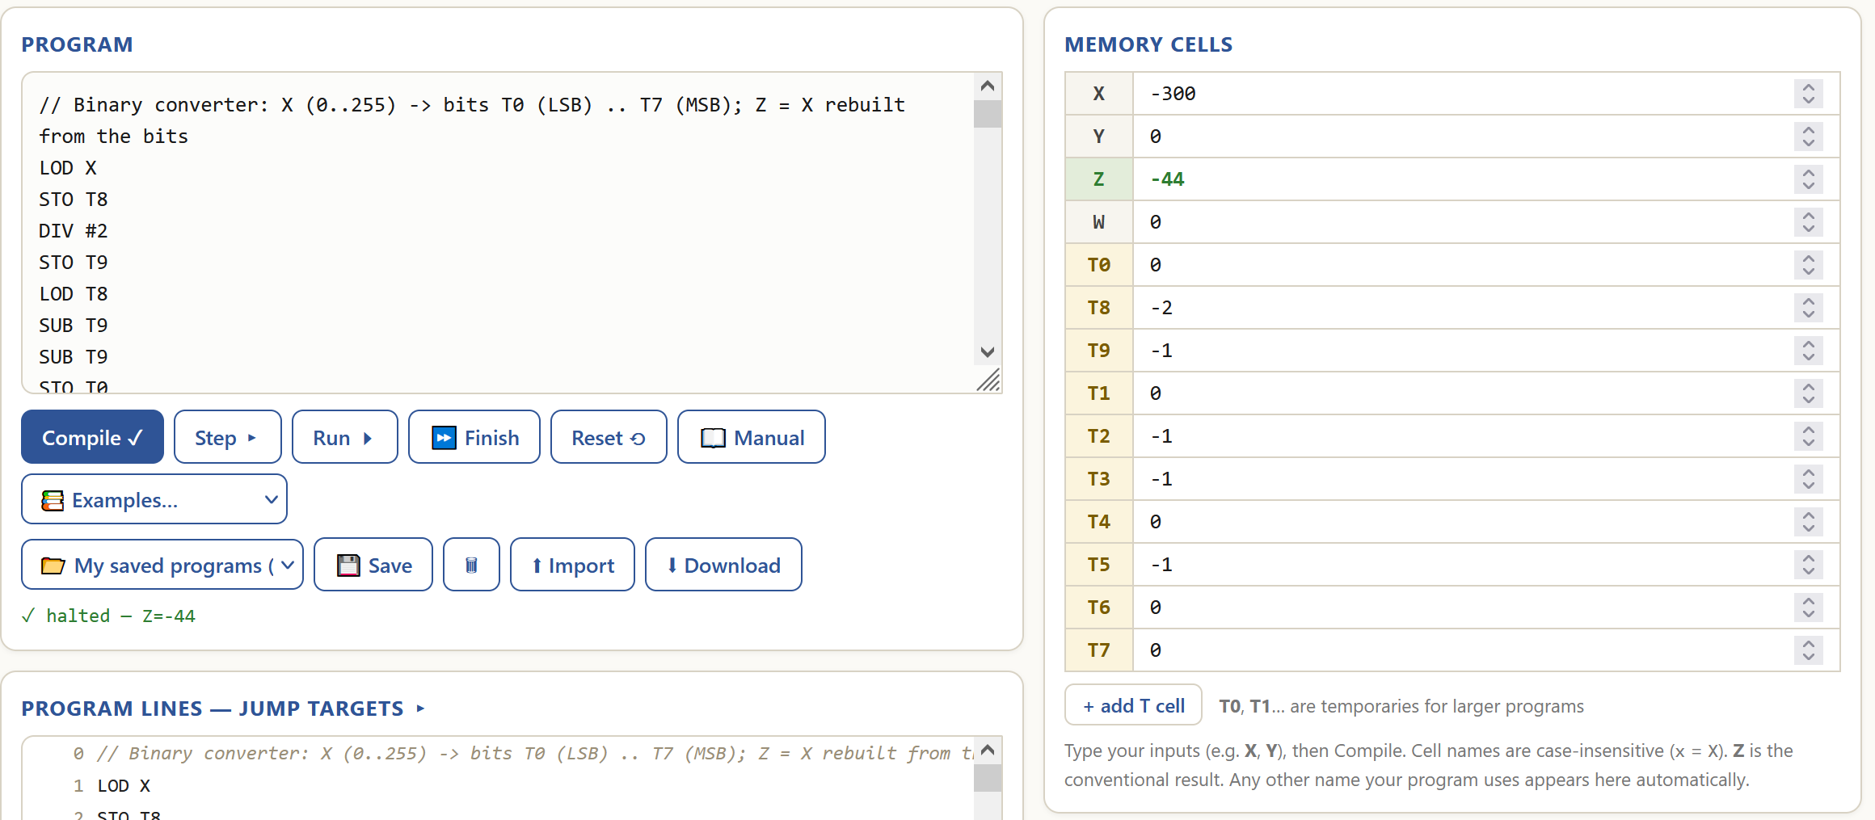

The program works as intended for the general case (181₁₀=10110101₂ , 5₁₀=00000101₂). It also unexpectedly handles edge cases 1 and 2 (-99₁₀=-01100011₂ , (-300 mod 256) = -44₁₀=-00101100₂).

- Multiply by repeated addition

Purpose:
The program calculates the product of X and Y by adding Y to Z X times.

Functionality:
Code analysis | Visualised algorithm
// X times Y by repeated addition -> Z is a comment.  LOD #0 loads immediate 0 into ACC.  STO Z stores ACC’s value into memory cell Z.  LOD Y loads the value of memory cell Y into ACC.  SUB #1 subtracts immediate 1 from ACC.  STO Y stores ACC’s value into memory cell Y.  JMZ 12 sets PC to 12 if ACC’s value is 0.  LOD Z loads the value of memory cell Z into ACC.  ADD X adds the value of memory cell X to ACC.  STO Z stores ACC’s value into memory cell Z.  JMP 3 sets PC to 3.  // done – a comment.  HLT halts the program. | 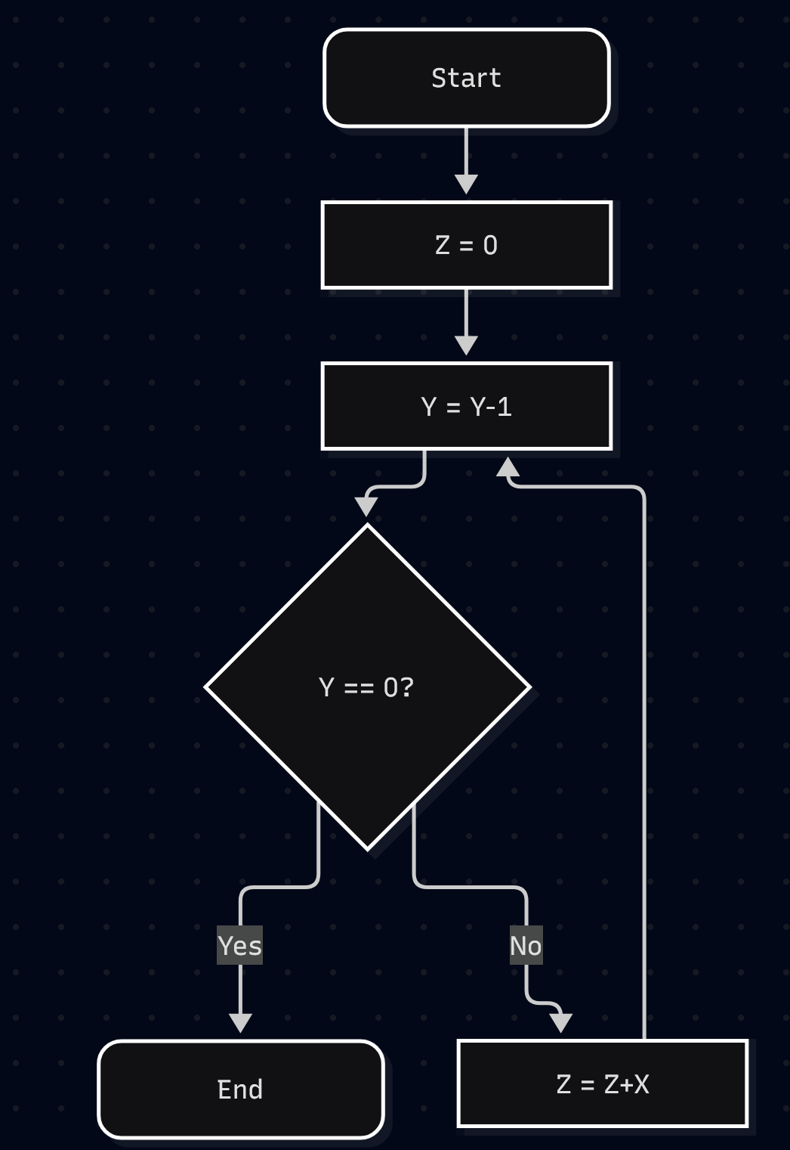

Intended behaviour:
General case – for any X and Y greater than or equal to 0, set Z to X*Y.
Edge case – for any X and Y less than 0, give a step limit exceeded error.

Real behaviour:
General case – for any X and Y greater than 0, set Z to X*Y.
Edge case – for any X and Y less than or equal to 0, give a step limit exceeded error.

General case tests:
Initial state:
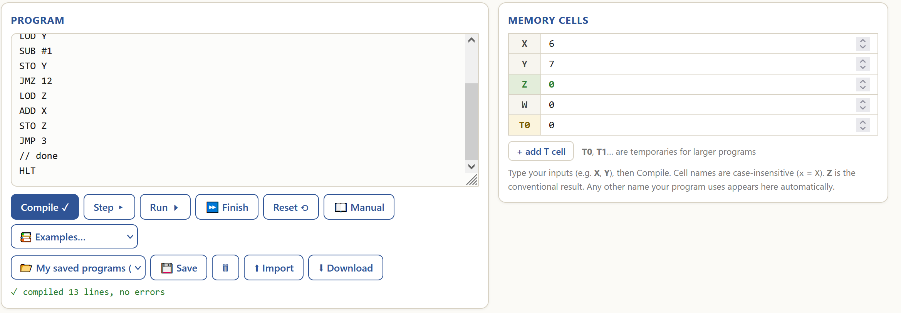
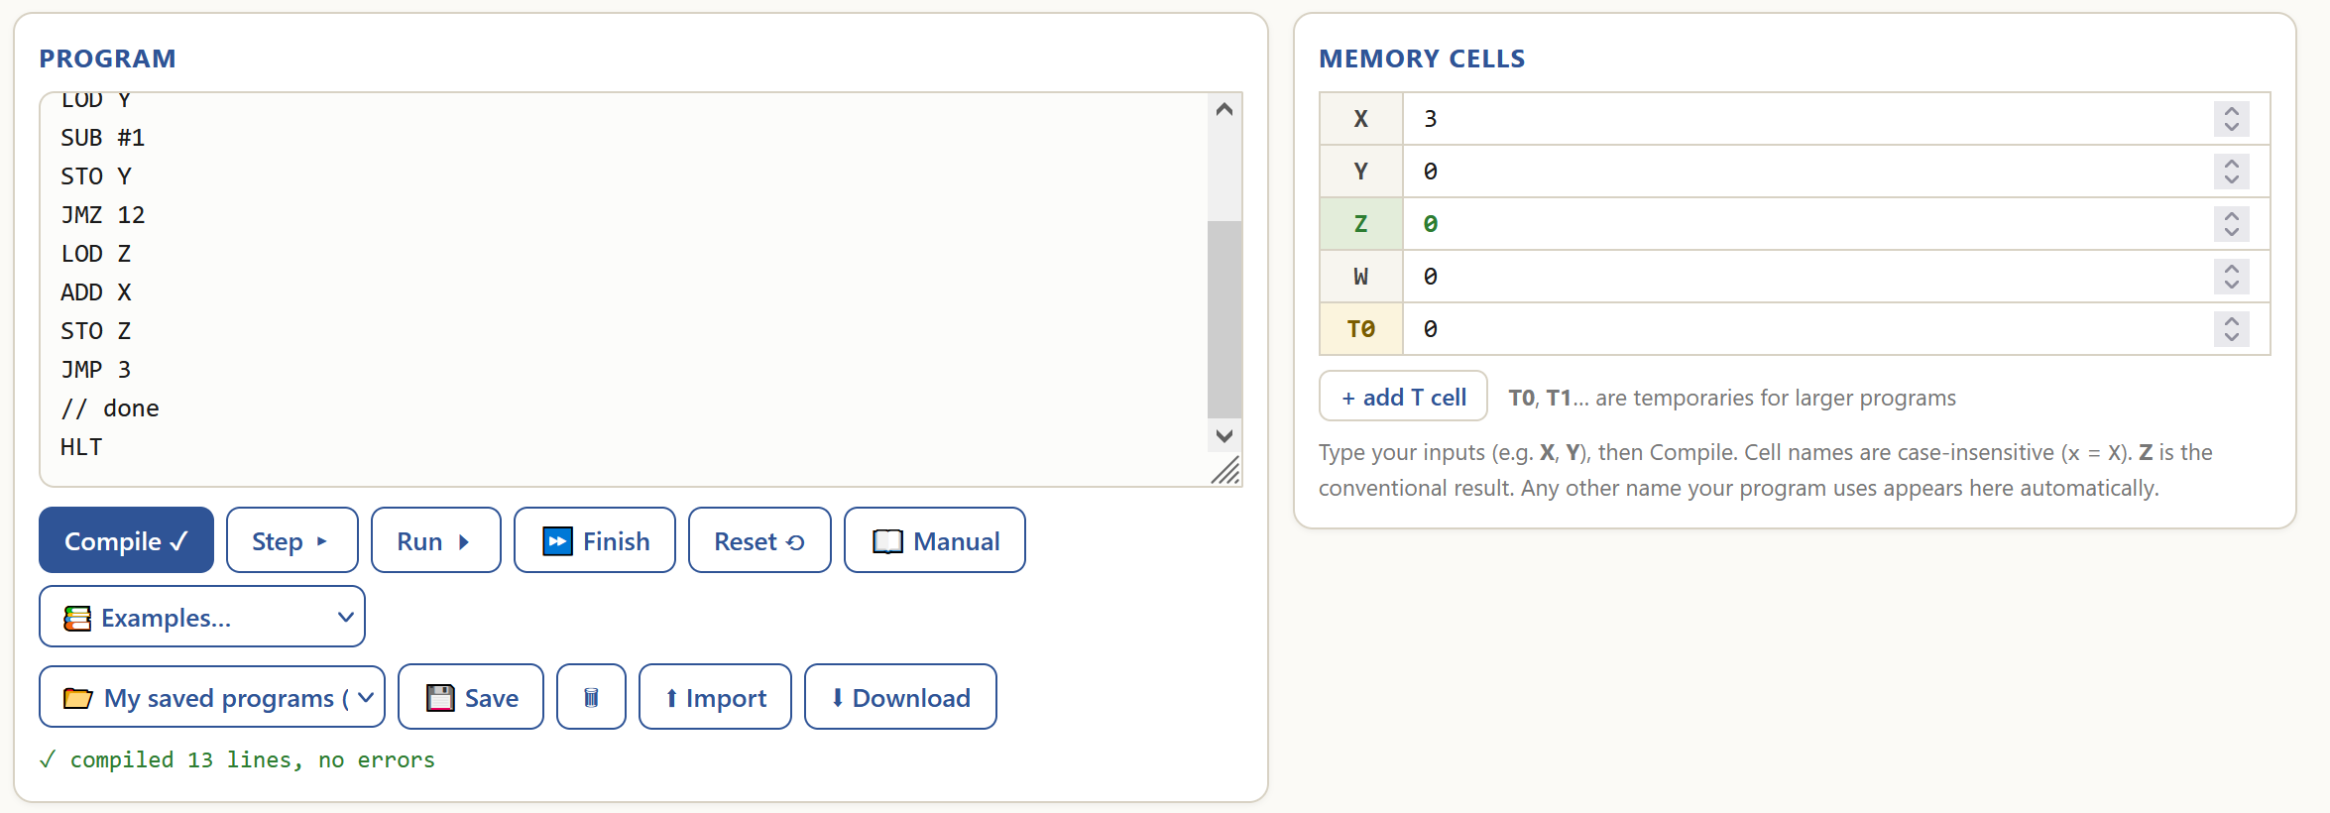
Final state:
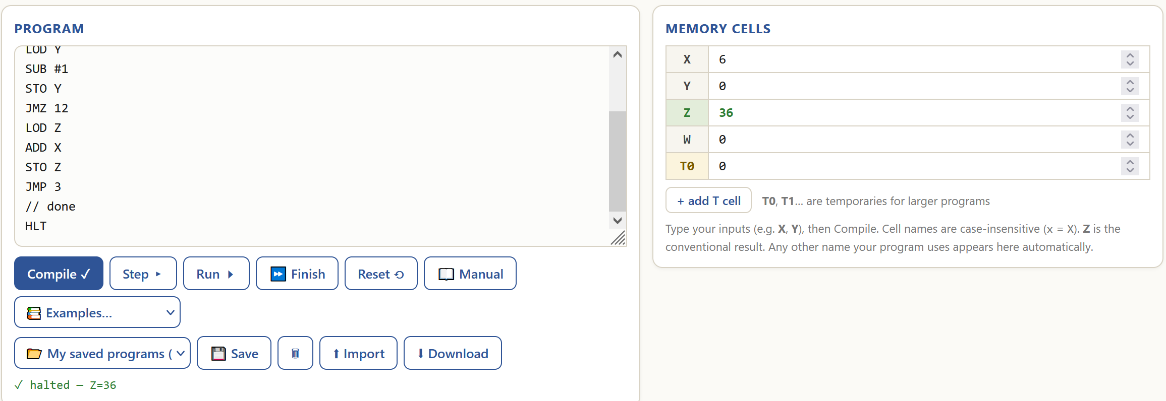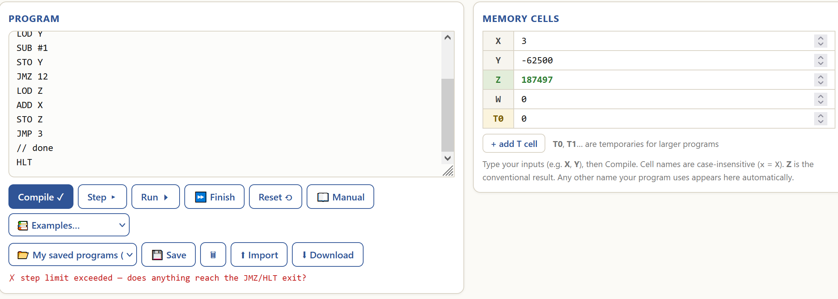
Edge case test:
Initial state:
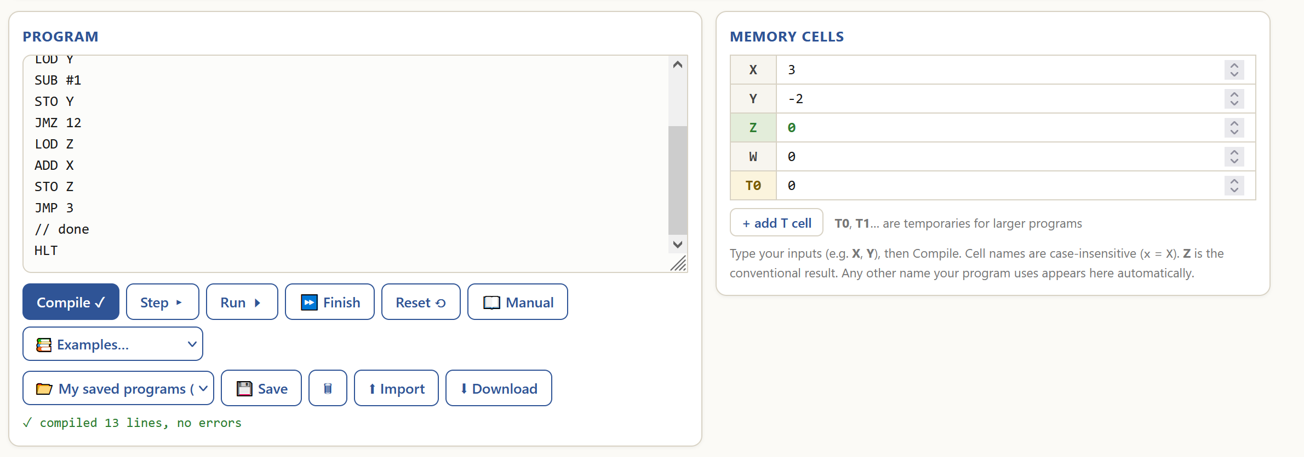
Final state:
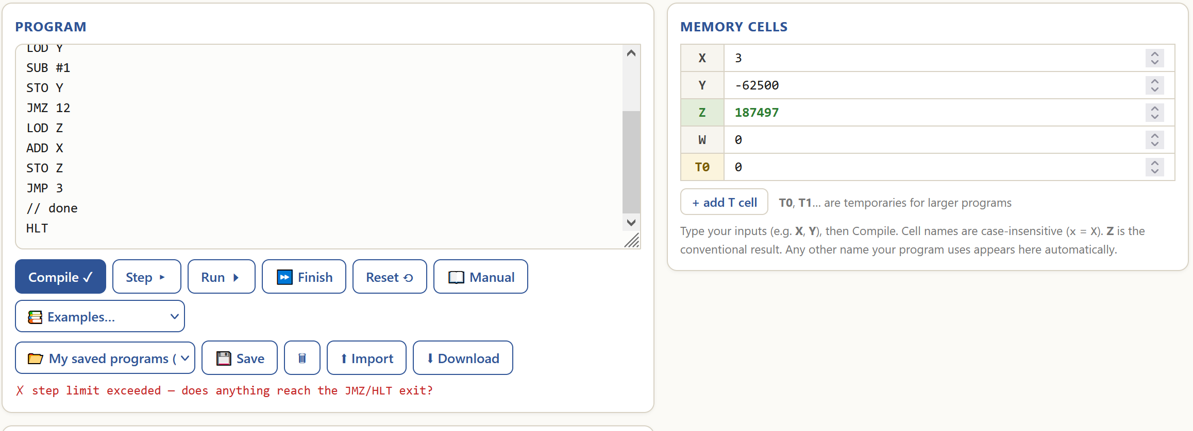
The program does not work as intended because it fails all tests (6*7=36 while it should be 42 and 3*0 results in an error, while the result should be 0). It does not handle the intended edge case and gives an error. The reason why the program gives a wrong result is because it subtracts 1 from Y before entering the loop.

- Maximum of X and Y

Purpose:
The program finds what value is larger, X or Y.

Functionality:
Code analysis | Visualised algorithm
// Maximum of X and Y -> Z is a comment.  LOD X loads the value of memory cell X into ACC.  SUB Y subtracts the value of memory cell Y from ACC.  JMZ 12 sets PC to 12 if ACC’s value is 0.  STO T2 stores ACC’s value into memory cell T2.  SUB #1 subtracts immediate 1 from ACC.  DIV T2 performs integer division by the value of memory cell T2 on ACC.  JMZ 12 sets PC to 12 if ACC’s value is 0.  LOD Y loads the value of memory cell Y into ACC.  STO Z stores ACC’s value into memory cell Z.  HLT halts the program.  LOD X loads the value of memory cell X into ACC.  STO Z stores ACC’s value into memory cell Z.  HLT halts the program. | 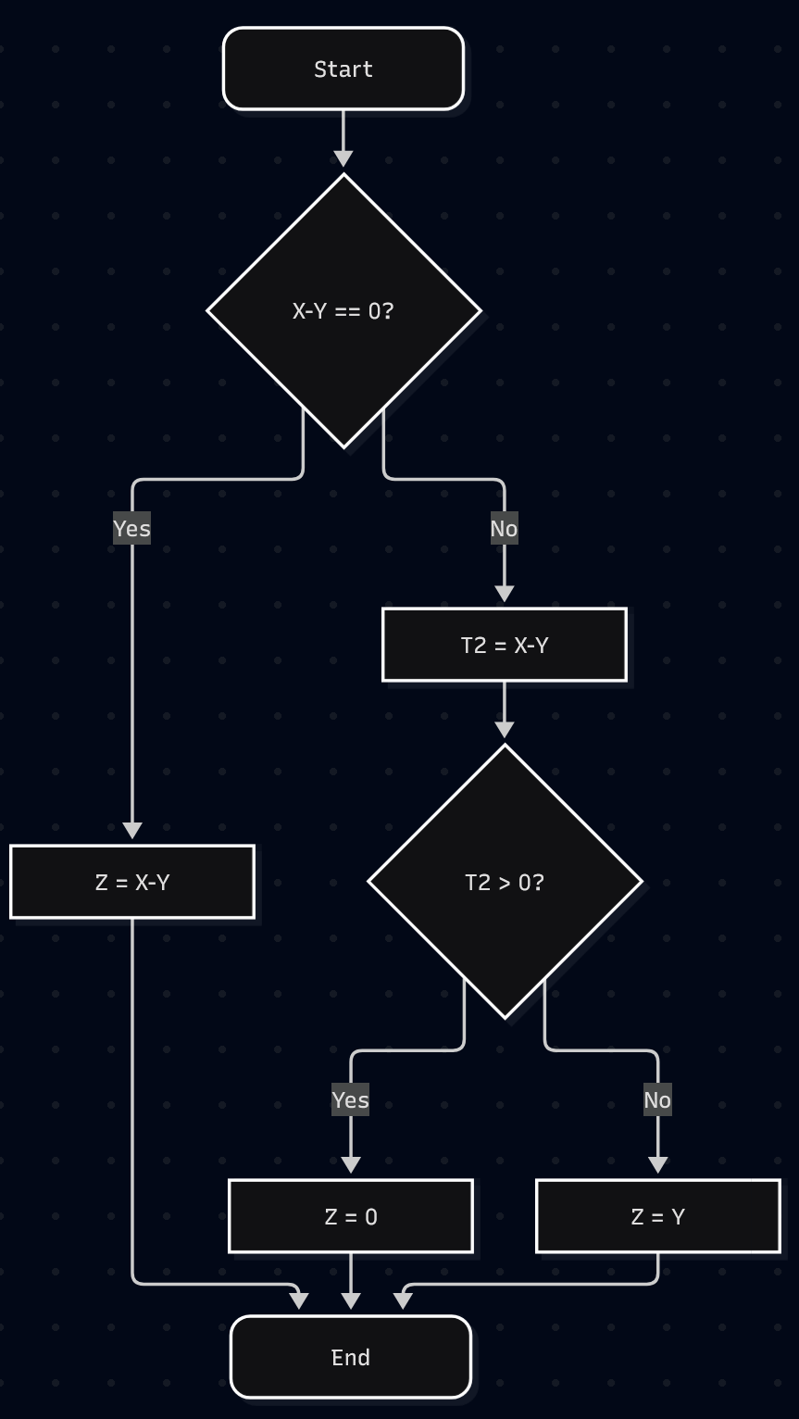

Intended behaviour:
For any X and Y, do the following
If X is equal to Y, set Z to X.
If X is greater than Y, set Z to X.
If X is less than Y, set Z to Y.

Real behaviour:
For any X and Y, do the following
If X is equal to Y, set Z to 0.
If X is greater than Y, set Z to 0.
If X is less than Y, set Z to Y.

Initial state:
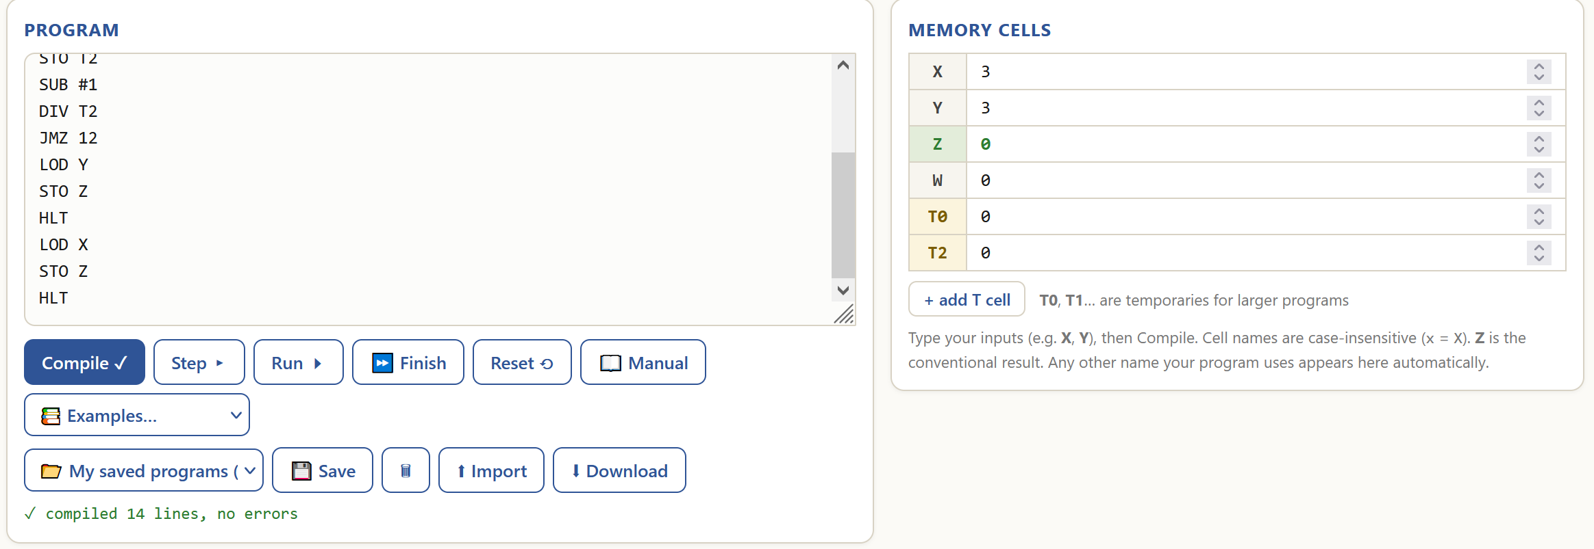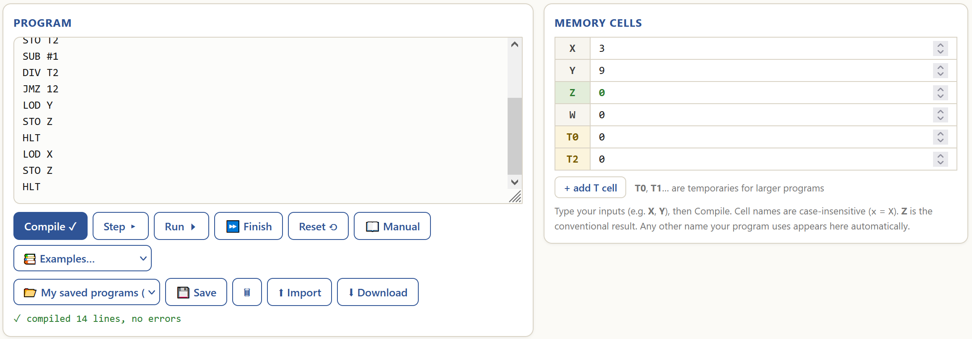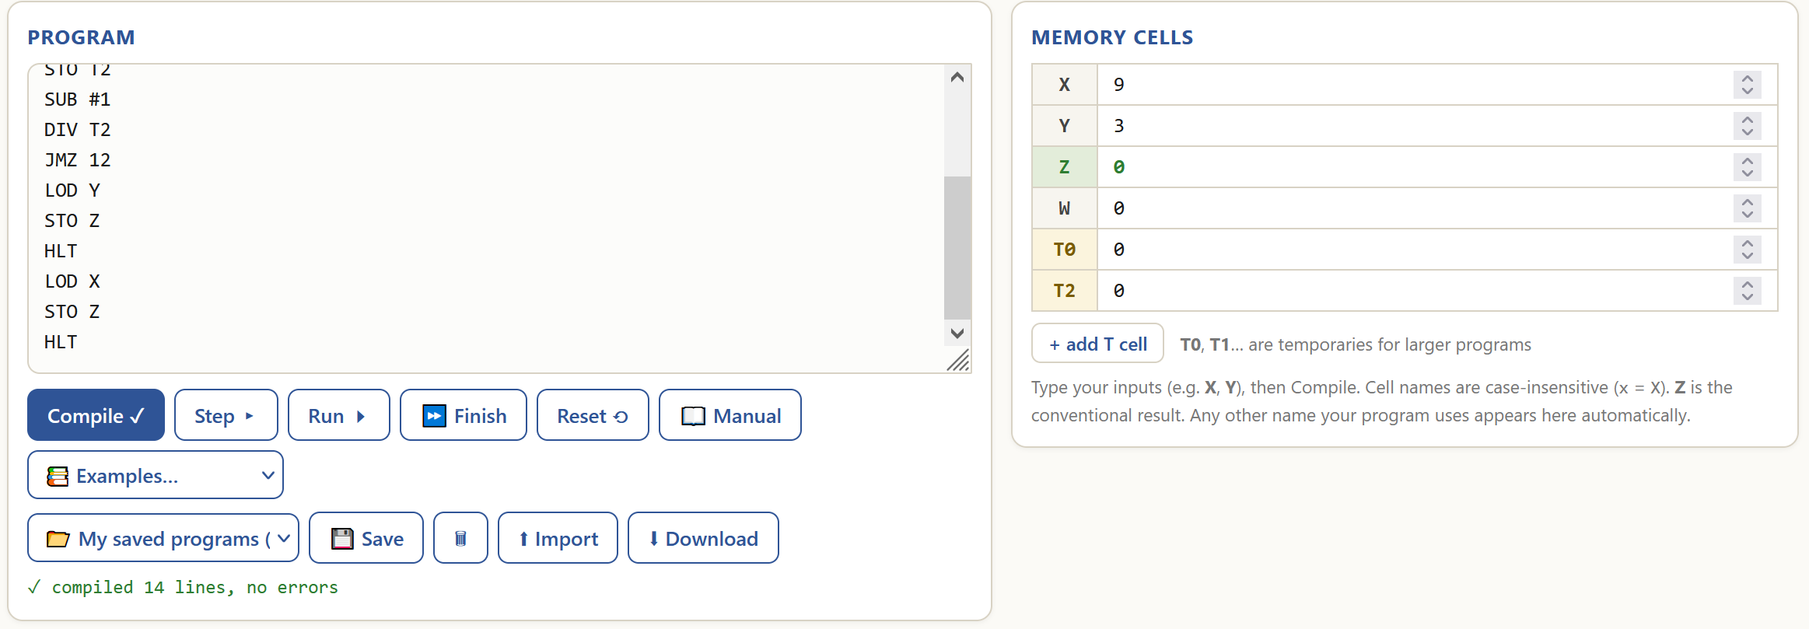
Final state:
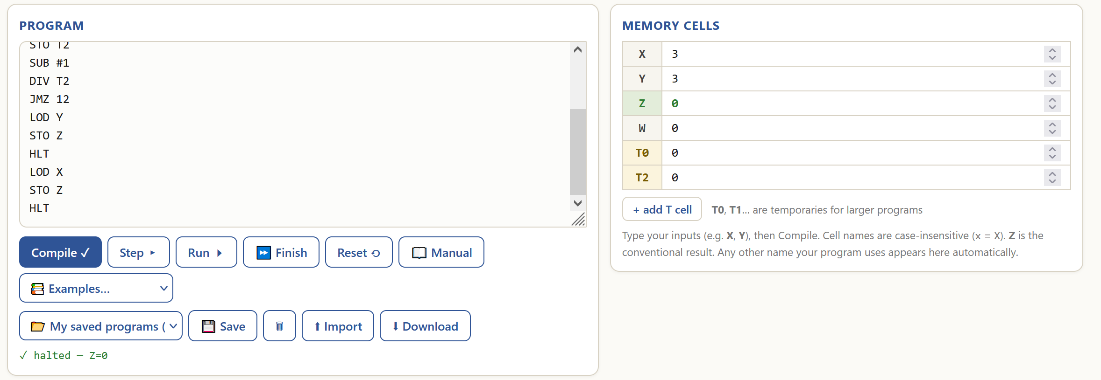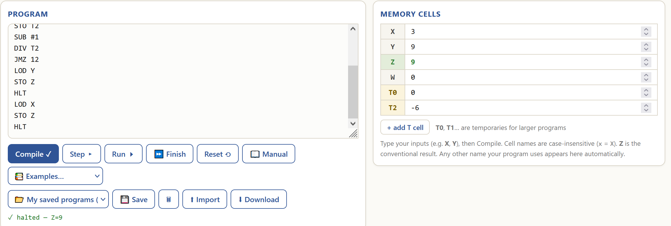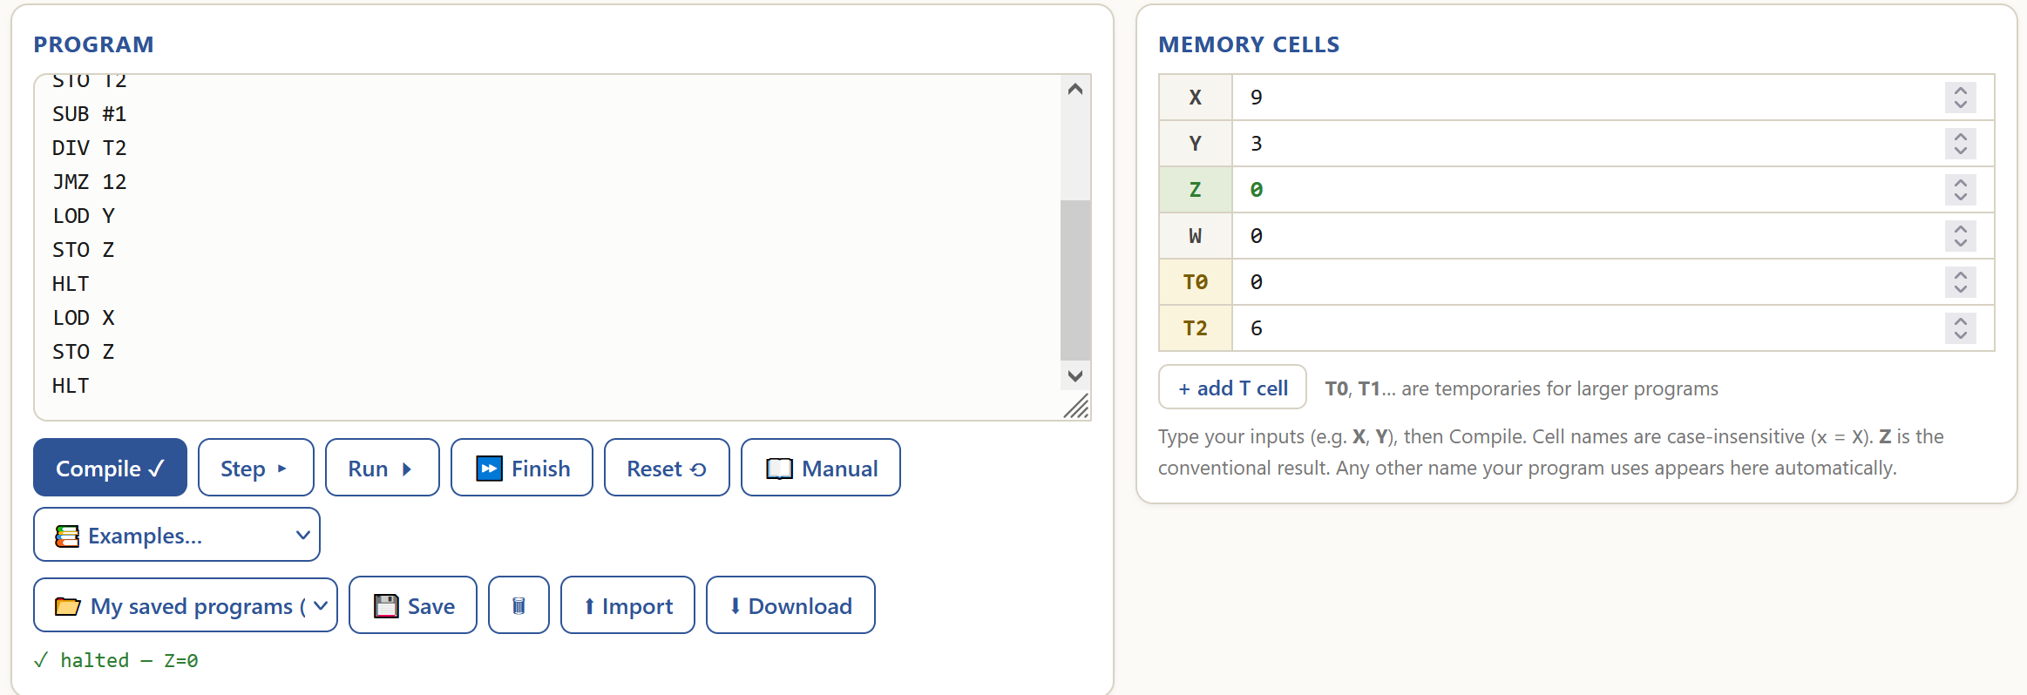
The program does not work as intended because it fails some tests (max(3,3)=0 while it should be 3, max(9,3)=0 while it should be 9, max(3,9)=9 is correct). The reason why it gives a wrong result is because the jump target of ‘JMZ 12’ is set to ‘STO Z’, which stores whatever is in ACC into Z, while it should be ‘JMZ 11’, so it loads the value of X into ACC first with ‘LOD X’ and then stores it into Z with ‘STO Z’.

Exercise 3: Conditional Swapping of Two Numbers
Objective: Develop a program that runs in the vnmsim simulator that swaps two numbers based on a condition. Learn to implement conditional logic and understand the importance of input in determining program behavior.
Tasks:
- Design a program that:
  - Reads two numbers (to be located in T1 and T2)
  - Reads a control value X. If X=0, the program should not swap the numbers; if X=1, the program should swap the numbers stored in T1 and T2
  - Implements conditional logic based on the value of X to determine the operation
  - Stores the swapped numbers back in T1 and T2
- Document the behavior of your program through screenshots. Make sure to capture:
  - Initial state (before running)
  - Final state (after running)
- Write a report detailing:
  - Your program's design and logic
  - How the program handled your specific combination of numbers
  - Any challenges you encountered and how you overcame them
Deliverables:
- Program code: P1_EX3_initials.txt
- Screenshots of program execution
- Design and analysis report
REPORT (you may extend the report as needed beyond this page)
Declaration of use of AI tools. If you've used AI tools to aid in understanding or completing this exercise, please acknowledge it below.
Acknowledgement of AI use: | No (Yes/No)
AI tool used: | [e.g., OpenAI, BARD, etc.]
Purpose: | [e.g., Clarification of a concept, content generation, error-checking, etc.]
Shared session (if available) | Example: https://chat.openai.com/share/24259216-abc1-4343-974d-95357368aae8
My program’s behaviour:
Initial state:
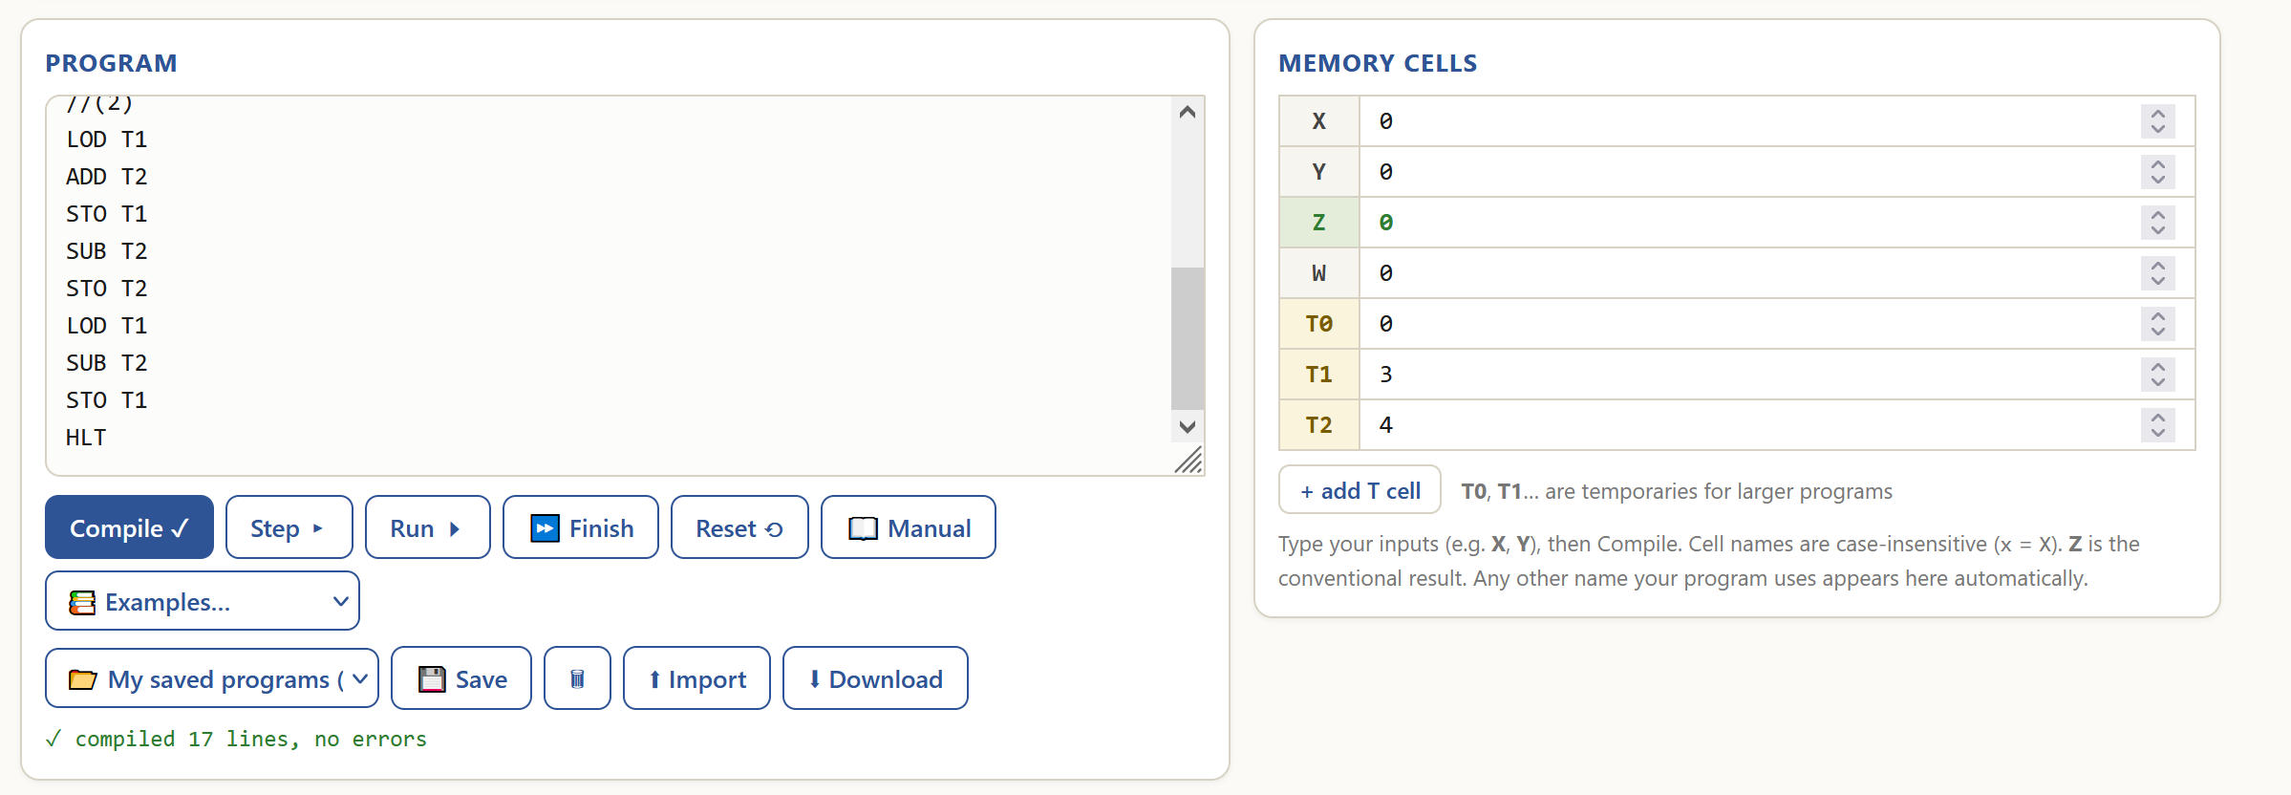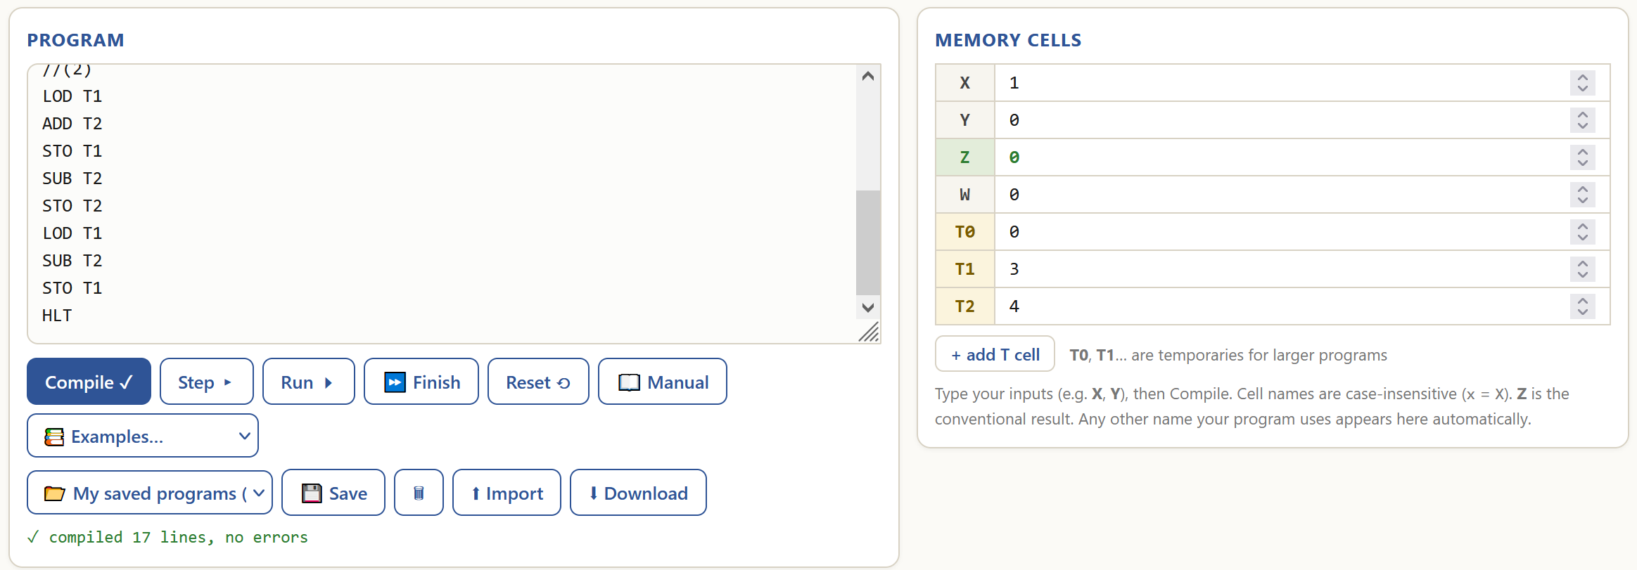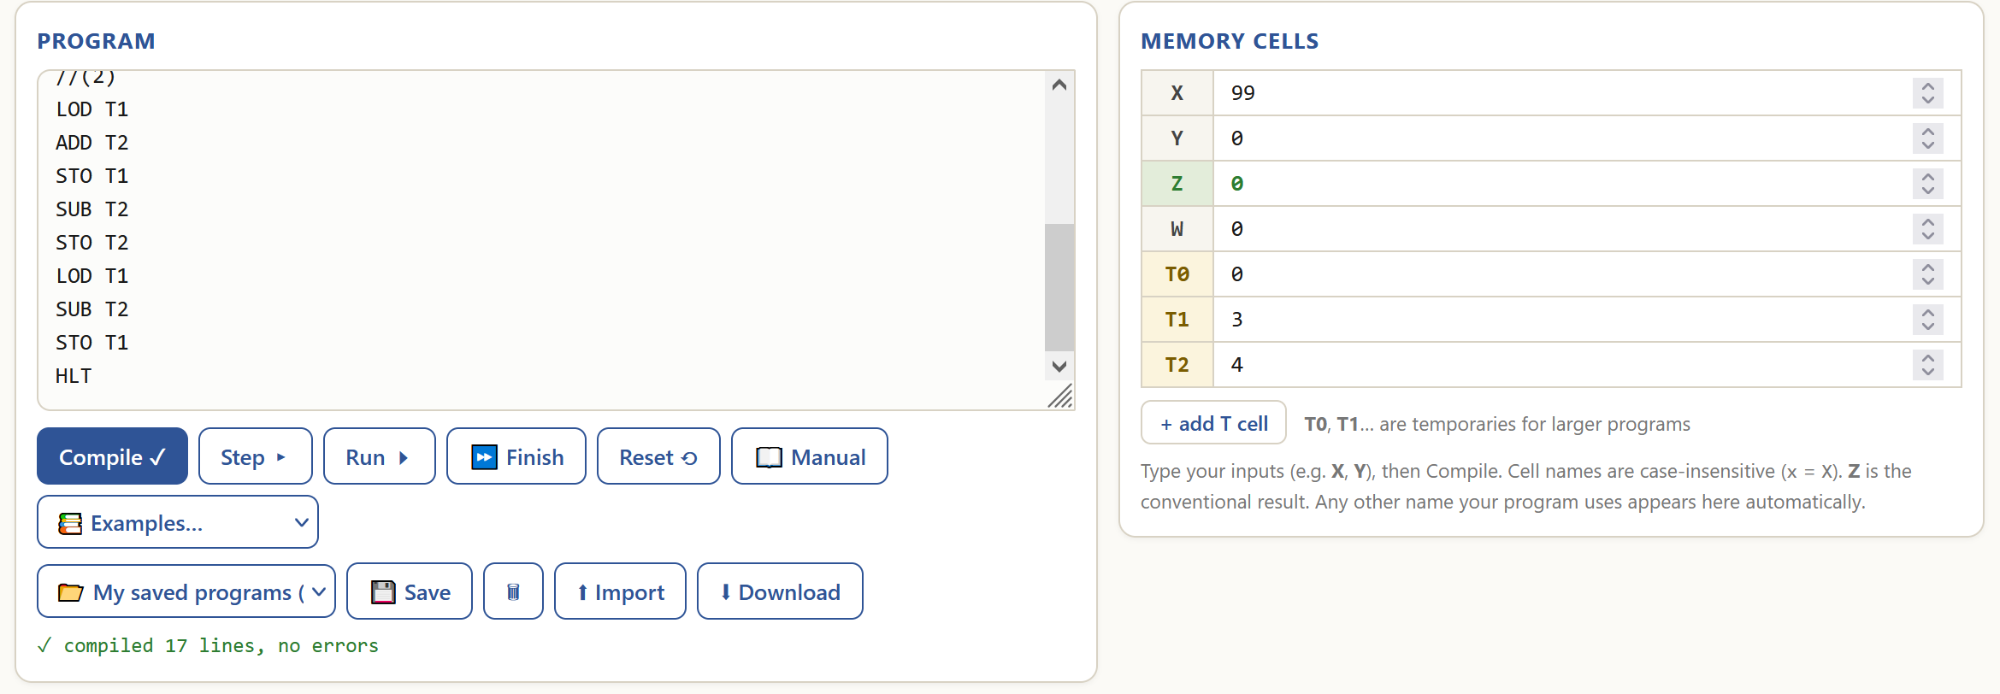
Final state:
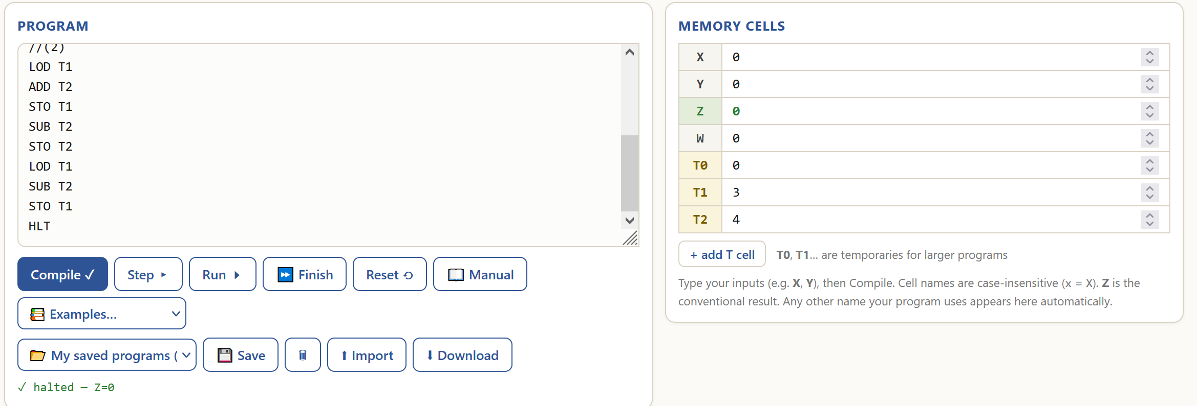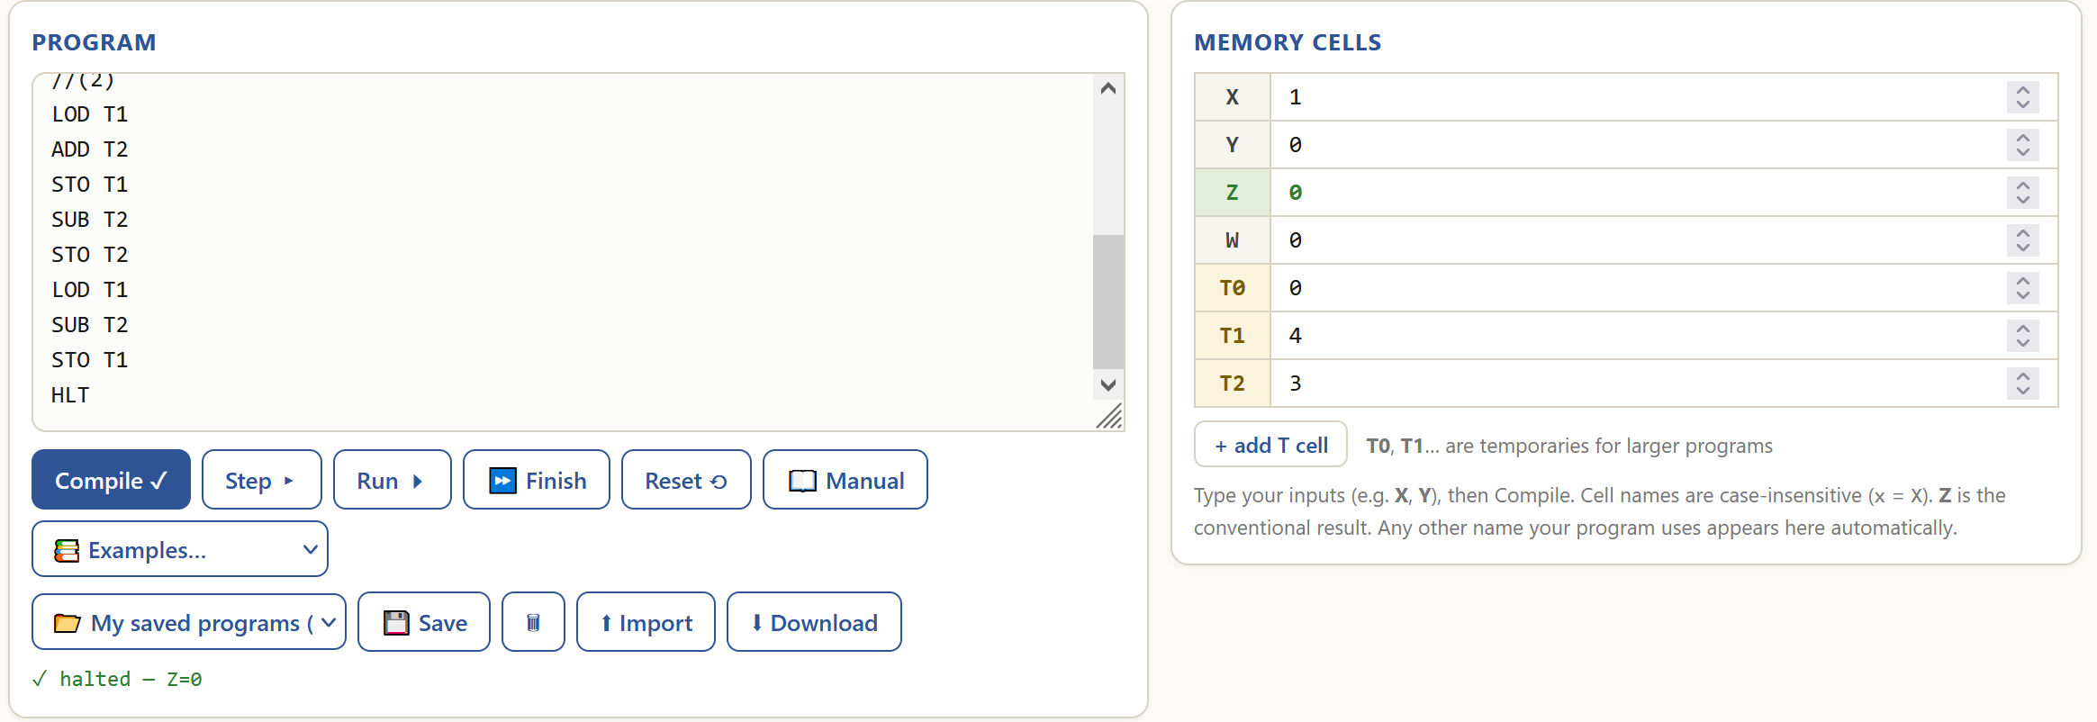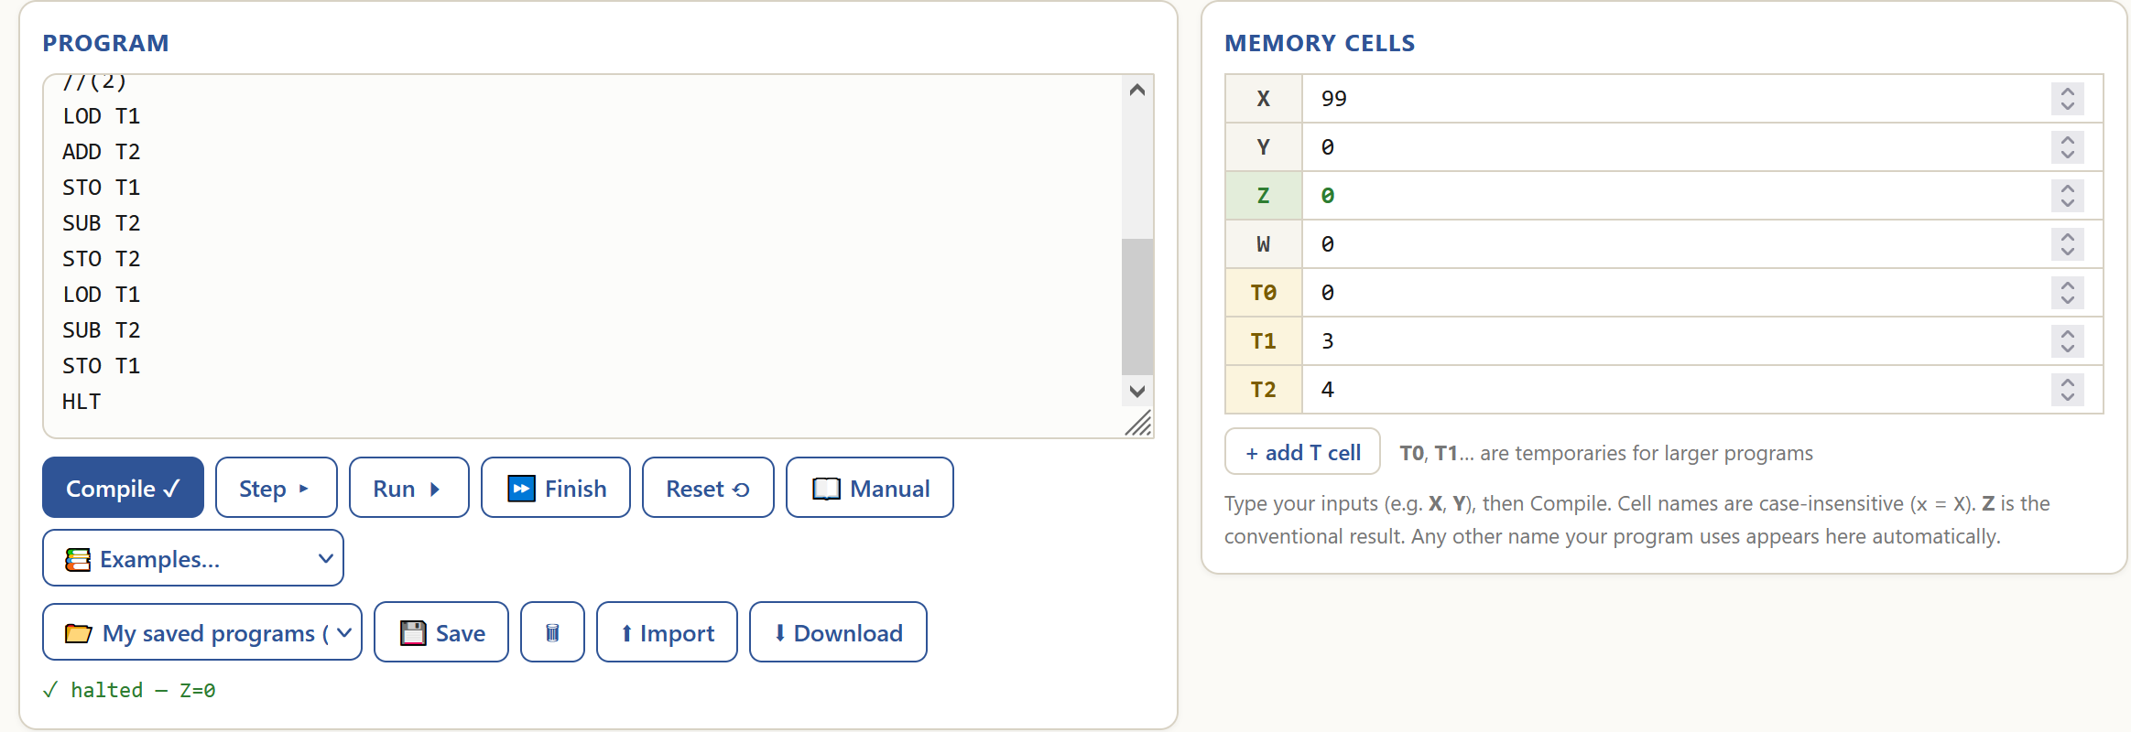

My program’s design:
It is split into 3 parts:
- Line 0 – the comment describes what the program does.
- Line 1-6 - checking the value of X.
- Line 7-16 - performing the swap.
Parts 2 and 3 are connected by manually labelled jumps for readability and ease of modifying the code.

My program’s logic:
Code analysis | Visualised algorithm
Line 0 – a comment.  Line 1 – load X into ACC.  Line 2 – if ACC is 0, go to comment 1 – halt the program.  Line 3-4 – if ACC is 1, go to comment 2 – begin the swap.  Line 5 – comment 1, and the general case for ACC.  Line 6 – halt the program before the swap.  Line 7 – comment 2.  Line 8-15 – the in-place swap of 2 numbers using math:  - A=A+B  - B=A-B to get B = (A+B)-B = A  - A=A-B to get A = (A+B)-A = B  Line 16 – halt the program after the swap. | 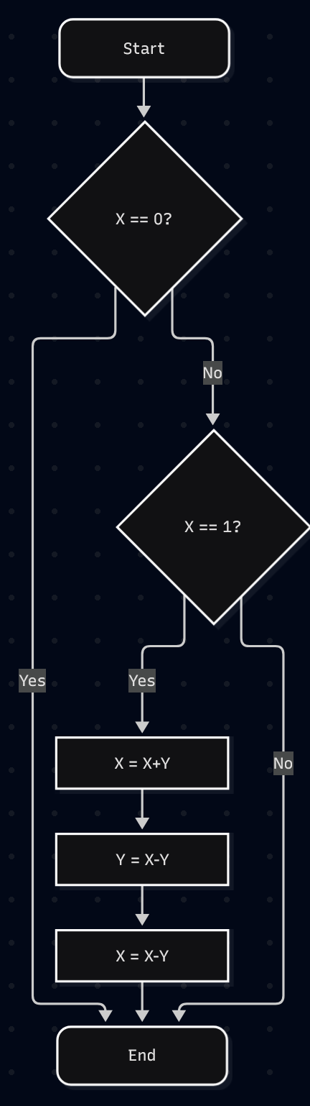

Behaviour examples of my program:
Example 1 – do not swap: X=0, T1=3, T2=4.
Line 0 – a comment, nothing happens.
Line 1 – loads X into ACC. (ACC=0)
Line 2 – checks if ACC is 0, if it is, go to line 5 (comment 1). (True, PC = 5)
Line 5 – a comment, nothing happens.
Line 6 – the program is halted.
Result: X=0, T1=3, T2=4.
The numbers did not swap – as intended.

Example 2 – do swap: X=1, T1=3, T2=4.
Line 0 – a comment, nothing happens.
Line 1 – loads X into ACC. (ACC=1)
Line 2 – checks if ACC is 0, if it is, go to line 5 (comment 1). (False)
Line 3 – subtracts 1 from ACC. (ACC is 0)
Line 4 - checks if ACC is 0, if it is, go to line 7 (comment 2). (True, PC = 7)
Line 7 – a comment, nothing happens.
Line 8 – loads T1 into ACC. (ACC=3)
Line 9 – add T2 to ACC. (ACC=3+4=7)
Line 10 – stores ACC to T1. (T1=7)
Line 11 – subtracts T2 from ACC (ACC=7-4=3)
Line 12 – stores ACC to T2. (T2=3)
Line 13 – loads T1 into ACC (ACC=7)
Line 14 – subtracts T2 from ACC. (ACC=7-3=4)
Line 15 – stores ACC to T1. (T1=4)
Line 16 – the program is halted.
Result: X=1, T1=4, T2=3.
The numbers are swapped – as intended.

Example 3 – undefined operation, do not swap: X=99, T1=3, T2=4.
Line 0 – a comment, nothing happens.
Line 1 – loads X into ACC. (ACC=1)
Line 2 – checks if ACC is 0, if it is, go to line 5 (comment 1). (False)
Line 3 – subtracts 1 from ACC. (ACC is 0)
Line 4 - checks if ACC is 0, if it is, go to line 7 (comment 2). (False)
Line 5 – a comment, nothing happens.
Line 6 – the program is halted.
Result: X=99, T1=3, T2=4.
The numbers did not swap – as intended.

Challenges I’ve surpassed:
- The Von Neumann machine does not have jumps to labels, only to code lines - I had to manually add them in using comments.
- Most changes in code require to recount the JMP, JMZ operation numbers – the label jumps from challenge 1 allowed an easier way to remember where the jumps are supposed to go.

Code:


Exercise 4: Sorting Two Numbers
Objective: Develop a program that runs in the vnmsim simulator that sorts two numbers, either in descending or ascending order.
Tasks:
- Design a program that:
  - Stores two numbers in T1 and T2
  - Uses X and Y as temporary registers to perform calculations or manipulations
  - Sorts the numbers in descending order if T2 is greater than T1
  - Sorts the numbers in ascending order if T1 is greater than T2
  - Stores the sorted numbers back in T1 and T2
- Test your program with different combinations of numbers in T1 and T2
- Document the behavior of your program through screenshots. Make sure to capture:
  - Initial state (before running)
  - Final state (after running)
- Ensure the code has clear comments explaining each instruction and its purpose
- Write a report detailing:
  - Your program's design and logic
  - How the program handled your specific combination of numbers
  - Any challenges you encountered and how you overcame them
Deliverables:
- Program code: P1_EX4_initials.txt
- Screenshots of program execution
- Design and analysis report
REPORT (you may extend the report as needed beyond this page)
Declaration of use of AI tools. If you've used AI tools to aid in understanding or completing this exercise, please acknowledge it below.
Acknowledgement of AI use: | No (Yes/No)
AI tool used: | [e.g., OpenAI, BARD, etc.]
Purpose: | [e.g., Clarification of a concept, content generation, error-checking, etc.]
Shared session (if available) | Example: https://chat.openai.com/share/24259216-abc1-4343-974d-95357368aae8
My program’s behaviour:
Initial state:
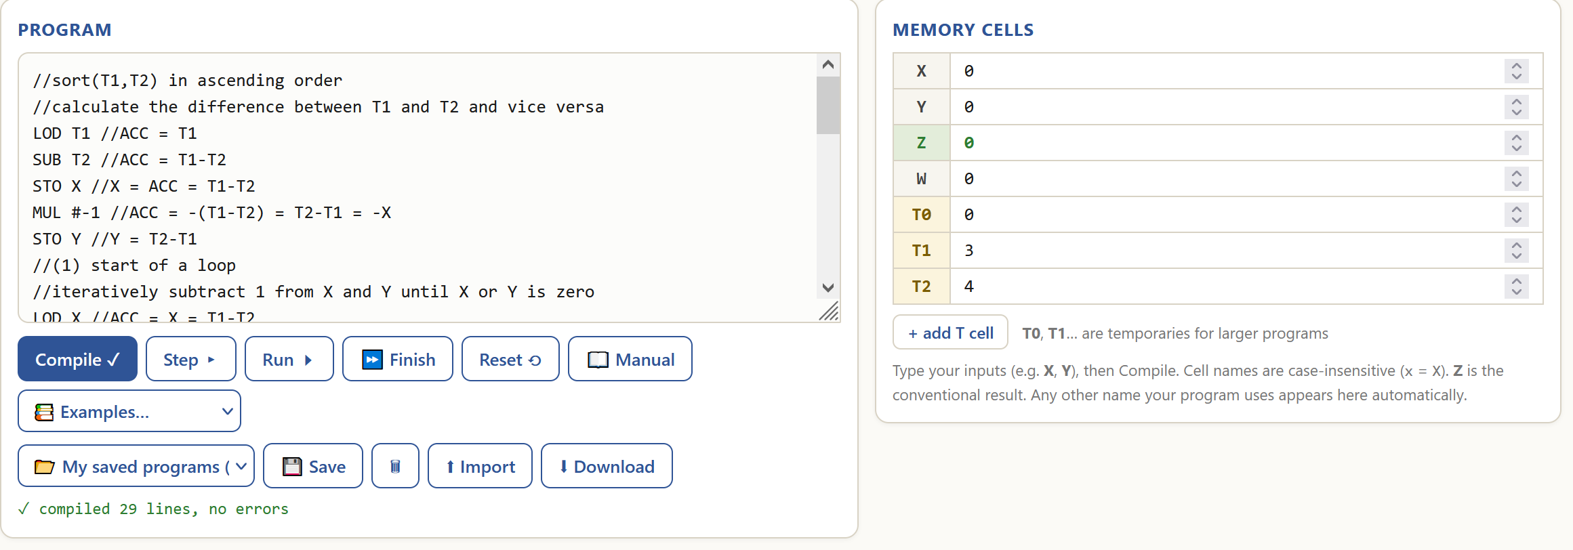
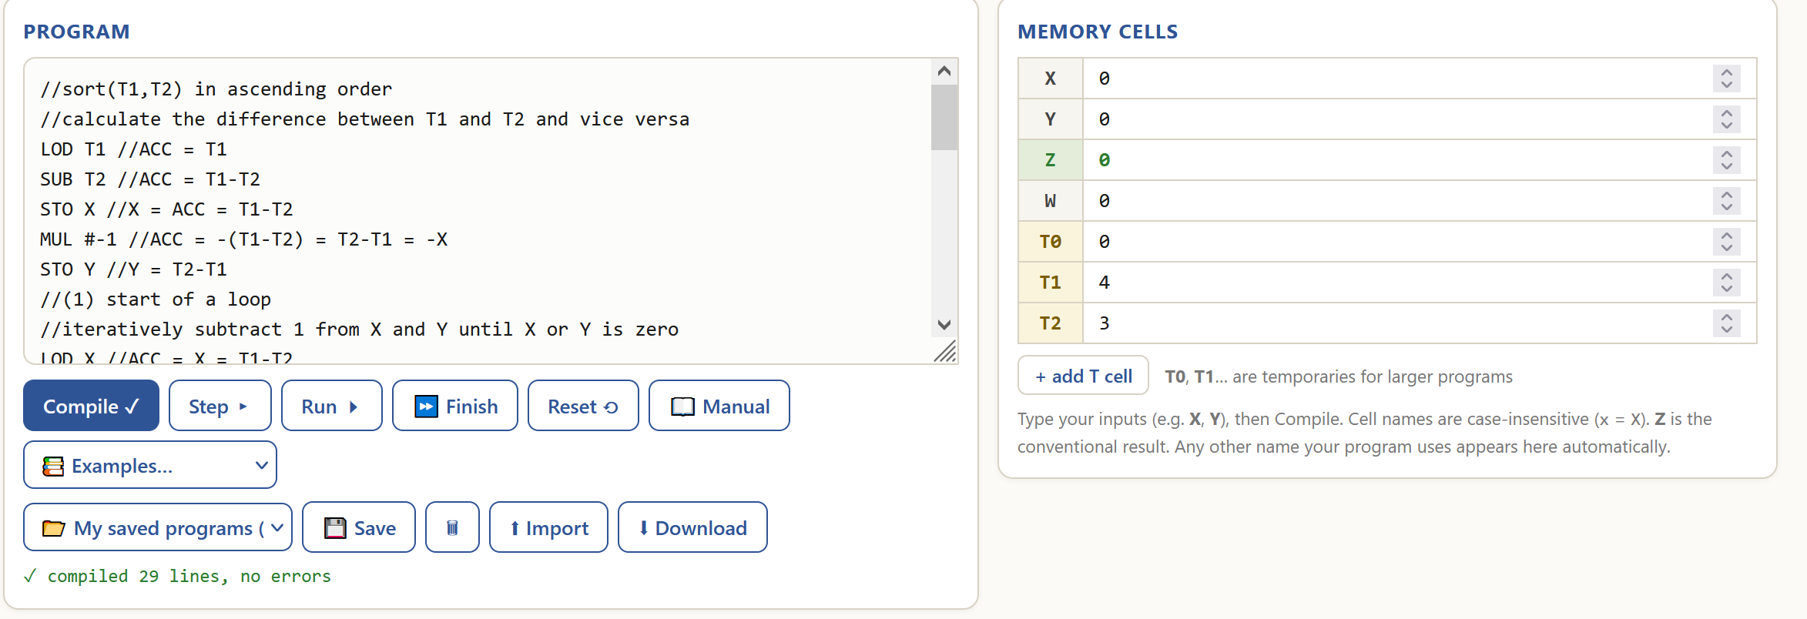
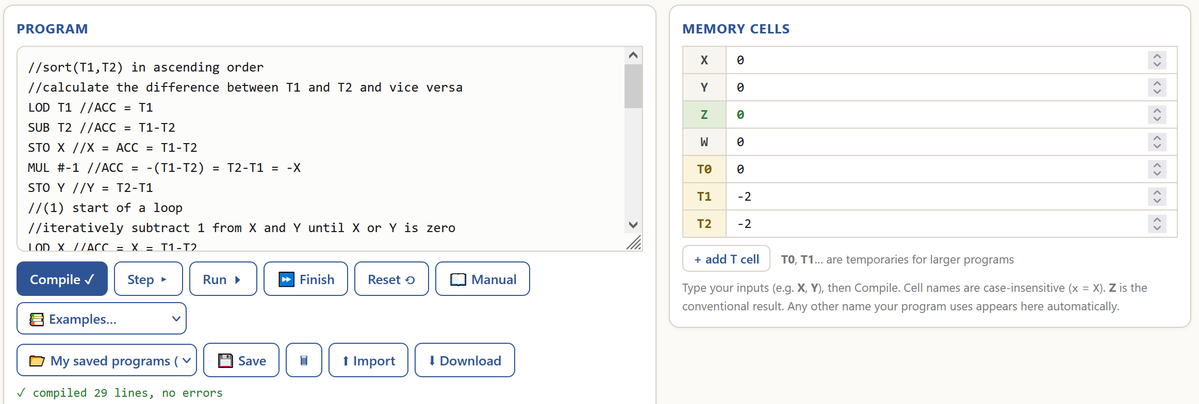
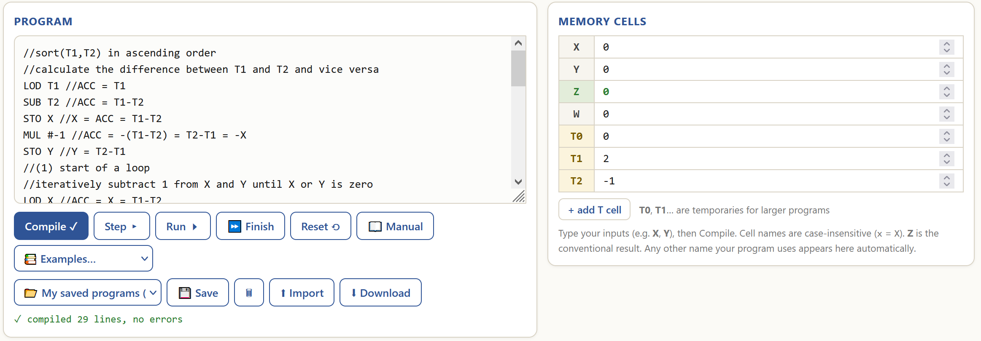
Final state:
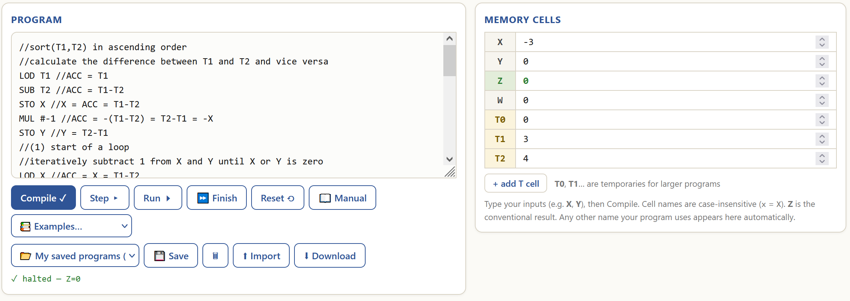
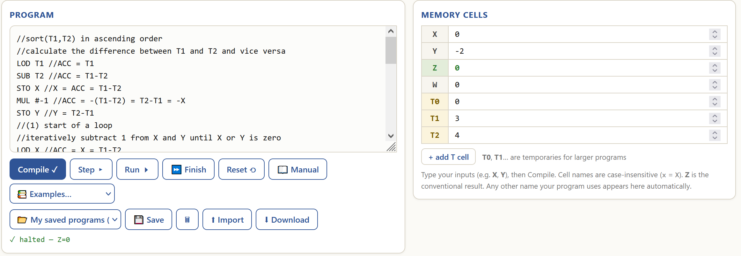
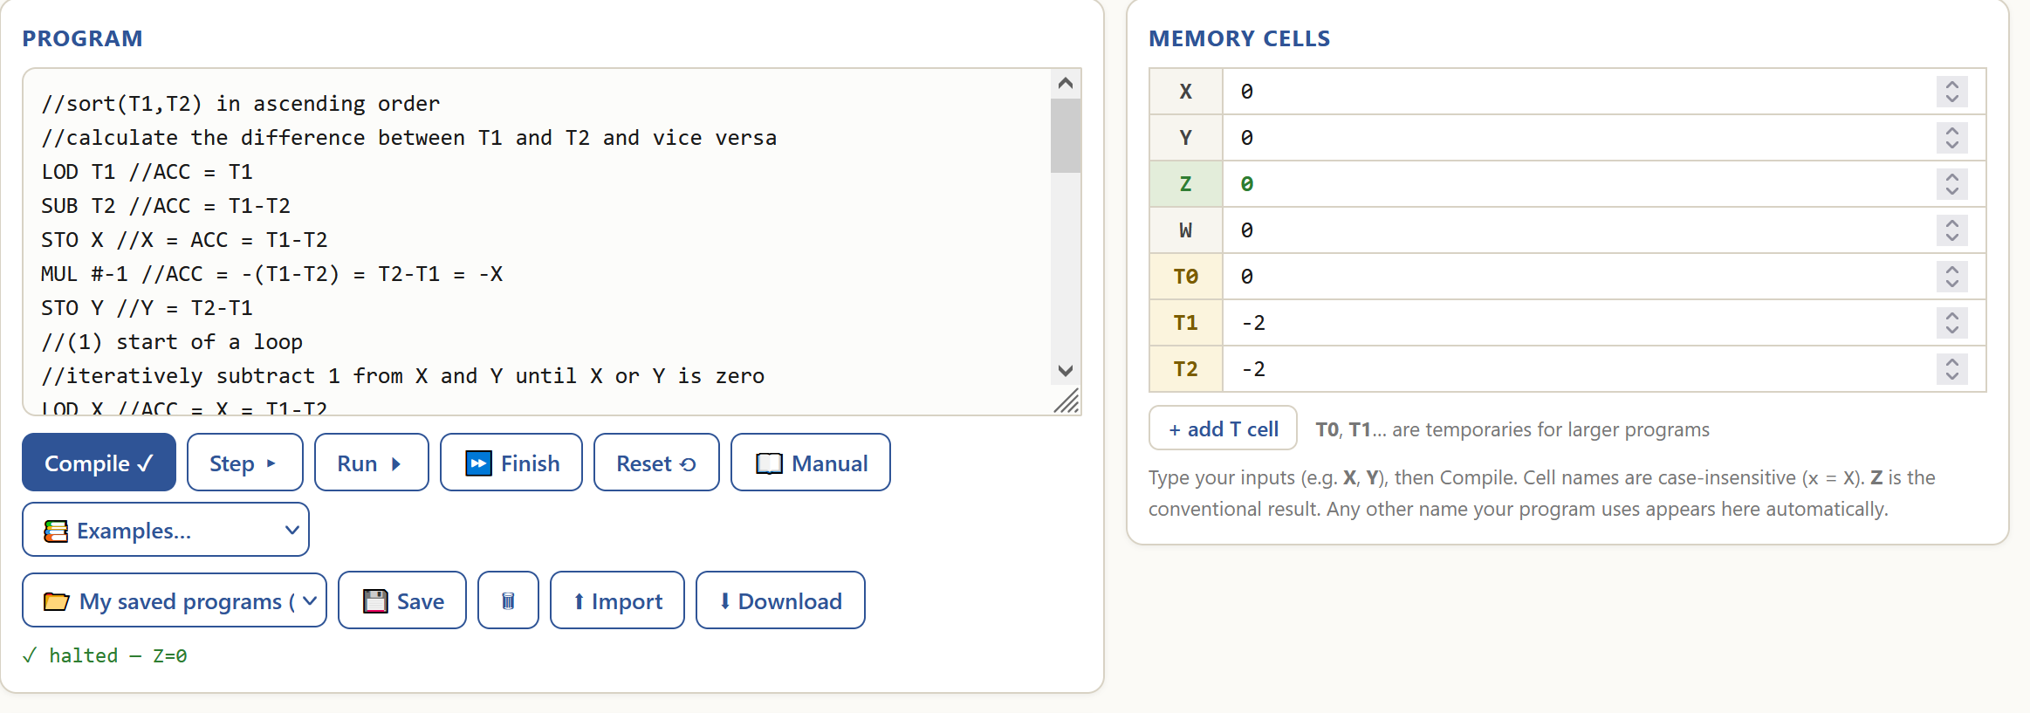
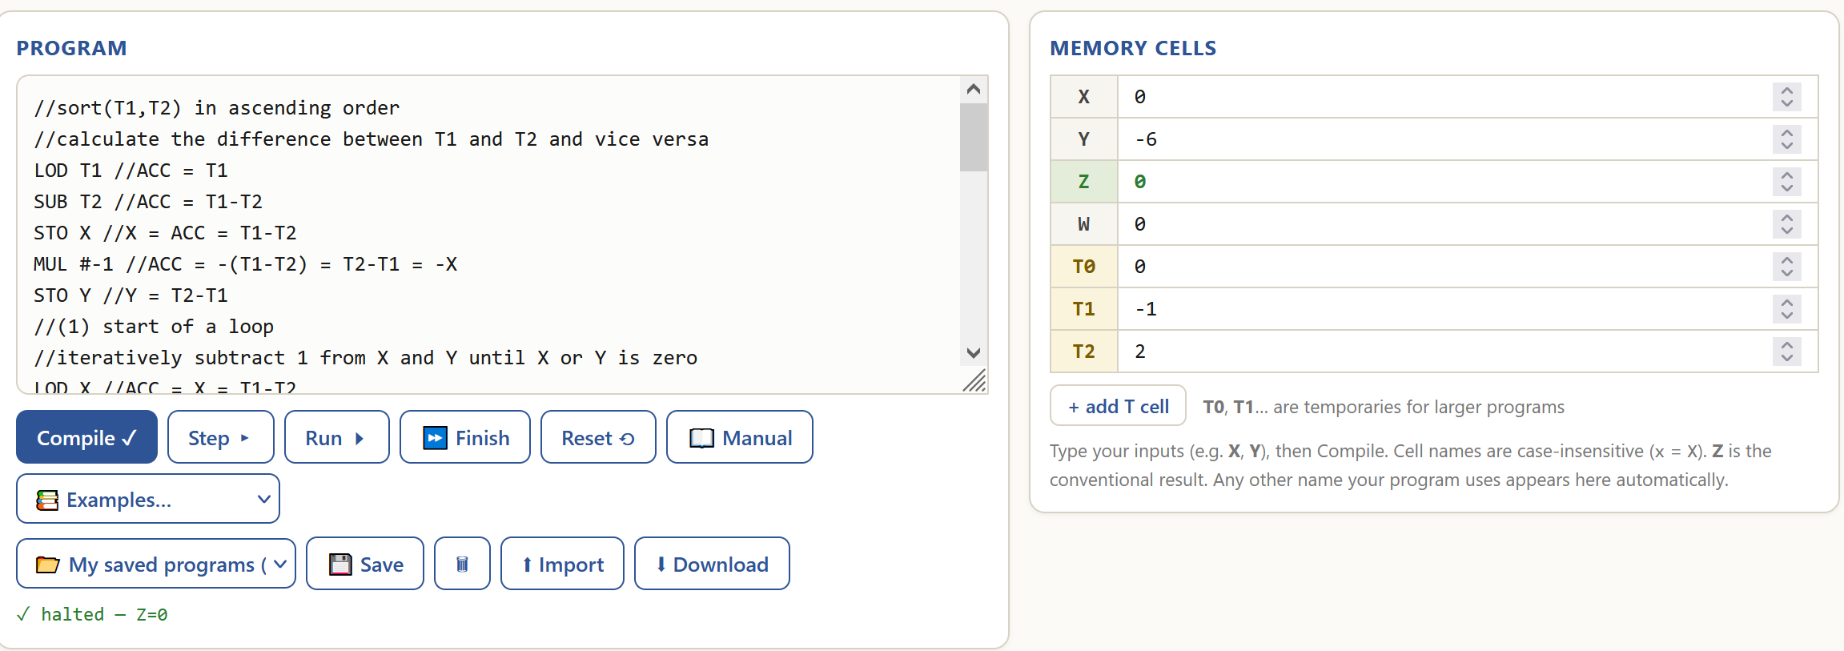
My program’s design:
It is split into 4 parts:
- Line 0 – a comment that explains what the program does.
- Line 1-6 – calculates the difference of T1 and T2 and the other way around.
- Line 7-17 – the main loop that decrements both differences.
- Line 18-28 – the swap of two numbers.
The parts 2-4 are connected by manually labelled jumps.
There are comments in the code that describe most operations.

My program’s logic:
Code analysis | Visualised algorithm
Line 0-1 – comments.  Line 2-4 – calculate the value of T1-T2, stores it in X.  Line 5-6 – calculate the value of -X, stores it in Y.  Line 7 – comment 1, the start of the main loop.  Line 8 – a comment.  Line 9-10 - if X is equal to 0, go to comment 3 (do not swap).  Line 11-12 – decrement X.  Line 13-14 - if Y is equal to 0, go to comment 2 (do the swap).  Line 15-16 – decrement Y.  Line 17 – go to comment 1, run the loop again.  Line 18 – comment 2.  Line 19-26 – the swap of two numbers, explained in EX3.  Line 27 – comment 3.  Line 28 – halt the program. | 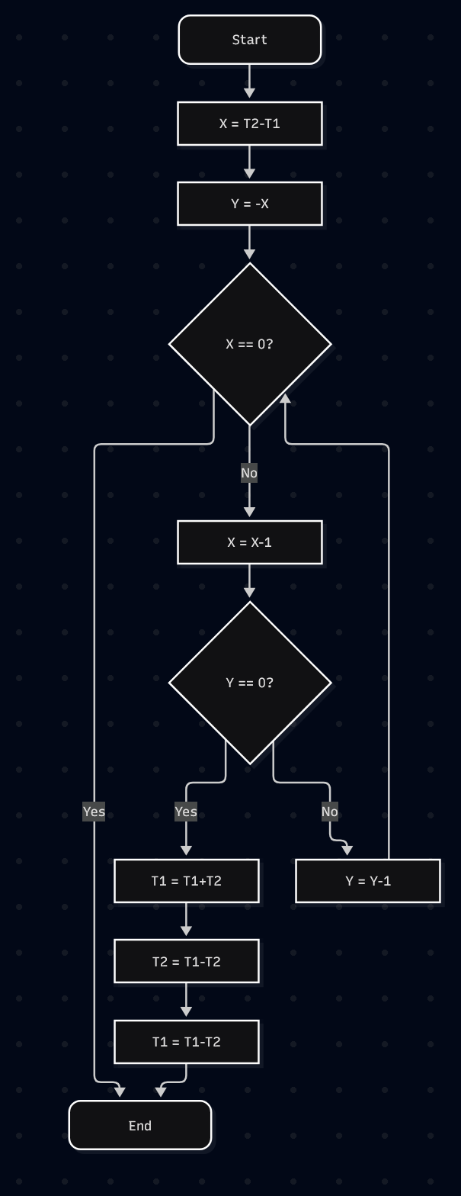

Behaviour examples of my program:
Example 1 – two positives, ascending order: T1=3, T2=4.
Line 0-1 – comments, nothing happens.
Line 2 – loads T1 into ACC. (ACC = 3)
Line 3 – subtract T2 from ACC. (ACC = 3-4 = -1)
Line 4 – stores ACC into X. (X = -1)
Line 5 – multiplies ACC by -1. (ACC = -(-1) = 1)
Line 6 – stores ACC into Y. (Y = 1)
Line 7-8 – comments, nothing happens.
Line 9 – loads X into ACC. (ACC = -1)
Line 10 – if ACC is 0, goes to line 18 (comment 2). (False)
Line 11 – subtracts 1 from ACC. (ACC = -1-1 = -2)
Line 12 – stores ACC into X. (X = -2)
Line 13 – loads Y into ACC. (ACC = 1)
Line 14 – if ACC is 0, goes to line 27 (comment 3). (False)
Line 15 – subtracts 1 from ACC. (ACC = 1-1 = 0)
Line 16 – stores ACC into Y. (Y = 0)
Line 17 – goes to line 7 (comment 1).
Line 7-8 – comments, nothing happens.
Line 9 – loads X into ACC. (ACC = -2)
Line 10 – if ACC is 0, goes to line 18 (comment 2). (False)
Line 11 – subtracts 1 from ACC. (ACC = -2-1 = -3)
Line 12 – stores ACC into X. (X = -3)
Line 13 – loads Y into ACC. (ACC = 0)
Line 14 – if ACC is 0, goes to line 27 (comment 3). (True)
Line 27 – a comment, nothing happens.
Line 28 – the program is halted.
Result: T1=3, T2=4.
The numbers are in ascending order – as intended.

Example 2 – two positives, descending order: T1=4, T2=3.
Line 0-1 – comments, nothing happens.
Line 2 – loads T1 into ACC. (ACC = 4)
Line 3 – subtract T2 from ACC. (ACC = 4-3 = 1)
Line 4 – stores ACC into X. (X = -1)
Line 5 – multiplies ACC by -1. (ACC = -(1) = -1)
Line 6 – stores ACC into Y. (Y = -1)
Line 7-8 – comments, nothing happens.
Line 9-12 – the X is not 0, subtracts 1 from X (X = 1-1 = 0)
Line 13-16 – the Y is not 0, subtracts 1 from Y (Y = -1-1 = -2)
Line 17 – goes to line 7 (comment 1).
Line 7-8 – comments, nothing happens.
Line 9 – loads X into ACC. (ACC = 0)
Line 10 – if ACC is 0, goes to line 18 (comment 2). (True)
Line 18 – a comment, nothing happens.
Line 19-26 – swap T1 and T2 in-place, explained in EX3. (T1 = 3, T2 = 4)
Line 27 – a comment, nothing happens.
Line 28 – the program is halted.
Result: T1=3, T2=4.
The numbers are in ascending order – as intended.

Example 3 – two negatives, the same: T1=-2, T2=-2.
Line 0-1 – comments, nothing happens.
Line 2 – loads T1 into ACC. (ACC = -2)
Line 3 – subtract T2 from ACC. (ACC = -2-(-2) = 0)
Line 4 – stores ACC into X. (X = 0)
Line 5 – multiplies ACC by -1. (ACC = -(0) = 0)
Line 6 – stores ACC into Y. (Y = 0)
Line 7-8 – comments, nothing happens.
Line 9 – loads X into ACC. (ACC = 0)
Line 10 – if ACC is 0, goes to line 18 (comment 2). (True)
Line 18 – a comment, nothing happens.
Line 19-26 – swap T1 and T2 in-place, explained in EX3. (T1 = -2, T2 = -2)
Line 27 – a comment, nothing happens.
Line 28 – the program is halted.
Result: T1=-2, T2=-2.
The numbers are in ascending order – as intended.

Example 4 – one positive, one negative, descending order: T1=2, T2=-1.
Line 0-1 – comments, nothing happens.
Line 2 – loads T1 into ACC. (ACC = 2)
Line 3 – subtract T2 from ACC. (ACC = 2-(-1) = 3)
Line 4 – stores ACC into X. (X = 3)
Line 5 – multiplies ACC by -1. (ACC = -(3) = -3)
Line 6 – stores ACC into Y. (Y = -3)
Line 7-8 – comments, nothing happens.
Line 9-12 – the X is not 0, subtracts 1 from X (X = 3-1 = 2)
Line 13-16 – the Y is not 0, subtracts 1 from Y (Y = -3-1 = -4)
Line 17 – goes to line 7 (comment 1).
Line 7-8 – comments, nothing happens.
Line 9-12 – the X is not 0, subtracts 1 from X (X = 2-1 = 1)
Line 13-16 – the Y is not 0, subtracts 1 from Y (Y = -4-1 = -5)
Line 17 – goes to line 7 (comment 1).
Line 7-8 – comments, nothing happens.
Line 9-12 – the X is not 0, subtracts 1 from X (X = 1-1 = 0)
Line 13-16 – the Y is not 0, subtracts 1 from Y (Y = -5-1 = -6)
Line 17 – goes to line 7 (comment 1).
Line 7-8 – comments, nothing happens.
Line 9 – loads X into ACC. (ACC = 0)
Line 10 – if ACC is 0, goes to line 18 (comment 2). (True)
Line 18 – a comment, nothing happens.
Line 19-26 – swap T1 and T2 in-place, explained in EX3. (T1 = -1, T2 = 2)
Line 27 – a comment, nothing happens.
Line 28 – the program is halted.
Result: T1=-1, T2=2.
The numbers are in ascending order – as intended.

Challenges I’ve surpassed:
- The written instruction weren’t crystal clear at first (Sorts the numbers in descending order if T2 is greater than T1; Sorts the numbers in ascending order if T1 is greater than T2 – that defines a swap) – took some time to comprehend it (the former is for descending order sort, the latter is for ascending order sort).
- Checking which number is greater (I did this before looking at EX2 with a similar example) – took a short break to come up with an idea.

Code:


Exercise 5: Conditional Addition of Numbers from an Array
Objective: Process an array of 10 numbers to calculate different sums within the array.
Tasks:
- Design a program for the vnmsim simulator that:
  - Stores 10 numbers from T1 to T10
  - Calculates the total sum of the array if X=0
  - Calculates the sum of the first five numbers of the array if X=1
  - Calculates the sum of the last five numbers of the array if X=2
  - Does nothing if X has other values
- Document the behavior of your program through screenshots for each case
- The code should have clear comments explaining each instruction and its role in the overall logic
- Write the report of the exercise detailing:
  - Your approach to implementing the conditional logic
  - How you managed array processing within vnmsim constraints
  - The program's behavior for your specific set of 10 numbers
Deliverables:
- Program code: P1_EX5_initials.txt
- Screenshots of program execution for each case
- Implementation analysis report

REPORT (you may extend the report as needed beyond this page)
Declaration of use of AI tools. If you've used AI tools to aid in understanding or completing this exercise, please acknowledge it below.
Acknowledgement of AI use: | No (Yes/No)
AI tool used: | [e.g., OpenAI, BARD, etc.]
Purpose: | [e.g., Clarification of a concept, content generation, error-checking, etc.]
Shared session (if available) | Example: https://chat.openai.com/share/24259216-abc1-4343-974d-95357368aae8
My program’s behaviour:
Initial state:
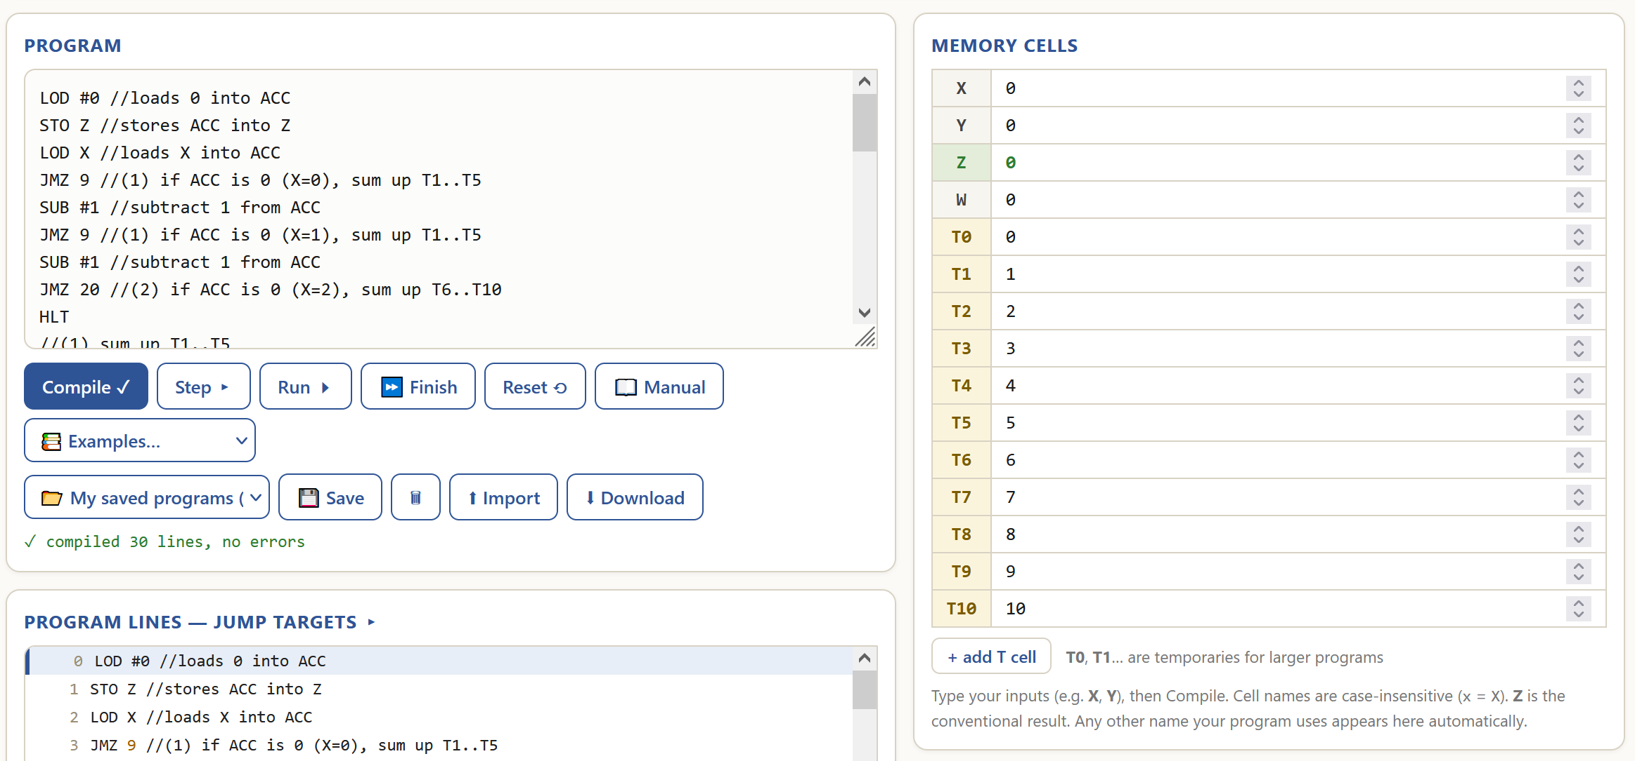
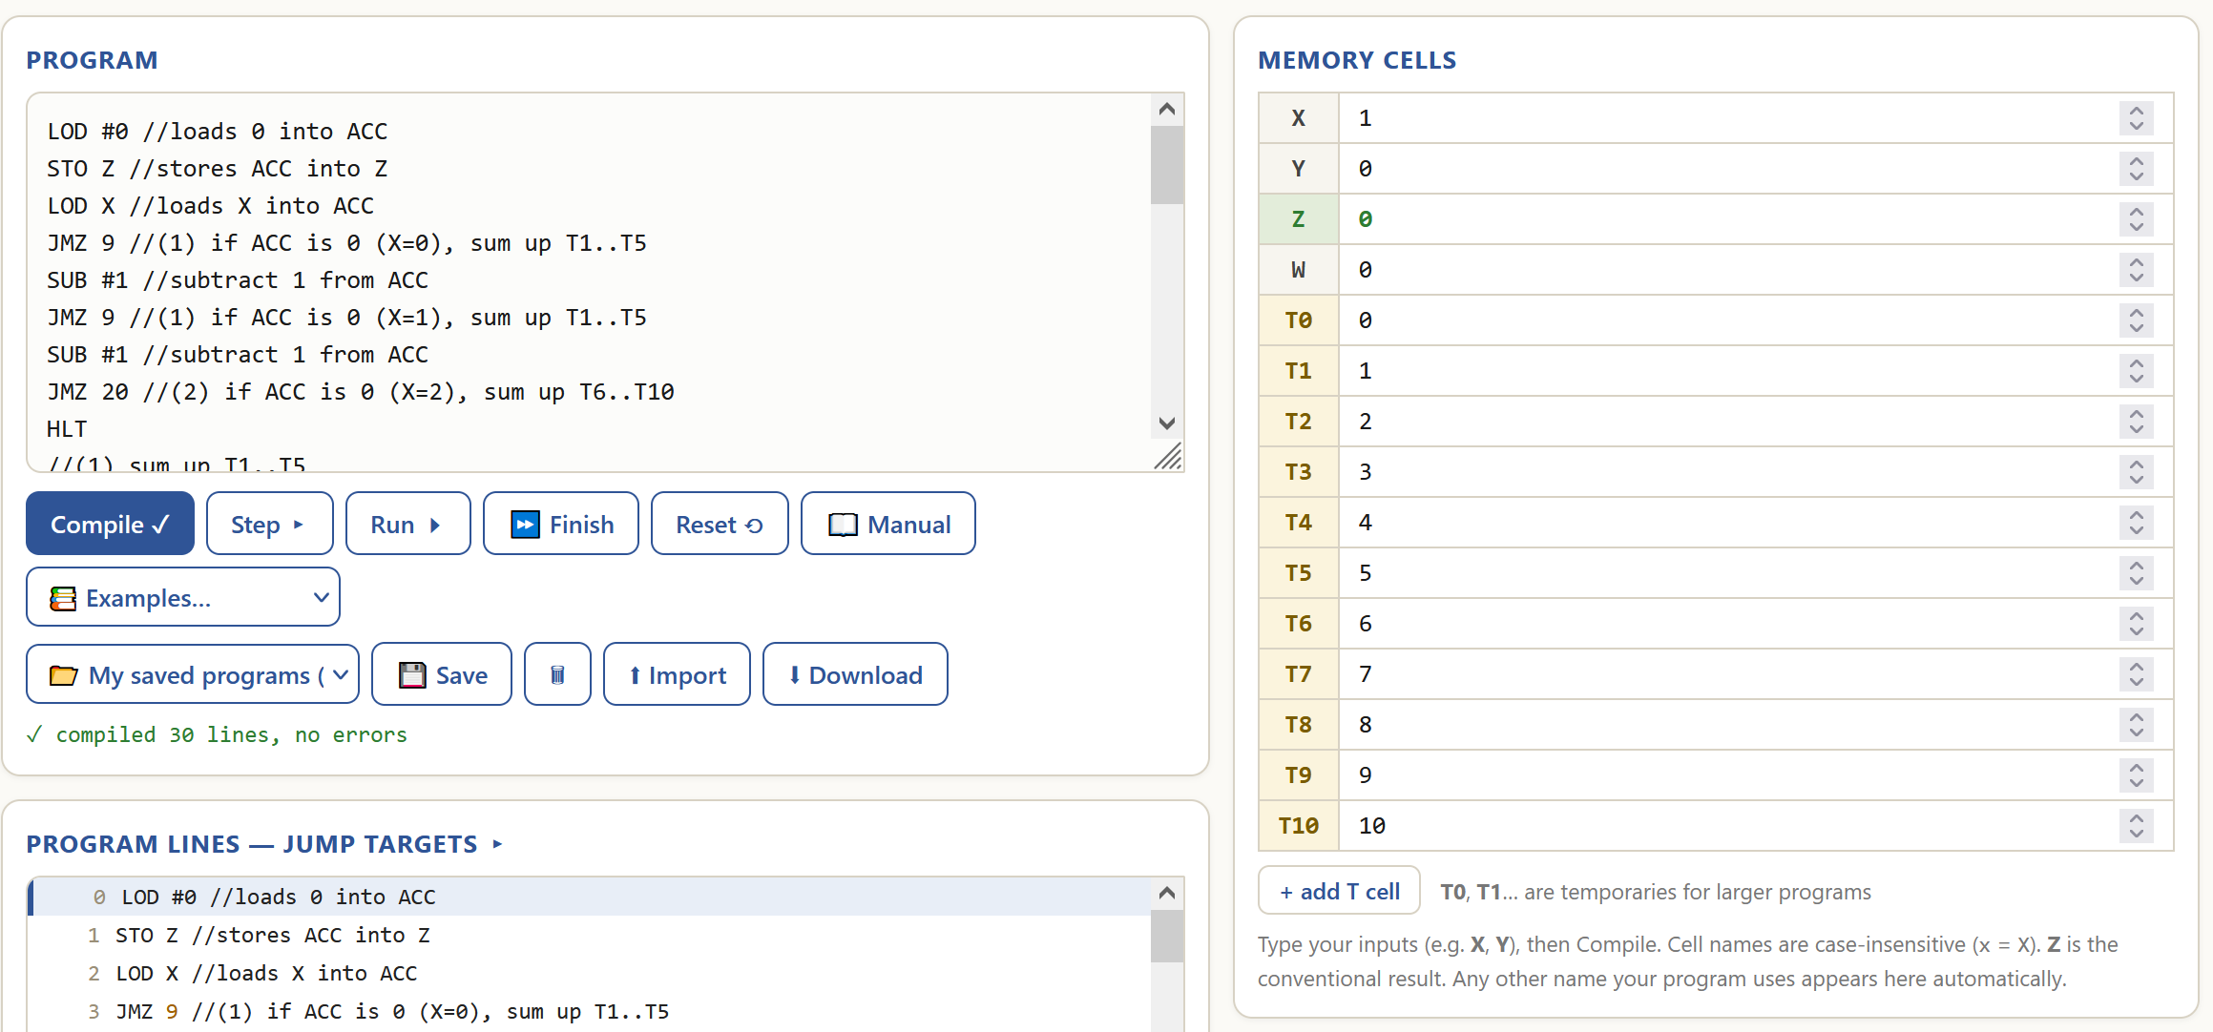
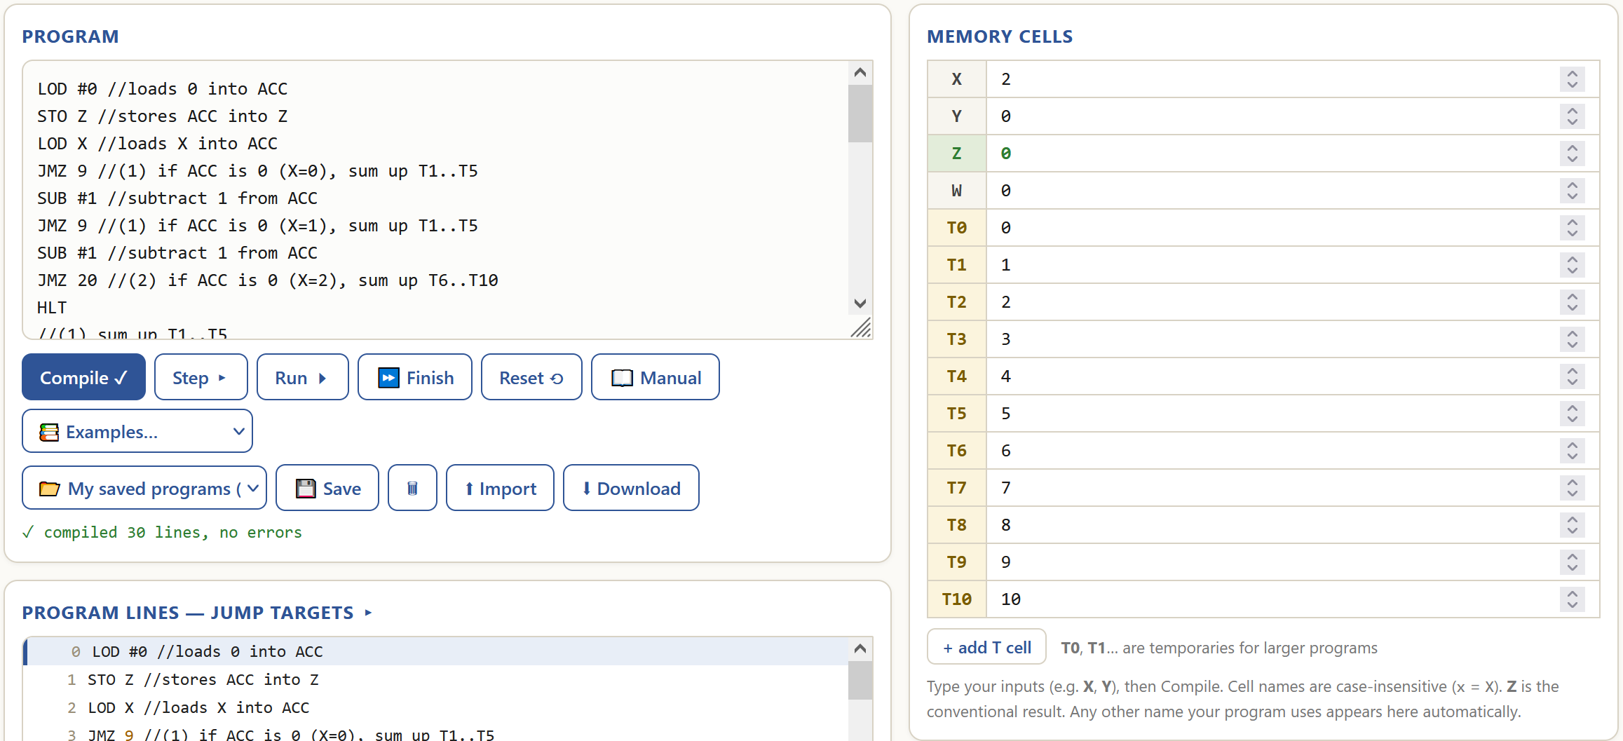
Final state:

My approach to conditional behaviour in this program:
- If X is 0 or 1, sum up T1 through T5 into Z.
- After summing that up, check if X is 1, if it is, halt. Else, sum up T6 through T10 and add that to Z.
- If X is 2, skip forward to sum up T6 through T10 into Z, then halt.
- If X is neither (undefined operation specified), halt the program.
Visualised algorithm:
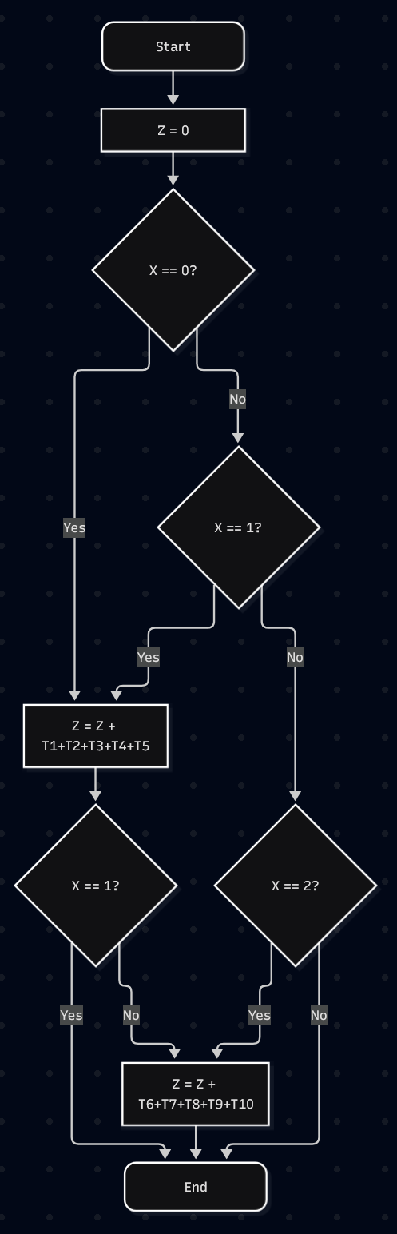

How I managed to process an array:
Simply put, I process the array manually, one operation at a time, one memory cell at a time, the same way a processor would in reality.

Examples of my program’s behaviour:
Data: T1=1,T2=2,T3=3,T4=4,T5=5,T6=6,T7=7,T8=8,T9=9,T10=10.
Example 1 – sum up everything: X=0.
Line 0-1 – set Z to 0. (Z = 0)
Line 2-3 – if X is 0, go to line 9 (comment 1). (True)
Line 9 – comment 1, nothing happens.
Line 10-16 – adds up T1..T5 to Z. (Z = 0 + 1+2+3+4+5 = 15)
Line 17-19 – if X is 1, go to line 28 (comment 3). (False)
Line 20 – comment 2, nothing happens.
Line 21-27 – adds up T6..T10 to Z. (Z = 15 + 6+7+8+9+10 = 55)
Line 28 – comment 3, nothing happens.
Line 29 – the program is halted.
Result: Z=55.
The result is correct (sum 1..10 = 55) – as intended.

Example 2 – sum up 1st half: X = 1.
Line 0-1 – set Z to 0. (Z = 0)
Line 2-3 – if X is 0, go to line 9 (comment 1). (False)
Line 4-5 – if X is 1, go to line 9 (comment 1). (True)
Line 9 – comment 1, nothing happens.
Line 10-16 – adds up T1..T5 to Z. (Z = 0 + 1+2+3+4+5 = 15)
Line 17-19 – if X is 1, go to line 28 (comment 3). (True)
Line 28 – comment 3, nothing happens.
Line 29 – the program is halted.
Result: Z=15.
The result is correct (sum 1..5 = 15) – as intended.

Example 3 – sum up 2nd half: X=2.
Line 0-1 – set Z to 0. (Z = 0)
Line 2-3 – if X is 0, go to line 9 (comment 1). (False)
Line 4-5 – if X is 1, go to line 9 (comment 1). (False)
Line 6-7 – if X is 2, go to line 20 (comment 2). (True)
Line 20 – comment 2, nothing happens.
Line 21-27 – adds up T6..T10 to Z. (Z = 15 + 6+7+8+9+10 = 55)
Line 28 – comment 3, nothing happens.
Line 29 – the program is halted.
Result: Z=40.
The result is correct (6+7+8+9+10 = 40) – as intended.

Example 4 – undefined operation: X=99.
Line 0-1 – set Z to 0. (Z = 0)
Line 2-3 – if X is 0, go to line 9 (comment 1). (False)
Line 4-5 – if X is 1, go to line 9 (comment 1). (False)
Line 6-7 – if X is 2, go to line 20 (comment 2). (False)
Line 8 – the program is halted.
Result: Z=0.
The result is correct (the program did not sum up anything) – as intended.

Code:


Exercise 6: Creative Case Implementation in vnmsim using an LLM as a Co-developer (TEAM Activity)
Objective: Create an original program that showcases your understanding of vnmsim capabilities while learning to effectively collaborate with an LLM as a co-developer. This exercise will help you understand both the advantages and limitations of using AI tools in programming.
Description
For this exercise, you'll work in teams to create an original program for the vnmsim simulator. The key requirement is that you must use an LLM (Large Language Model) of your choice as a co-developer throughout the development process, not just as a helper tool.
Phase 1: LLM Co-development Setup (Week 1)
- Choose Your LLM Co-developer: Select an LLM tool (ChatGPT, Claude, Bard, Copilot, etc.) and establish how your team will collaborate with it.
- Initial Brainstorming with LLM Co-developer:
  - Present the vnmsim constraints to your LLM co-developer
  - Brainstorm with your team about possible programming challenges suitable for vnmsim of your interest and ask the LLM to evaluate your ideas and suggest an implementation roadmap
  - Evaluate the LLM's suggestions with your team
  - Document this interaction in your report (screenshots, copied conversations, or detailed summaries)
- Problem Selection:
  - Define which challenge from those discussed within the team and the LLM co-developer and justify your selection in terms of originality and complexity
  - Have the LLM help you refine the problem scope to fit vnmsim limitations
Phase 2: Collaborative Co-development (Week 1-2)
- Algorithm Design with LLM Co-developer:
  - Work with the LLM to break down your chosen problem into steps
  - Ask the LLM to identify potential challenges given vnmsim's instruction set
  - Have the LLM suggest alternative approaches when you hit limitations
  - Document key insights and suggestions from your LLM co-developer
- Code Co-development Process:
  - Start coding with LLM assistance, but don't let it write everything
  - Use the LLM co-developer to:
    - Suggest instruction sequences for specific operations
    - Help debug logical errors
    - Optimize memory usage (registers T1-T20, X, Y, Z, W)
    - Generate meaningful comments for your code
  - Important: You must write and test the actual code yourself - the LLM is your advisor, not your programmer
Phase 3: Testing and Refinement (Week 2)
- Collaborative Testing:
  - Test your program thoroughly on vnmsim
  - When encountering issues, describe them to your LLM co-developer
  - Use LLM suggestions to debug and improve your solution
  - Document instances where LLM advice was helpful vs. unhelpful
Phase 4: Documentation and Reflection
- Comprehensive Documentation:
  - Problem Description: Clearly explain what your program does
  - LLM Co-development Log: Document key interactions with your LLM co-developer (include screenshots, conversation excerpts, or detailed summaries)
  - Program Logic: Detailed explanation of your solution with comments
  - Testing Results: Screenshots showing your program working
  - Code: Complete, commented program ready for vnmsim
- LLM Co-development Analysis: Write a detailed reflection on your LLM co-development experience:
Advantages of LLM Co-development:
  - What aspects were most helpful?
  - How did the LLM enhance your problem-solving process?
  - What suggestions improved your final solution?
Limitations and Challenges:
  - Where did the LLM provide incorrect or unhelpful advice?
  - What vnmsim-specific knowledge did the LLM lack?
  - How did you verify and validate LLM suggestions?
Co-development Effectiveness:
  - Rate the LLM as a programming co-developer (1-5 scale) and justify
  - What would you do differently next time?
  - How did this change your coding process compared to working alone?
Phase 5: Self-Evaluation
- Enhanced Self-Assessment:
Originality (1-5 scale):
  - How unique was your chosen problem?
  - Did the LLM collaboration lead to more creative solutions?
  - Reflection: What makes your solution stand out?
Complexity (1-5 scale):
  - How challenging was the problem within vnmsim constraints?
  - Did LLM assistance allow you to tackle a more complex problem?
  - Reflection: How did the collaboration enhance your understanding of vnmsim?
Solution Quality (1-5 scale):
  - Evaluate efficiency and effectiveness of your final program
  - How did LLM input improve your solution?
  - Reflection: What could be optimized further?
LLM Co-development Skills (1-5 scale):
  - How effectively did you use the LLM as a programming co-developer?
  - Did you maintain critical thinking while using AI assistance?
  - Reflection: What co-development strategies worked best?
Phase 6: In-Class Demonstration
- Team Presentation Requirements:
  - Problem Introduction (2 minutes): Explain your chosen challenge
  - LLM Co-development Showcase (3 minutes):
    - Show key LLM interactions that shaped your solution
    - Highlight one particularly helpful and one problematic LLM suggestion
  - Code Walkthrough (3 minutes): Demonstrate your program logic
  - Live Demo (2 minutes): Run your program on vnmsim with commentary
  - Reflection (2 minutes): Share insights about LLM co-development
  - Q&A (3 minutes): Answer questions from class and instructor
Deliverables
- Program Code: P1_EX6_teamname.txt (with comprehensive comments)
- LLM Interaction Documentation: Screenshots, conversation excerpts, or detailed summaries of key LLM interactions (shared session links if available)
- Comprehensive Report: Including all documentation and reflections
- Presentation: In-class demonstration following the structure above
Important Notes
- Academic Integrity: You must clearly document all LLM interactions and contributions
- Critical Thinking: Don't blindly accept LLM suggestions - verify and validate everything
- Team Collaboration: All team members must participate in both LLM co-development and presentation
- Learning Focus: The goal is to learn effective AI co-development, not to have AI do the work for you
- Documentation Flexibility: If shared sessions aren't available, use screenshots, conversation exports, or detailed summaries to document your LLM interactions

Remember: The LLM is your co-developer and collaborator, not your replacement. The most valuable learning comes from understanding when and how to effectively partner with AI tools while maintaining your own critical thinking and problem-solving skills.
REPORT (you may extend the report as needed beyond this page)
Declaration of use of AI tools. If you've used AI tools to aid in understanding or completing this exercise, please acknowledge it below.
Acknowledgement of AI use: | Yes (Yes/No)
AI tool used: | Claude Sonnet 5.5 Medium [e.g., OpenAI, BARD, etc.]
Purpose: | Co-development of a program [e.g., Clarification of a concept, content generation, error-checking, etc.]
Shared session (if available) | https://claude.ai/share/4673c57f-84cc-4823-8783-1e12f9785fea Example: https://chat.openai.com/share/24259216-abc1-4343-974d-95357368aae8
We – Timur, Aydin and Sergey – worked as a team TAS (made from our first letters of names) to accomplish this task.
We decided to use Claude as a co-developer because it is typically better at coding tasks such as this one.
I, Timur, took on a role of a lead developer by directly working with AI to code the program.
Aydin and Sergey were co-developers who contibuted by testing the code, designing the logic, preparing the documentation and making the presentation.
We came up with the following ideas for a program:
- Checking if a number is prime.
- Solving a two equation matrix by Cramer’s rule.
- Solving a three equation matrix by Cramer’s rule.
- Sorting memory cells using bubble sort.
- Computing the GCD of 2 numbers.
- Checking if memory cells make a palindrome.
We asked Claude to rate these ideas on the following criteria: complexity, creativity, practicality and received a following response:
Ultimately, we chose idea 3 as the best overall option because it offers great usability while providing a solid challenge for our team due to the following limitations: tight memory budget, only integer operations, hard to debug code.
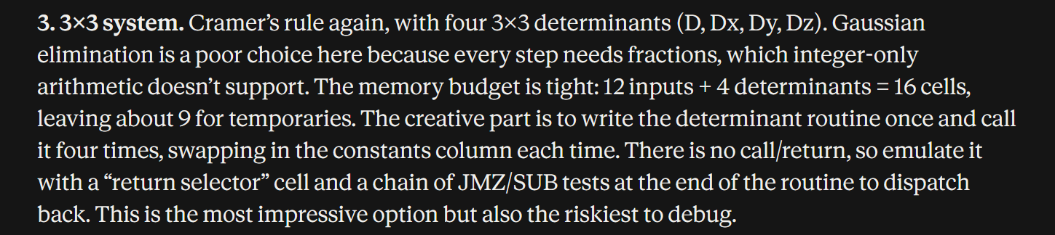

To understand and establish the logic of the program thoroughly, we required guidance from AI for steps to solve it, possible difficulties and workarounds, as well as coding with Von Neumann machine code, similar to assembly.
In response, we received:
- The logic of our program
- The memory map.
- A chunk of code to calculate a determinant.
- The limits of VNMSIM and possible bypasses.
However, we changed the logic and memory slightly to fit our view better:
Logic:
//Setup
X = 0
Y = 0
Z = 0
W = 0
//det(A) by Laplace expansion by row 1
T12 = T0 * (T5*T10 - T6*T9) - T1 * (T4*T10 - T6*T8) + T2 * (T4*T9 - T5*T8)
//D = det(A) == 0
W = 1
HLT
//det(A) =/= 0
//Dx
T13 = T3 * (T5*T10 - T6*T9) - T1 * (T7*T10 - T6*T11) + T2 * (T7*T9 - T5*T11)
X = Dx/D
//Dy
T13 = T0 * (T7*T10 - T6*T11) - T3 * (T4*T10 - T6*T8) + T2 * (T4*T11 - T5*T8)
Y = Dy/D
//Dz
T13 = T0 * (T5*T11 - T7*T9) - T1 * (T4*T11 - T7*T8) + T3 * (T4*T9 - T5*T8)
Z = Dz/D
HLT

Memory:
T0..T11 – input, the equations in augmented matrix style
T12..T15 – memory cells for calculations
X,Y,Z – output cells
W – flag for “no unique solution”

We then prompted AI to implement our logic in code and received the first implementation of the code and the following response:
However, the jumps were set wrong, so we reprompted it to check the JMP, JMZ operations.

AI responded this way:
After that, the code still had an error if the was no unique solution, required another reprompt:
AI responded:

When we started, we tested on integer numbers only:
Initial state:
Final state:
However, we then decided to implement support for fractional numbers as well with this logic:
X.YYY --> XYYY
Then, we prompted AI to add this functionality to our program:
AI gave us the code with this logic added:
...
//X = (Dx*1000)/D in XYYY format
LOD T13
MUL #1000
DIV T12
STO X
...

We then thoroughly tested the program:
Test 1 - whole numbers:
Initial state:
Final state:
Test 2 – fractional numbers:
Initial state:
Final state:
Test 3 – zero matrix:
Initial state:
Final state:
Test 4 – no solutions:
Initial state:
Final state:
Test 5 – infinite solutions:
Initial state:
Final state:

All test results are correct:
- X=1,Y=2,Z=3
- X=0.5,Y=0.666,Z=0.75
- W=1, infinite solutions
- W=1, no solution
- W=1, infinite solutions

Code:
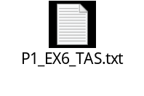
Reflection on LLM co-developer experience:
- What aspects were most helpful?
Before writing any code, the LLM allowed the team to brainstorm and evaluate multiple project ideas (from prime numbers to 3x3 Cramer’s rule) based on complexity, creativity, and practicality. This ensured the team picked a project that was both challenging and technically rewarding.
- How did the LLM enhance your problem-solving process?
AI helped us implement our logic of the program into code, gave algorithm suggsetions, helped to find logical mistakes and provided key information about the problem.
- What suggestions improved your final solution?
AI suggested using this program idea in the first place and advised to add fractional number functionality and watch out for overflow.
- Where did the LLM provide incorrect or unhelpful advice?
The LLM’s first version of a program had incorrect syntax, gave wrong JMP, JMZ line numbers and incorrectly initialised immediate values.
- What vnmsim-specific knowledge did the LLM lack?
The LLM had no idea about Vnmsim limits, syntax and specifics (line numbers start at 0, comments count towards line total, whether vnmsim handles negative values, integer bit limit, etc.).
- How did you verify and validate LLM suggestions?
When LLM changed the code, we reviewed parts of code and tested the new version.
- Rate the LLM as a programming co-developer (1-5 scale) and justify
We’d rate Claude a solid 4 out of 5 because it provided us with good coding support and suggestions, but it did not know the specific vmnsim implementation we were using and made stupid mistakes.
- What would you do differently next time?
The next time we work with an LLM for making code in vmnsim, we will try to provide as much detail as possible about its limitations and syntax.
- How did this change your coding process compared to working alone?
Instead of just creating the code ourselves we observed AI doing it and we were just reviewing it and checking for mistakes.

Self-assessment:
Originality (1-5 scale): 4
  - How unique was your chosen problem?
Our chosen problem was quite unique, because it can solve many practical problems in many areas of work.
  - Did the LLM collaboration lead to more creative solutions?
No, the LLM only helped us rate our own ideas, not create more, as we did not require it as a replacement for creativity.
  - Reflection: What makes your solution stand out?
Our solution combines complex mathematical equations and real-world use, making it useful in a variety of fields.
Complexity (1-5 scale): 5
  - How challenging was the problem within vnmsim constraints?
With limited memory and only integer arithmetic, some logical thinking was needed to bypass those restrictions.
  - Did LLM assistance allow you to tackle a more complex problem?
Yes, instead of original plan of making a 2 equation system solver, the use of AI allowed us to take on a 3 equation system solver with only a slight increase in difficulty.
  - Reflection: How did the collaboration enhance your understanding of vnmsim?
I have learned that LLMs do not possess knowledge of the specifics of the vnmsim we use as there are many variations across the internet. Working with AI requires good prompting skills and a in-depth understanding of the code.
Solution Quality (1-5 scale): 4
  - Evaluate efficiency and effectiveness of your final program
The final program solves a 3 equation system for X,Y and Z using as little memory as needed for computations, while also not destroying the input. It halts the program as early as needed, not requiring unnecessary operations to be executed.
  - How did LLM input improve your solution?
LLM helped implement our logic of the program as well as provided suggestions on what to improve, for instance, adding fractional number support.
  - Reflection: What could be optimized further?
Currently, the program does not discern the “no solution” case from “infinite solutions”, that could be added by implementing Gaussian elimination, but would use up a lot more memory. Theoretically, removing empty lines and comments could make it run a few cycles faster, but would hurt the readability of the code.
LLM Co-development Skills (1-5 scale): 4
  - How effectively did you use the LLM as a programming co-developer?
I used AI effectively because I wrote detailed prompts for it, as well as a master prompt at the beginning, however it required some reprompting to get the asked result.
  - Did you maintain critical thinking while using AI assistance?
Yes, I reviewed AI-generated code before running and tested it before accepting it as correct. Furthermore, I read its suggestions and considered whether to implement them or not, for example, in the logic it mentioned overflow, however, after testing in vnmsim, I understood that is handles 64-bit integers, so there was no need for it for most values.
  - Reflection: What co-development strategies worked best?
A precise and detailed prompt followed by actually reading and analysing its result worked best, as it allowed me to find logical and syntax mistakes before running the code.

Presentation:
https://docs.google.com/presentation/d/1pP5jC2KSGXMLeo3VjRH_MvFsYKcDEI5unEcaHNnJc_A/edit?usp=sharing

YOU SHOULD NOT EXPECT TO GET ANY REMINDERS FROM TUTORS ABOUT ANY OF THESE
RESPONSIBILITIES OR DEADLINES

